RigExpert FoxRex 144 – An Inside View

Nick Roethe, DF1FO

About this Document

RigExpert from Kiev / Ukraine is offering the 2 m ARDF receiver FoxRex 144 since 2018. In Western Europe it is distributed by WiMo. The receiver comes with a detailed user manual. That manual is limited to just the operation. Of course, a real radio amateur would like to know what's inside, how it works, and how to realign or fix it if necessary. The answers are in this document. This is not a RigExpert document – it is all my personal opinion and responsibility.
This is a translation of my German document. Sorry for the bad English, it is all Google Translates fault!

On the design history
The FoxRex is based on my 2m ARDF receiver Version 4, developed in 2010, which builds on the experience gained with several previous generations. Descriptions of these designs can be found on my homepage www.df1fo.de . Hundreds of these receivers have been built by radio amateurs around the world (and still are). Many YLs and OMs, mainly in DL, OE and PA0, have tested the design and made valuable contributions towards improving it. RigExpert had the idea that there should also be a market for a ready-to-use version of this receiver, and (with my happy consent) has made a commercial product out of my receiver. Their version is mechanically completely redesigned. Electrically, the changes are small, and the software is identical.
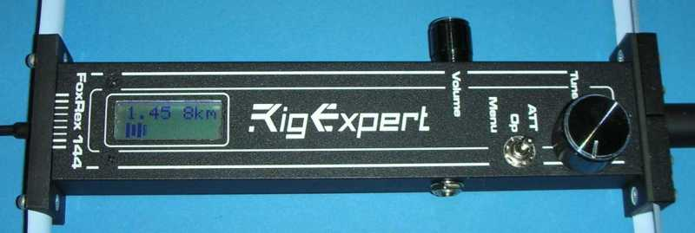

Contents

What you get for your Money 2
How to open the FoxRex 3
Removing and Exchanging Antenna Elements 5
Circuit Diagram 6
Circuit Description 7
Alignment & Calibration 8
Re-Programming 10
Headphone 11
Compass 11
Demagnetizing the antenna 11
Red Fox 144 12
Moving the Volume Control 12
Some Remarks on the Distance Estimation 13

What you get for your Money

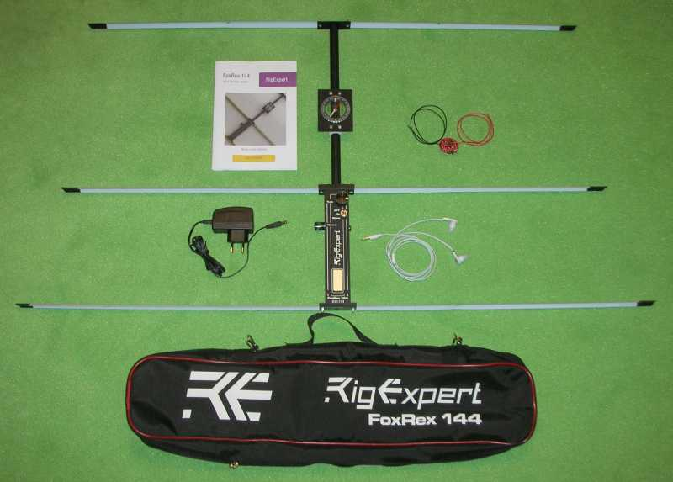

Here is what you get for your money:
- ARDF receiver FoxRex 144
- Earphones 2 x 32Ω
- Charger, primary 100-240 V AC, secondary 12 V =
- Manual
- Black carrying bag, 62 x 13 x 8 cm (25 x 5 x 3 inches)
- Test fox ‘Red Fox 144’
Everything is packed into the carrying bag. The antenna elements are made from steel tape measure, and are folded to make fit the receiver into the carrying bag.
Tip: Some rubber bands help to hold the folded antenna elements in place. Fold the antenna elements only towards the hollow side, see picture below.
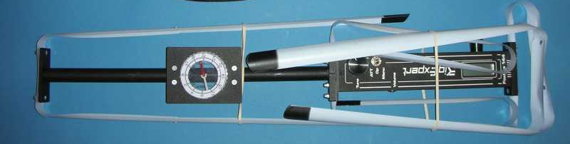

The manual is available in German, English and Russian. The latest version can be found on the RigExpert homepage: https://rigexpert.com/products/ardf-receivers/foxrex-144/downloads/
To print open the PDF with Adobe Acrobat Reader, print double-sided in the format 'Brochure'.

How to open the FoxRex

This section describes how the receiver can be opened and what it looks like inside. There is a good reason not to open the receiver: the potential loss of warranty. On the other hand: a real ham opens everything. So I opened one for you.
The housing consists of two aluminum L profiles and two end plates. These end plates, like some other parts used to hold the antenna elements, are manufactured with a 3D-printer. The housing is opened as follows:
- Remove rear antenna element (reflector, longest element) – 2 cap nuts
- Remove rear end plate – two countersunk screws
- Rotary encoder: pull off knob, unscrew nut and washer
- Toggle switch: unscrew nut and washer
- Charger jack: unscrew nut and washer
- Remove four countersunk screws from the top L profile (two next to display, two near ‘Tune’)
- Now you can remove the top L profile
And this is what you see:
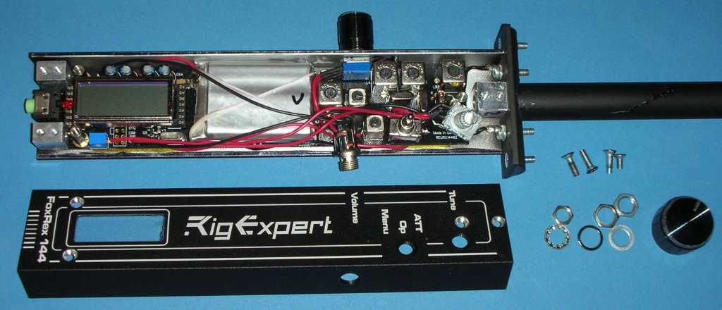
All components are mounted on a double-sided printed circuit board.
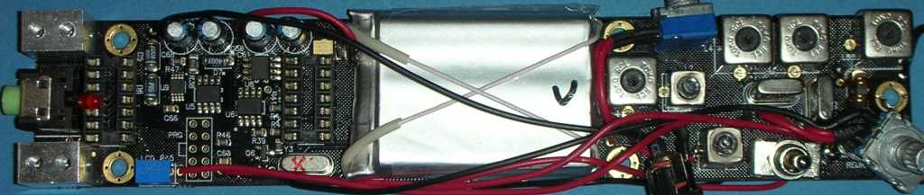

In the middle of the board you can see the Lithium-Polymer-accumulator, on the right side the RF and IF stages, and on the left side the display, processor and charger and voltage regulation circuits. The display is plugged into a socket and can be removed easily.
Now all alignment and measurement points and the programming connector are easily accessible, see also the chapter ‘Alignment’.
If you also want to inspect the bottom side of the board, you have more work to do:
- Unsolder the two black antenna leads from the solder lugs
- Volume control: pull off knob, unscrew nut and washer
- Remove LCD display (mark correct position first)
- Remove two M3 nuts and three M3 hex bolts on the top of the board
Now the board can be removed.
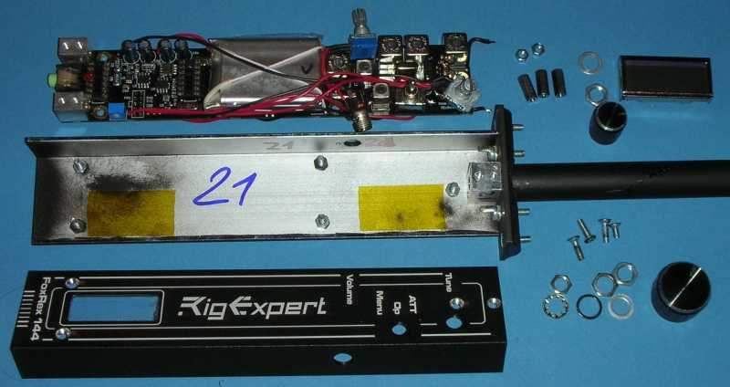

The bottom side of the board:

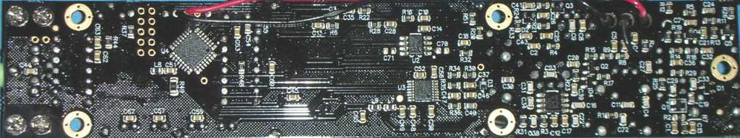

Above: The big circuit on the left is the Atmel processor, the RF/IF stages are on the right

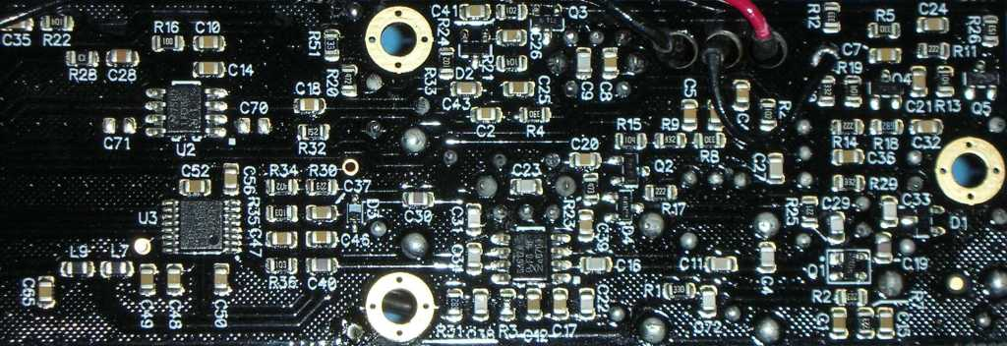

Above: A closer look at the RF/IF stages.

Removing and Exchanging Antenna Elements

The three antenna elements can be unscrewed easily. This is not necessary for transport, as they are just folded in. But when you do measurement or alignment work on the receiver, they are very much in the way.

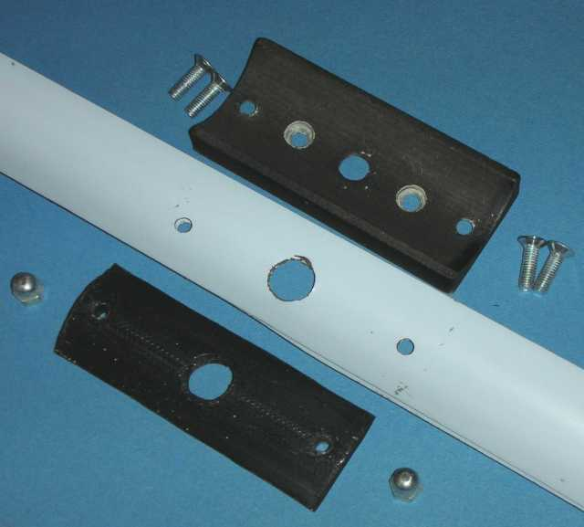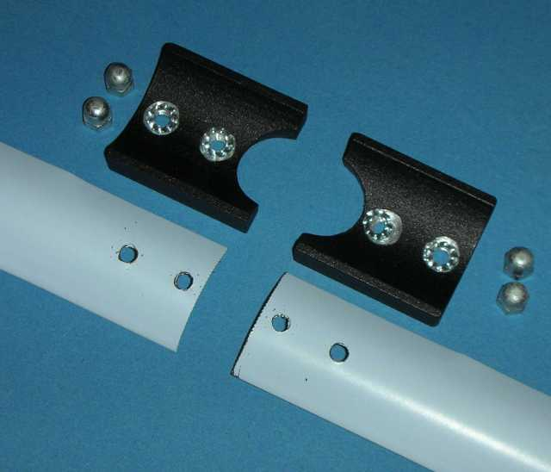

To remove the reflector (longest/rear element) unscrew two cap nuts, remove the narrow plate and reflector. See left photo. The large end plate is held by two countersunk screws. They must be removed only if you want to open the receiver.

To remove the dipole (middle element) unscrew four cap nuts, remove two cover plates and the two element halfs. See right photo. When reassembling do not forget the four lock washers.

To remove the director (front/shortest element) just unscrew two cap nuts.

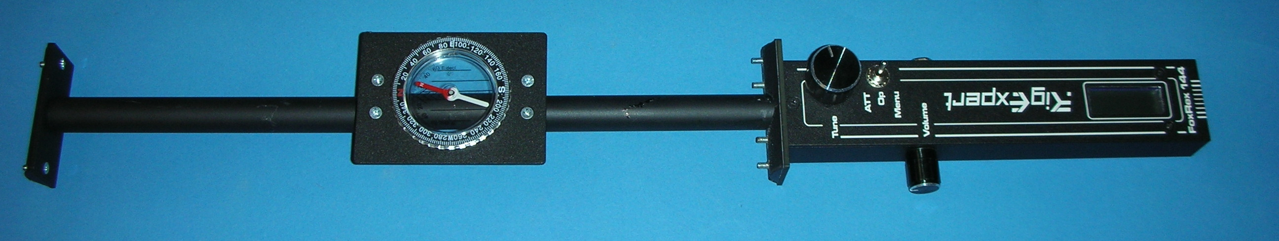

Antenna elements of 2 m ARDF- receivers do not live forever. They suffer from corrosion by rain and sweat, and from mechanical stress, especially when you trip and fall. They must therefore be replaced occasionally.
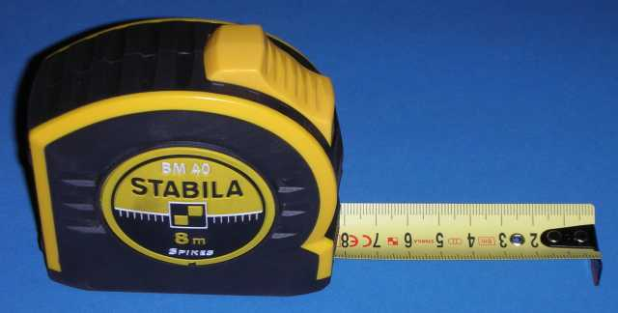
The elements are made of the same material from which tape measures are made. Such tape measures with 25 mm (1 inch) width can be bought in any hardware store. They are on a dispenser and usually 6 - 8 m long. More expensive versions are usually more stable and therefore more suitable.
The material can be cut easily with old nail scissors. With a file you can round off the sharp edges. Drilling the holes in the spring steel is not easy, it tends to crack. I hold the tape measure between two wooden boards. It's best to make a few attempts first.
RigExpert reinforces the elements in the center with a 40 cm long second layer, which is riveted at the ends. This is not absolutely necessary, but helps in case of strong wind or violent movements.

Circuit Diagram
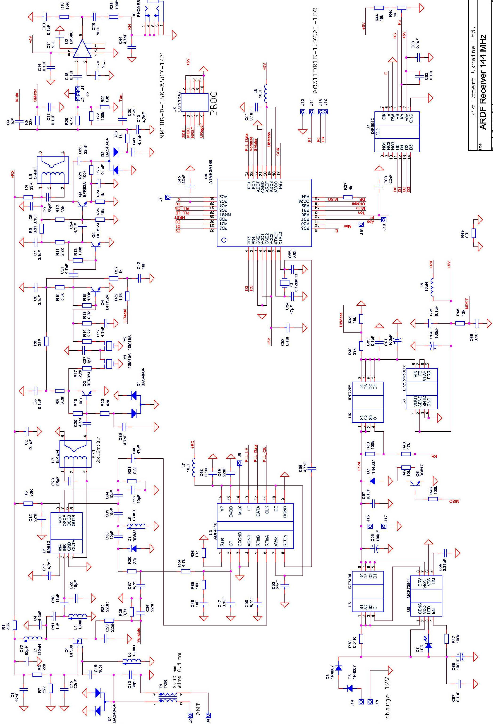

Circuit Description

See the circuit diagram on the previous page. In better quality on the RigExpert homepage: https://rigexpert.com/files/manuals/fr144/Schematics_FoxRex_144MHz.pdf

The 3-element Yagi antenna is based on a design by Joe Leggio, WB2HOL. The balanced antenna is matched to the unbalanced receiver input via the Guanella transformer T1.
The receiver is a super-het with 10.7 MHz intermediate frequency.
The preamplifier Q1 is a dual-gate MosFet. Its gain can be reduced by 0 / -15 / -50 dB by increasing the source voltage. This is controlled by the processor.
Mixer and oscillator are realized with the SA612 (Double Balanced Mixer) U1. The oscillator is controlled by the PLL circuit U3 (ADF4110 from Analog Devices). The tuning step size is 1 kHz.
The mixer is followed by a discretely constructed four-stage IF amplifier at 10.7 MHz. Two crystal filters between the first and second stage limit the receivers bandwidth. The gain of these two IF stages is controlled by lowering the operating voltage. The attenuation range achieved in this way is > 70 dB. The regulated operating voltage is generated by the processor via a 20 kHz pulse width modulator and smoothed via the two-stage low-pass filter R32/C42 and R27/C6. D4 reduces the temperature dependence of the control characteristic.
The IF amplifier is followed by the demodulator D2. It generates the AF signal and the S-meter voltage. The AF signal is mixed with the beep sounds generated by the processor. Then it goes via the volume control (at J1-3) to the AF amplifier U2 (LM386) and on to the headphones.
The receiver is controlled by a microprocessor ATMega168 U4. It loads the PLL circuit, controls the attenuator, measures the S-meter and operating voltage, and generates various beep tones. Its ‘user interface’ is a rotary encoder on J10-13, a toggle switch on J15 / 18, and a 2x8 LCD display U7. It can be reprogrammed ‘in circuit’ via the 10-pin connector J8.
The processor clock of 5.12 MHz is set by a crystal. It is also the reference frequency for the PLL. The configuration and desired frequency are loaded serially into the PLL chip, using the processor I/Os PC1, PC4 and PC5.
The receiver is switched on with the FET U6 by plugging in the headphones. The battery voltage must be between 5.5 and 10 volts. From this, the operating voltage of 5V is generated by the low-drop regulator U8. To switch off, the headphones are first removed. The receiver is still holding itself with Q6 (in case you inadvertently ripped out the headphone cord). It is finally switched off by a long press on the rotary encoder
The Power supply is a 2-cell lithium-polymer battery built into the receiver. It is connected to J16 / 17. A charging circuit with U5 + U9 is also built in. Charging requires a 12V power supply or car outlet.

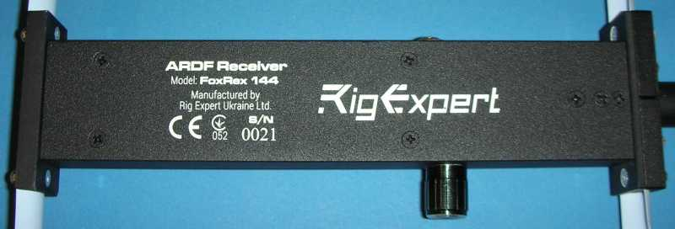

Alignment & Calibration

The receiver is shipped aligned and calibrated. If you want to re-align it you should be sure that you know what you are doing. The alignment requires a signal generator for 144.5 MHz, AM, 0,3µV – 300 mV calibrated output level.
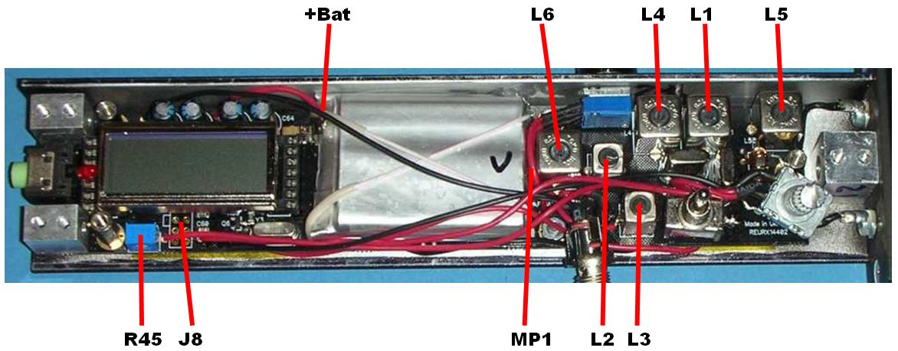
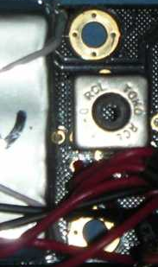

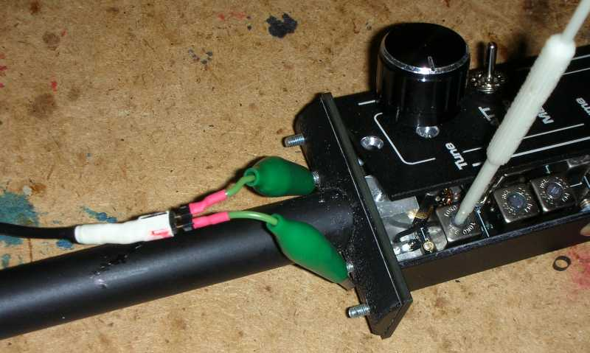
For the alignment of the receiver, the top L profile must be removed, as described above.
Turn receiver on by plugging in the headphone.
Set Contrast pot R45 for the best readability of the display. Switch between different display indications with the rotary encoder, adjust R45 so that the display changes as quickly as possible.
To set the PLL connect a voltmeter to measurement point MP1. The MP1 pad is hidden between the battery and L6. MP1 measures the tuning voltage (junction R34-R30). Set L6 so, that for the total frequency range 143.9 - 148.1 MHz the tuning voltage is in the range 1.5 - 3.5 V. This leaves some room for drift compensation in either direction.
Connect a signal generator to the receiver, see the photo on the left. Remove the dipole (4 cap nuts) and connect the generator with a short adapter coax to 2 x mini crocodile clip.
Set the receiver to 144,500 MHz and 0 dB attenuation. Turn off the automatic attenuator (press toggle switch long to ‘ATT’). You hear a faint noise. Turn the signal generator on: 144.500 MHz, 1 μV, 80% AM 1kHz.
Now the 1 kHz signal should be audible, if necessary adjust the generator level. Set the three 144MHz filters L5, L1, L4 and the two IF filters L2, L3 to maximum sensitivity = maximum bar S meter indication. All five must show a clear maximum. L1 and L4 must be set alternately. This completes the receiver hardware alignment.
The 2m filters require a 2mm hexagonal key. If you do not have a suitable plastic key, you can also use a metal 2mm Allen key. Please do not try a normal screwdriver! The two IF filters are filled with wax, but you will never have to retune those anyway.
The receiver has a tuning range of 4 MHz. However, the 2m filters limit the bandwidth to about +/- 500 kHz. Beyond that the sensitivity decreases significantly. In the IARU region 1, the foxes are always in the range 144,000 - 145,000 MHz, so the receiver is aligned to 144,500 MHz.
For the further alignment steps the Calibration menu must be started. Set switch to ‘Menu’ and turn receiver on (= plug headphone) with the encoder pressed.
In the calibration menu, select 'Cal VBat'. Measure the supply voltage at the battery (see photo above ‘+ Bat’) with a DVM. Press + Turn to set the displayed voltage to the measured value.
Set the transmitter and receiver to 144.500 MHz. In the calibration menu, select ’CalF '. The lower line of the display shows the bar-S meter. Pressing + turning the encoder varies the receive frequency in 1 kHz steps. Adjust so that there is an equally large distance (about 7 kHz each) to the filter edges in both tuning directions. To do this, select the measurement level so that the S meter bar is in the right half.
In the calibration menu, select 'Cal Att Start’ and click the encoder. Set the signal generator to 0.3 μV. Turn encoder until the S-meter bar fills ¾ of the display. Click, increase generator level 5 dB, turn to set bar to ¾, and so on until 300 mV input level and 120 dB attenuation are reached. One last click completes the attenuator alignment.
Finally, the calibration values ​​must be stored to the EEPROM. Select the menu item 'Save Cal Values’ and click.
When the alignment is complete, it is recommended to go through the calibration menu items once again and write down all values. This way you can easily restore them, if you should lose them while experimenting with the receiver.

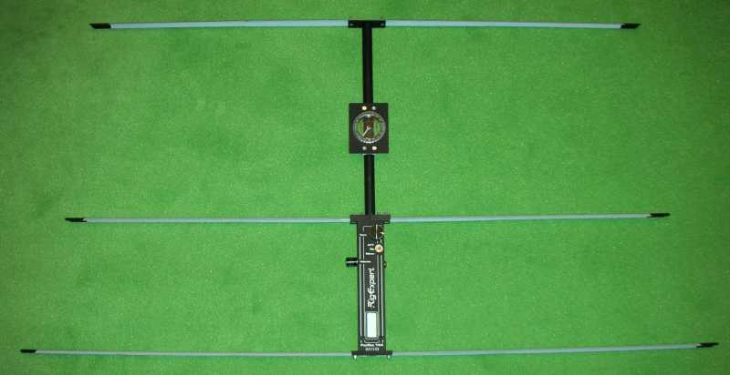

Re-Programming

In this section I describe how new software (= firmware) can be loaded into the receiver. Anyone trying this should know what he is doing. This description is therefore intended for real experts with Atmel experience.
The software of the receiver can be found on my website, the change history in the source code or under http://www.df1fo.de/SMDFragen&Antworten.html#Code
The source code has the filename fjrx24.asm. It is pure assembler code. It must be assembled with TARGET = 1 in order to support the rotary encoder installed by RigExpert.
To get access to the programming connector, you must remove the top L profile as described above. Then unplug the display, mark correct orientation. The connector J8 is simply 2x5 holes in the board. J8 does not follow the Atmel AVR ISP pin layout convention. See the table below (the pin assignment is the same as in the FoxRex 3500).
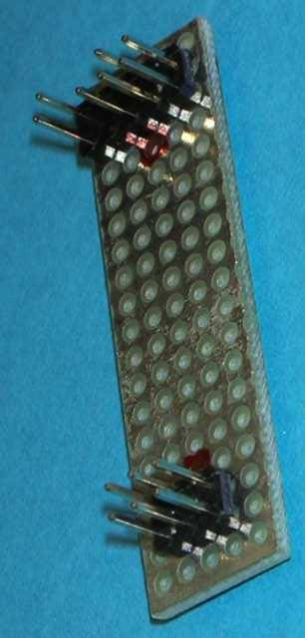
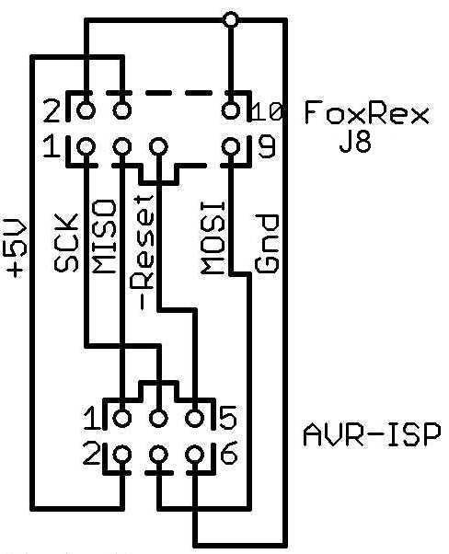
FoxRex 144 | Atmel ISP  6 pins | Atmel ISP 10 pins | Signal-  name
4  2, 10  9  3  1  5  6,7,8 | 2  6  4  1  3  5  - | 2  4, 6, 8, 10  1  9  7  5  3 | +5V  Gnd  MOSI  MISO  SCK  Reset  Unused

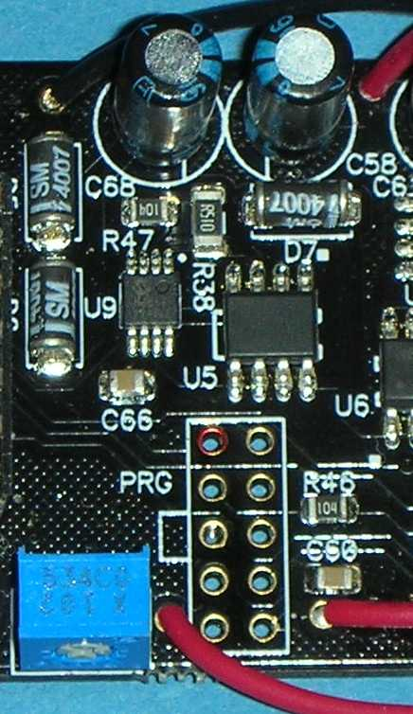
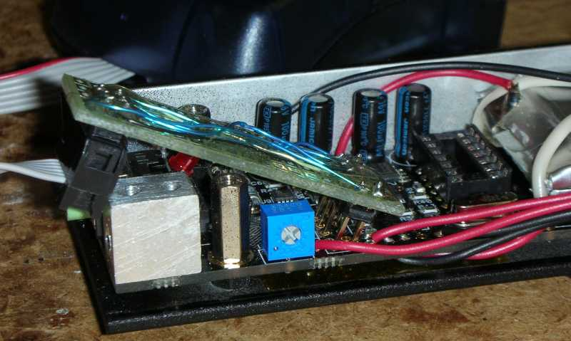
Pin1
The circuit diagram shows my adapter FoxRex to 6-pin Atmel, looking at the solder side of both connectors. The photo shows my implementation on a piece of perforated board. I had made this adapter for the FoxRex 3500, for the 144 it is a bit too short, but it works ok.
The AVR-ISP is plugged into the 6-pin header, and the 10-pin header is plugged into the J8 holes and tilted with slight pressure, so that the pins get in good contact. It helps if the outer row of pins is about 1 mm shorter than the inner one.
If everything was done correctly, flash and fuses can now be read out and reprogrammed.
However, I strongly advise not to change the fuse settings - it makes no sense and too much can go wrong!


Headphone

The receiver can be used with any standard stereo headphone or earphone with an impedance of at least 2 x 32Ω. The earphones supplied by RigExpert are an example of this, but you can easily loose them when running.
I prefer light earphones with behind-the-ear brackets, and they must be open, so that I can hear warning calls from riders or mountain bikers. The phones shown on the right are sold in the Media Markt for 15 €.
Not recommended for this receiver are the stethoscope headphones (secretary style) popular in Germany, because they have a mono plug that shorts the receiver output.

Compass

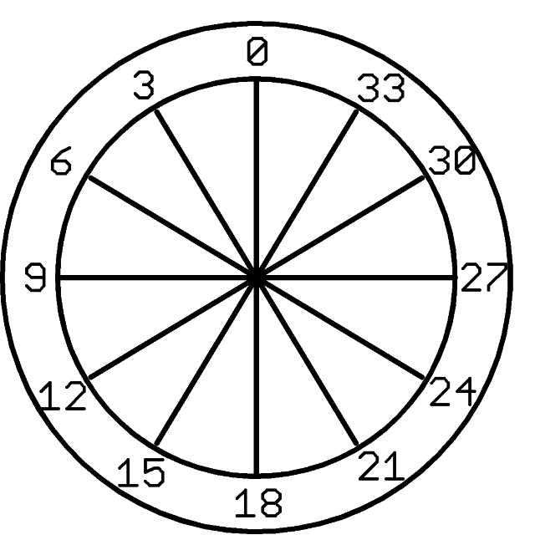
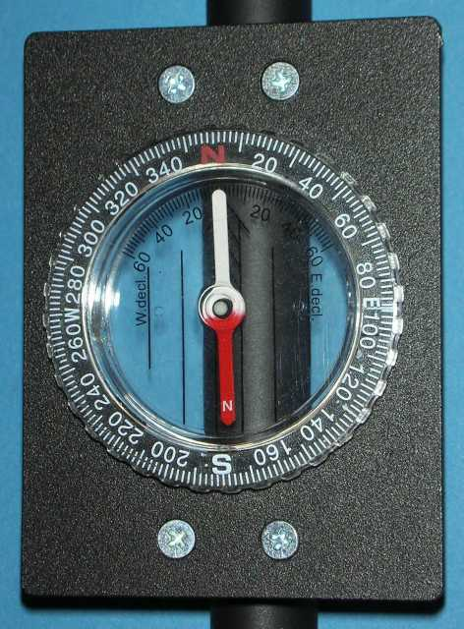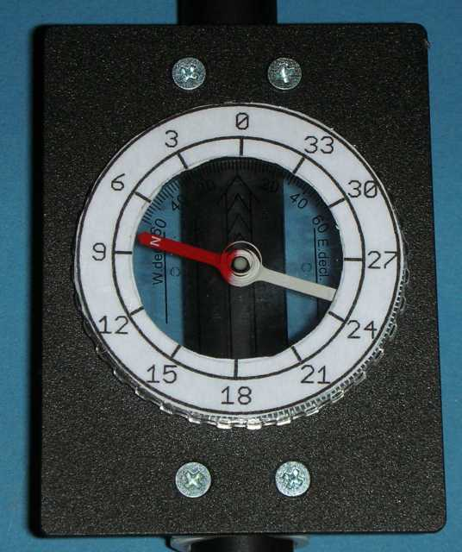

The FoxRex comes with a compass mounted on the director boom. It is not the fastest, but it finds the direction to (magnetic) North. If you want to read the headings to the fox directly, an inverse scale must be glued on, see the example above. The red end of the compass needle indicates the heading of the receiver’s forward maximum (divided by 10).
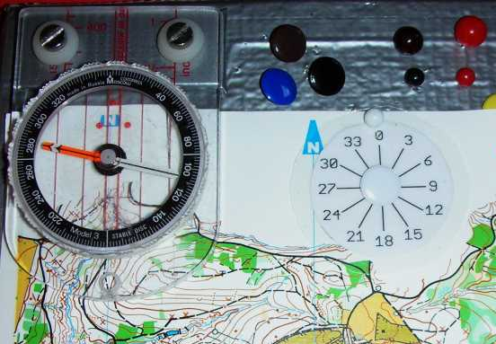
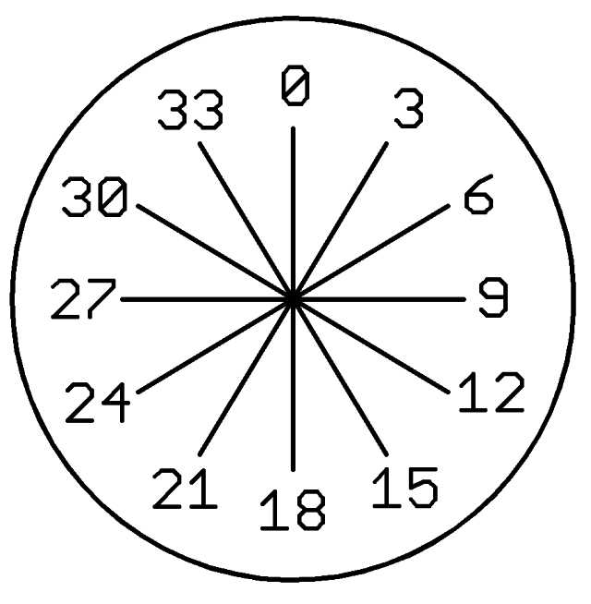
On my map board I have a compass rose, see the photo on the left. That helps me to remember where 240 ° is. And there is another compass on the map board, so that I can quickly adjust the board to North-up.
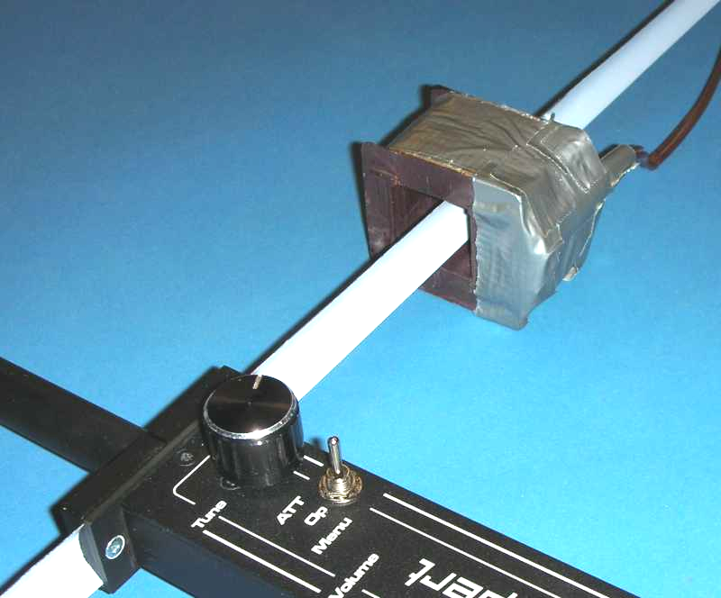
Demagnetizing the antenna
The antenna elements are made of spring steel, which can be easily magnetized. You can check your antenna by moving a compass along the antenna elements. On my receiver, the elements where strongly magnetic at the points where the two layers had been riveted together. That disturbs the compasses. Demagnetizing the antenna is simple. I removed the laminated steel core from an old power transformer. The winding on its holder has a window opening of 27 x 27 mm and easily fits over the antenna elements. This makes a good demagnetization coil. The 220 V primary winding has 40 Ω. I apply 20 V / 50 Hz, 0.5 A. The coil is slowly pushed over each half of the elements and back - done!

Red Fox 144

Included with the receiver is a small test fox ‚Red Fox 144‘.

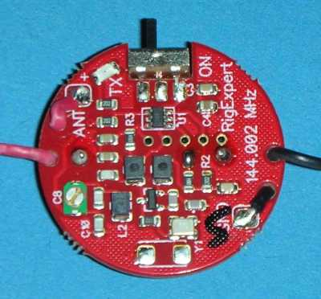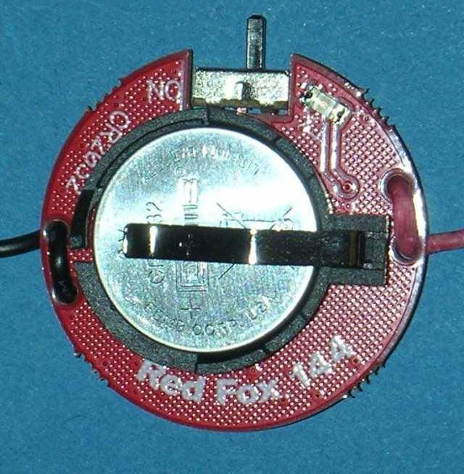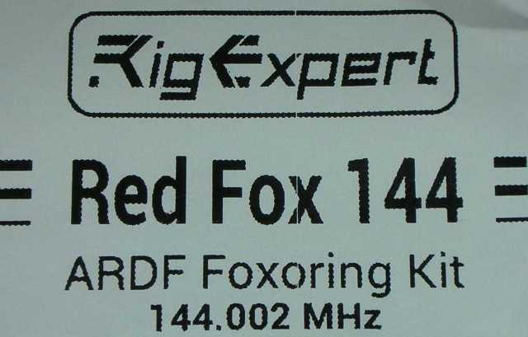

The transmitter is a simple one-transistor crystal oscillator just above 48 MHz. Its third harmonic is radiated by the antenna. The antenna consists of 2 x 50cm of flexible wire. It also emits many other 48 MHz harmonics. That is no problem because of the very low output power (in the micro-Watt range).
The AF modulation and keying is generated with a small Atmel processor. Depending on the programming, the morse code identification MOE to MO5 will be sent. It runs constantly, not timed.
Power supply is a single 3V lithium battery CR2032. The peak current consumption is 4 mA (= 12 mW), so the battery lasts for up to 100 hours. It is switched on with the slide switch, an LED flashes for control.
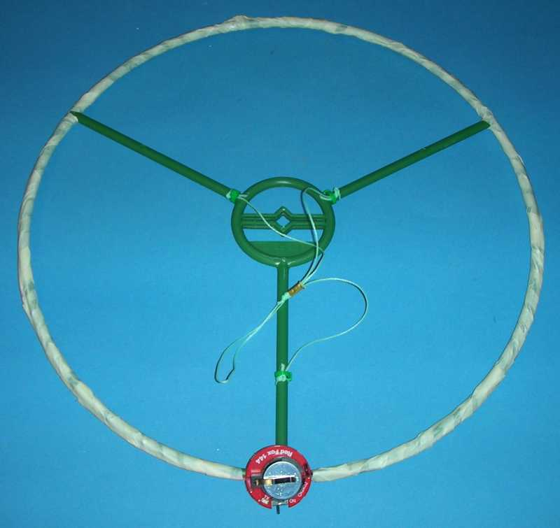
To receive the Red Fox, the receiver is set to 144.002 MHz and PFox = 3.0 μW. The range is a few hundred meters depending on the terrain.
In order to get a defined omni-directional characteristic, I made a ring dipole (halo) out of the two antenna wires.
It is held by a 30 cm perennial ring from the garden market. The two wires run along the ring and are held there by adhesive tape. On the side opposite to the transmitter, the wire ends meet again. The ends should be 25 mm apart. If necessary, the wires are slightly shortened (or lengthened).
With some cord, the whole thing can then be hung (horizontally!) on the branch of a tree, and you are ready to start testing your receiver.
.

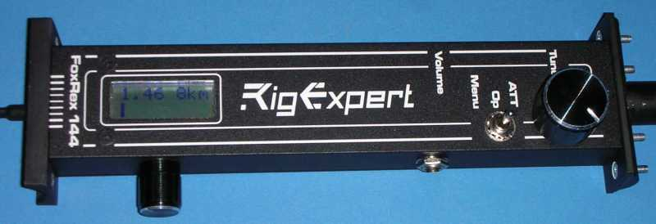
Moving the Volume Control

Anyone who, like me, holds the receiver in the left hand, quickly realizes that the volume control is in the way. That's why I've moved the volume control on my receiver to the right of the display. To do this, the three connecting wires had to be slightly extended and a new mounting hole had to be drilled.

Some Remarks on the Distance Estimation
The FoxRex estimates the distance to the transmitter based on field strength, some user settings and assumptions. The field strength is known to FoxRex thanks to the 'calibrated' attenuator. The output power of the transmitter is specified by the user in the settings menu, an additional correction constant can be specified in the calibration menu. For the conversion of the field strength into distance the FoxRex assumes a loss of 30dB per 10x distance.
When you use the receiver for a while, you will find that the distance estimation is often amazingly good, but at other times more confusing than helpful.
This is because at 144 MHz the path loss from the transmitter to the receiver depends not only on the distance but also very much on the terrain. The estimate works best on typical open forest and flat terrain, and at distances of less than 1 km. As soon as the transmitter and receiver cannot see each other, because there is a hill or mountain between them, the estimated distances are much too far. If, on the other hand, there is a valley between transmitter and receiver, the estimate is too close.
If you stand looking down into a valley and have a 200m estimate indication in the direction to the other side of the valley, it may mean that the transmitter sits 500m away on the other side of the valley, or that it is only 50m away, somewhat hidden in the valley.
In such situations, the distance estimation, unfortunately, is not very helpful. Rather, the fox hunter must develop a feeling and strategies for such situations through much practice. That is why 2m-fox hunting is considered to be more difficult than all other ARDF disciplines.

Your Feedback

Your comments, corrections, suggestions and questions on this document are always welcome. Please email to
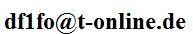



And if you need help directly from RigExpert,
this is the responsible design engineer:

Oleg Shuman, UT5UML
Senior Engineer
RigExpert Ukraine Ltd.
support@rigexpert.com

https://rigexpert.com/

Photo taken at the ARDF World Champs 2018 by Lee Namkyu (HL1DK)

