RigExpert FoxRex 3500 – An Inside View

Nick Roethe, DF1FO

About this Document

RigExpert from Kiev / Ukraine has been offering the 80m receiver FoxRex 3500 since 2017. In Western Europe it is distributed by WiMo. The receiver comes with a detailed user manual. That manual is limited to just the operation. Of course, a real radio amateur would like to know what's inside, how it works, and how to realign or fix it if necessary. The answers are in this document. This is not a RigExpert document – it is all my personal opinion and responsibility.
This is a translation of my German document. Sorry for the bad English, it is all Google Translates fault!

On the design history
The FoxRex is based on my 80m ARDF receiver Version 5, developed in 2012, which builds on the experience gained with several previous generations. Descriptions of these designs can be found on my homepage www.df1fo.de . Hundreds of these receivers have been built by radio amateurs around the world (and still are). RigExpert had the idea that there should also be a market for a ready-to-use version of this receiver, and (with my happy consent) has made a commercial product out of my receiver. Their version is mechanically completely redesigned. Electrically, the changes are small, and the software is identical.
Contributors
In my 80m-ARDF-receiver designs, and thus in the FoxRex 3500, I have used not only mine, but also the ideas of many other OMs. I borrowed the idea to do the ​​frequency control directly via Atmel from Reinhard Hergert, DJ1MHR. He also gave me valuable tips for suppression of noise from the display, and the trick to connect the display clock via a divider to the VCO. Reinhard was also the first to experiment with an automatic attenuator in an 80m receiver. The idea for the active low-pass filter comes from the receiver of Harald Gosch, OE6GC. I copied the product detector with SA612 from Bryan Ackerly, VK3YNG. Several OMs had, long before me, the idea to ​​use an SA612 as first mixer. The idea to do the attenuation by controlling the operating voltage of FET-stages comes from a Chinese CRSA receiver. The idea to use a forward and backward button to simplify operation is quite ancient and comes from Ewald Stadler, DJ2UE. Many early users of my receivers have contributed ideas for improving the software and operation, especially Wolfgang Böhringer, DL9TE, and my XYL Brigitte. The FoxRex is thus (for now) the endpoint of a long history of development.
Contents

What you get 2
How to open the FoxRex 3
Circuit Diagram 5
Circuit Description 6
Alignment & Calibration 8
Re-Programming 10
Headphone, Volume Control 11
Compass 12
Further Hints 13
Some remarks on the distance estimation 14

My FoxRex 3500 has the serial number 0036 (first production batch).

What you get for your money
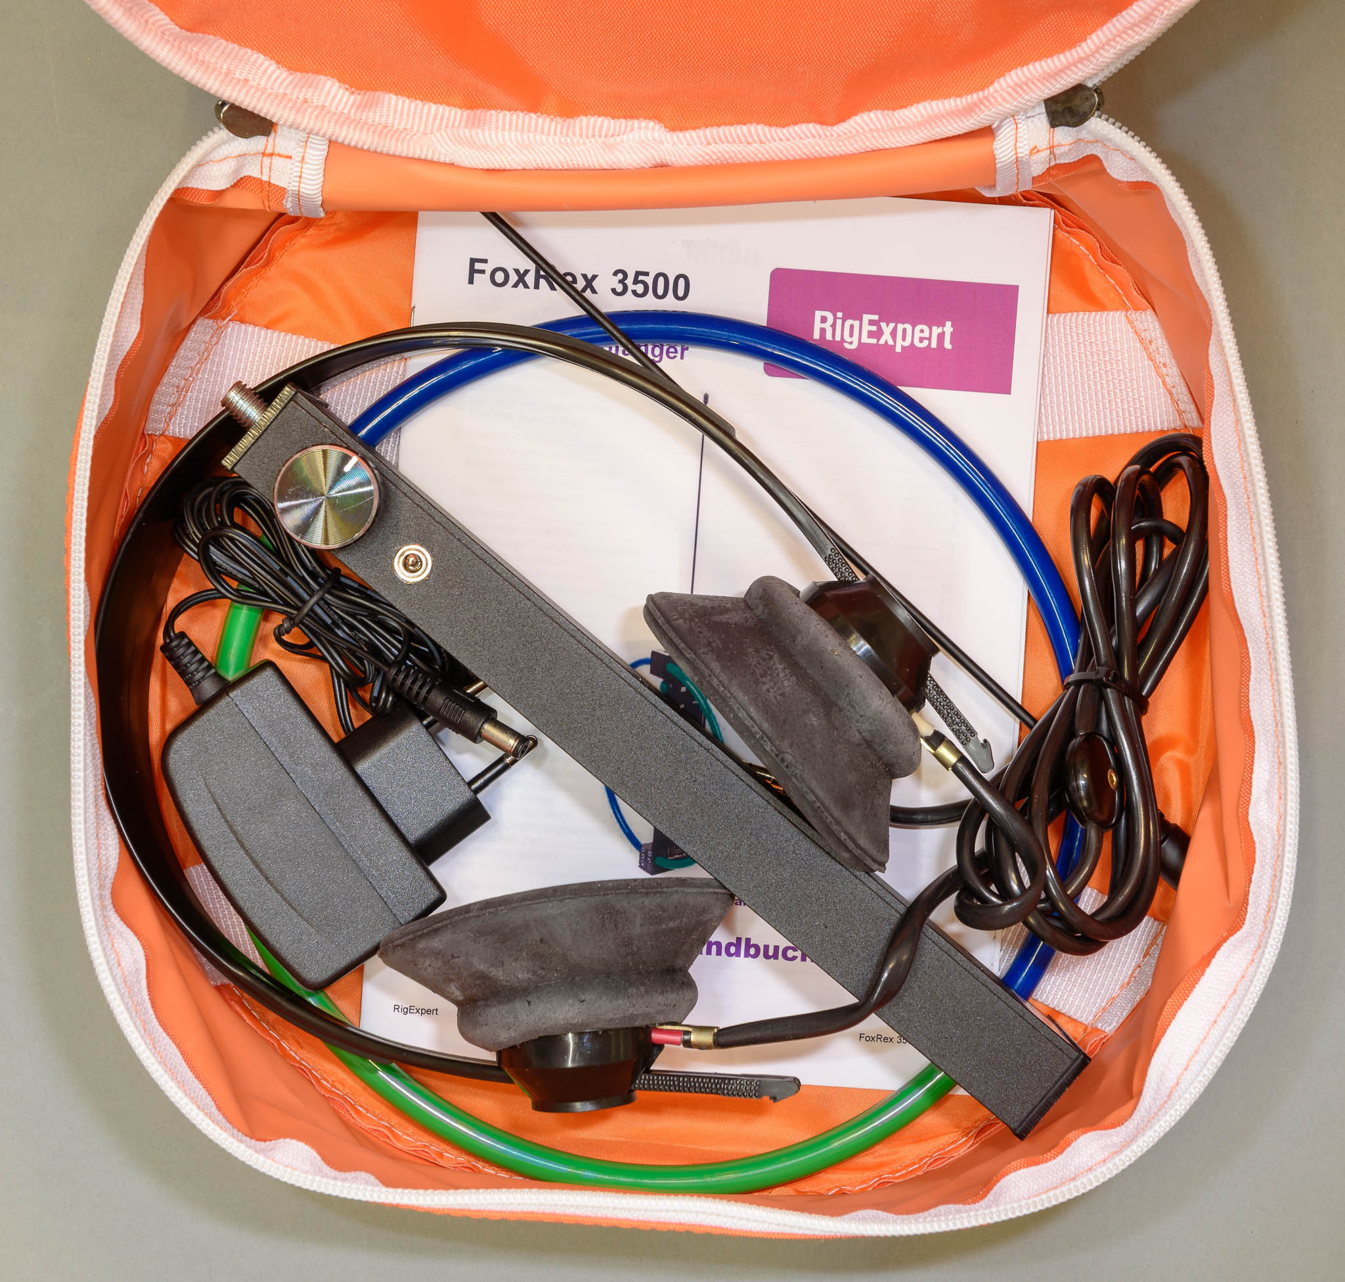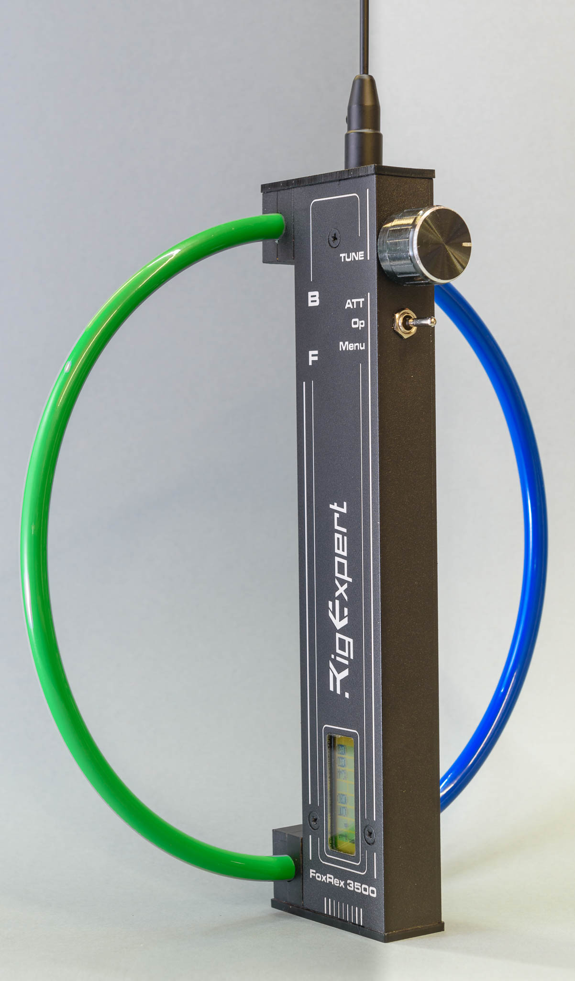

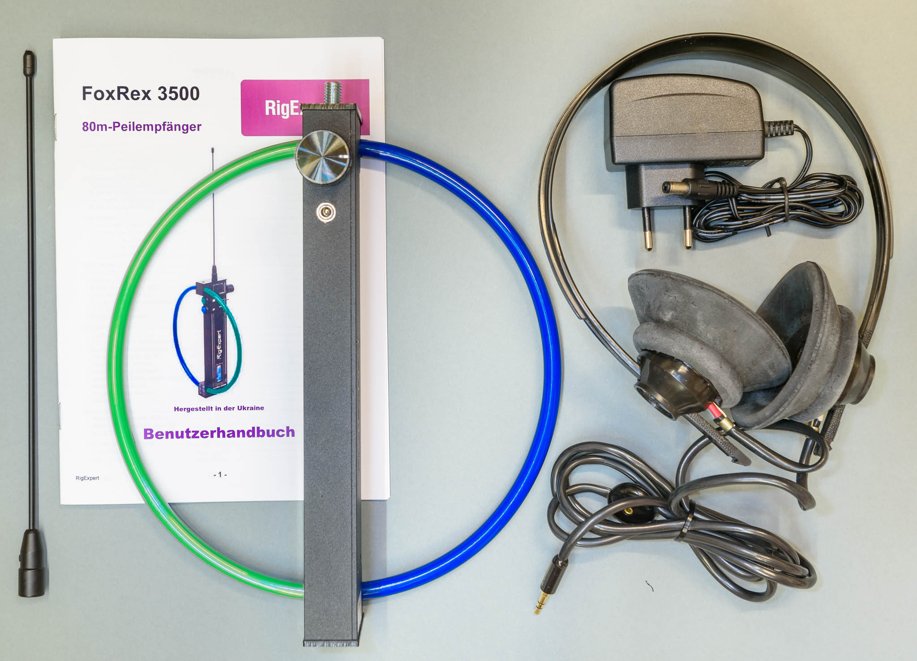

Here is what you get for your money:
- ARDF receiver FoxRex 3500
- Rod antenna, to be screwed on
- Headphones (soviet tank driver model)
- Charger, primary 110-230 V AC, secondary 12 V =
- Manual
- Orange carrying bag
The manual is available in German, English and Russian. The latest version can be found on the RigExpert homepage: https://rigexpert.com/products/ardf-receivers/foxrex-3500/downloads/
To print open the PDF with Adobe Acrobat Reader, print double-sided in the format 'Brochure'.
How to open the FoxRex

This section describes how the receiver can be opened and what it looks like inside. There are two good reasons not to open the receiver:
- Loss of warranty
- Damaging the waterproof sealant
On the other hand: a real ham opens everything. So I opened one for you.
The housing consists of two aluminum L profiles and two plastic lids on both ends. It is opened as follows:
- Pull off the knob from the rotary encoder
- Unscrew nut and washer from the encoder
- Remove three countersunk screws on the printed L profile (2 * next to display, 1 * at TUNE)
- Loosen 2 screws each on both plastic lids, or remove lids completely
- Now you can remove the printed L profile
- The switch is still mounted to this L profile, remove it
And this is what you see:
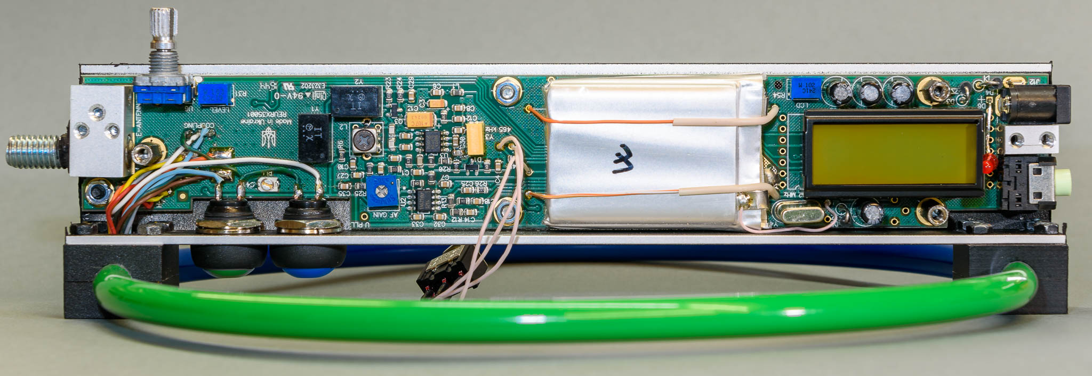
All components are mounted on a double-sided printed circuit board, the silver thing is the battery.
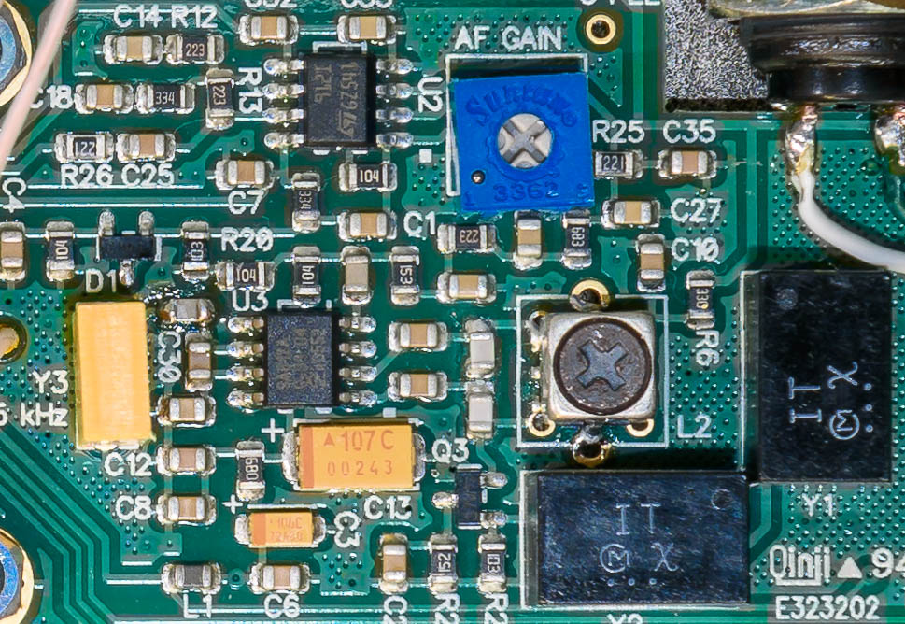

A look though a magnifying glass shows professional quality. Shown here: IF filters and amplifiers, product detector, NF filters and amplifiers.
After the receiver has been disassembled as described above, all alignment elements and measuring points are accessible - see also chapter Alignment&Calibration.
If you also want to inspect the underside of the board, you have more work to do:
- Unsolder, unscrew and remove the green and blue pushbuttons
- Remove three M3 nuts and three M3 hex bolts on the top of the board
- Remove an M3 screw under the serial number label
Now the board can be swung out. On the bottom side, the RF stage, the processor and the charging circuit come to light, and also the programming plug J10.
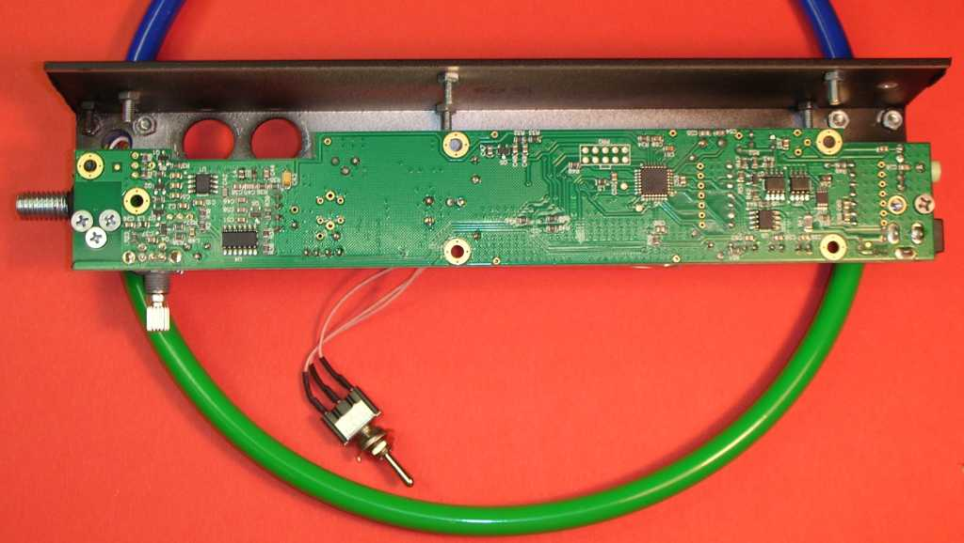
I have reaffixed the serial number label with double-sided adhesive tape in a more convenient location.
Between the serial-number-screw and the circuit board a (threadless) M3 nut is inserted as a spacer - do not lose.
And this is what the processor, programming connector, voltage regulator and charging circuit look like:
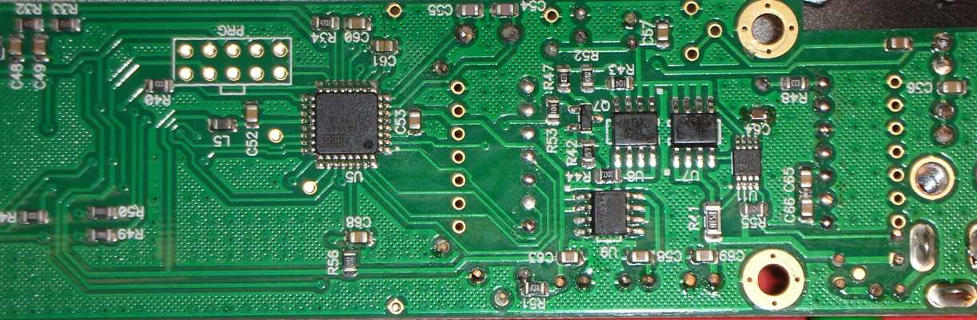
Circuit Diagram

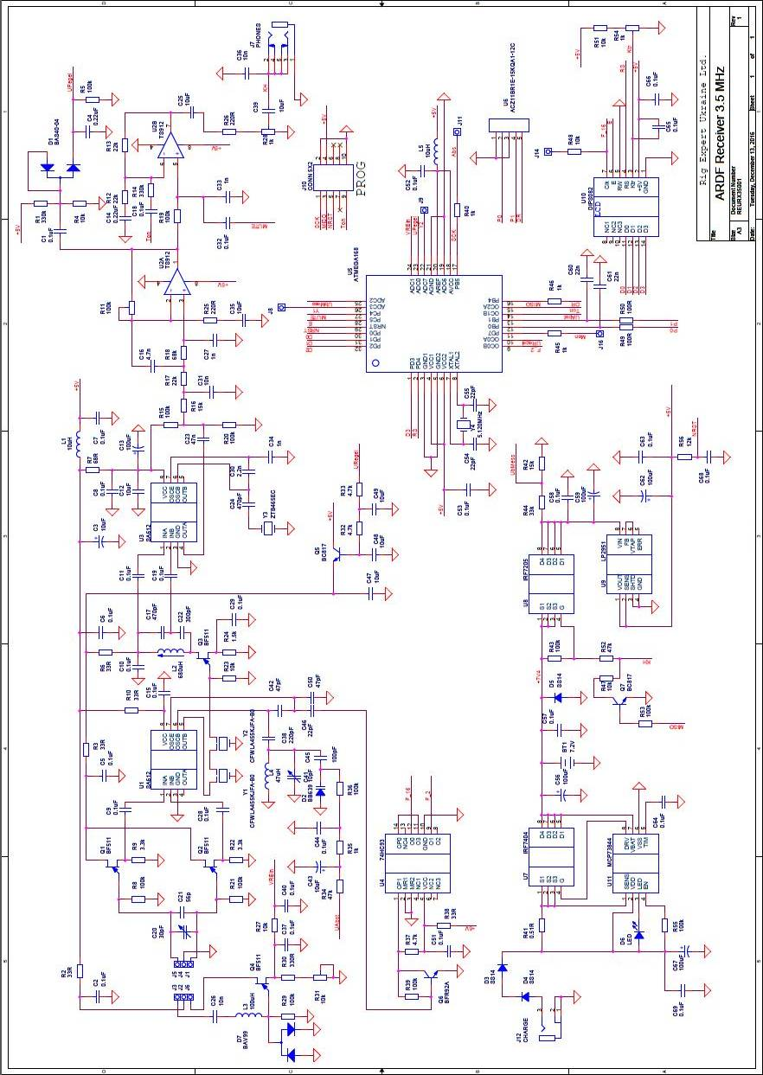

Circuit Description

See the circuit diagram on the previous page. In better quality on the RigExpert homepage:
http://www.rigexpert.com/files/manuals/fr3500/SCHEMATIC1_PAGE1.pdf
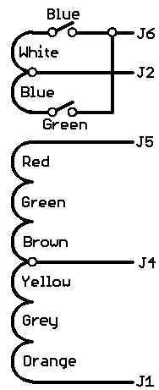
The receiver is of the single conversion type with 455 kHz IF, product detector and two-stage AF amplifier.
The antenna is a loop antenna with 6 turns, see picture on the left. The loop together with C20, C21 is resonant at 3.58 MHz - the most common frequency.
For the forward/backward distinction, the signal from an auxiliary electrical antenna at J3 is amplified with Q4 and coupled to the loop antenna via one of two auxiliary windings (White/Blue). Two buttons are used to select and compare the forward and backward directions without turning the receiver. The adjustment to the optimum F/B ratio is made with R31. The processor recognizes via the VREin signal when an F/B button is pressed. It suppresses the automatic attenuator function for the duration of the F/B-bearing and switches on an acoustic S-meter, to make the F/B-distinction easier (F/B-Zoom).
The high impedance antenna circuit is matched to the mixer U1 via a symmetrical RF amplifier Q1 / Q2. The RF amplifier provides power amplification for a good signal-to-noise ratio at weak signals, and it is also used as an attenuator, as described below.
In addition to the mixer, the SA612 U1 also contains the oscillator, which oscillates 455 kHz below the receive frequency. The oscillator coil is a fixed value choke L4.
Selectivity is provided by two cascaded ceramic filters. They are, like almost all filters used in ARDF receivers, intended for AM receivers and therefore actually too wide. To improve the selectivity an AF low-pass filter is used, see below. This is followed by the single-stage IF amplifier Q3 with an LC filter.
The attenuation of the receiver for strong signals is controlled via the operating voltage of the RF and IF FET-amplifier stages (Q1, Q2, Q3). Q5 supplies the regulated voltage, controlled by the processor. The gain can be reduced by up to 110 dB.
The IF amplifier is followed by the product detector U3. It also uses the mixer/oscillator IC SA612. The BFO is set to 458 kHz, and thus on the upper filter edge of the ceramic filter. So the lower sideband will be received. The BFO frequency is determined by the ceramic resonator Y3.
The AF amplifier U2 uses a dual op amp TS912. The left half is a 3rd degree active low pass filter with a cut-off frequency of 1.5 kHz, and in addition amplifies the audio signal about 250 times. The low pass is necessary because the ceramic filters are about 6 kHz wide. With R11 the gain of this stage is adjusted to compensate for a gain deviation of the RF portion due to component variations. The AF signal at the output of the low-pass amplifier is rectified via D1, read in from the processor via an A/D converter, and used for the bar-S-meter display, the acoustic S-meter and the automatic attenuator. The right half of the TS912 has a gain of only 2x. It limits the AF signal and drives the headphones. The processor generates signal tones or the acoustic S-meter with a programmable oscillator. It feeds these signals via Ton into the AF amplifier. When the processor pulls MUTE to ground, the AF signal coming from the receiver is suppressed, so that only the beeps are heard. The AF volume is adjusted with R28 to match the headphones used. An external volume control is not provided. (More about R28 in the chapter 'Headphones'.)
The frequency is not controlled by a PLL module, rather the processor solves this problem with its 'on-board resources'. To do this, the signal of the first oscillator is amplified to logic level with Q6, and divided by 2 and 16 by U4. The divided by 2 frequency (about 1.5 MHz) is fed via F_2 to the 16bit Timer/Counter1 in the ATmega. It counts the frequency for 100 ms, i.e. with 20 Hz resolution. This results in count values ​​around 155000. The 16-bit counter therefore wraps twice (after each 65536). From the counted frequency and the desired frequency, the frequency deviation is calculated. Depending on the direction and magnitude of the deviation the software generates at UAbst a high or low pulse of variable length. These pulses are integrated in the capacitor C43. It stores the tuning voltage for the capacitance diode D2. After the correction pulse, UAbst becomes high-impedance again. The pulse length is between 1 μs and 10 ms. Its length is so that a stable control loop results. Due to the 20Hz resolution of the frequency counter, the frequency fluctuates constantly (by up to +/- 20 Hz) around the desired frequency. When listening to a signal generator this is audible as a slightly whining tone. With real signals you will not hear this.
The tuning voltage at C43 should not be less than 1.5 Volts at the lower end of the tuning range, otherwise the capacitance diode may enter the conductive region in the negative half wave of the oscillator and influence the tuning voltage. With the BB639 and the specified frequency range this results at the upper end of the range in a tuning voltage of about 3.5 Volts.
The voltage for the gain control is generated by the processor with a 2.5 kHz pulse width modulator, output via URegel and smoothed with a two-stage low-pass filter. The PWM setting to attenuation value characteristic is specific for each individual receiver. It is determined during the receiver calibration and stored in the processor. The attenuation is increased by 5 dB each time the S-meter reaches full-scale. Thus, when the receiver is rotated in the maximum direction, it automatically adjusts the attenuation appropriate to the current field strength. Now it can estimate the distance from the attenuation (= field strength), the transmitters output power (in the settings menu), and a device-specific correction factor (in the calibration menu).
The processor ATmega168 U5 controls not only the receiver but also the user interface. An LCD display with 2 * 8 characters, a rotary encoder with additional push function, and the switch ‘Attenuator-Operate-Menu’ are connected to the processor. The processor measures the battery voltage via an A / D converter at UbMess. The connector PROG J10 makes it possible to reprogram the processor in-circuit.
The display normally uses an internal free-running clock of around 225 kHz. Its 16th harmonic would cause clearly audible ‘birdies’. Therefore the display is externally clocked with the VFO frequency divided by 16. With this trick the ‘birdies’ are kept away from the receive frequency over the entire reception range.
The receiver is switched on via the FET U8 by plugging the headphones. The battery voltage must be between 5.5 and 10 volts. From this, the operating voltage of 5V is generated with the low-drop regulator U9. To switch off, first the headphones are removed. The receiver is still holding itself over Q7. It is finally switched off by a long press on the rotary encoder. If you forget the long press, the receiver switches itself off some time after the last operation of the rotary encoder or switch.
The power source is a 2-cell lithium-polymer battery built into the receiver. It is connected to J13 / J15. A charging circuit with U7 + U11 is also integrated. Charging requires a 12V power supply or car outlet.

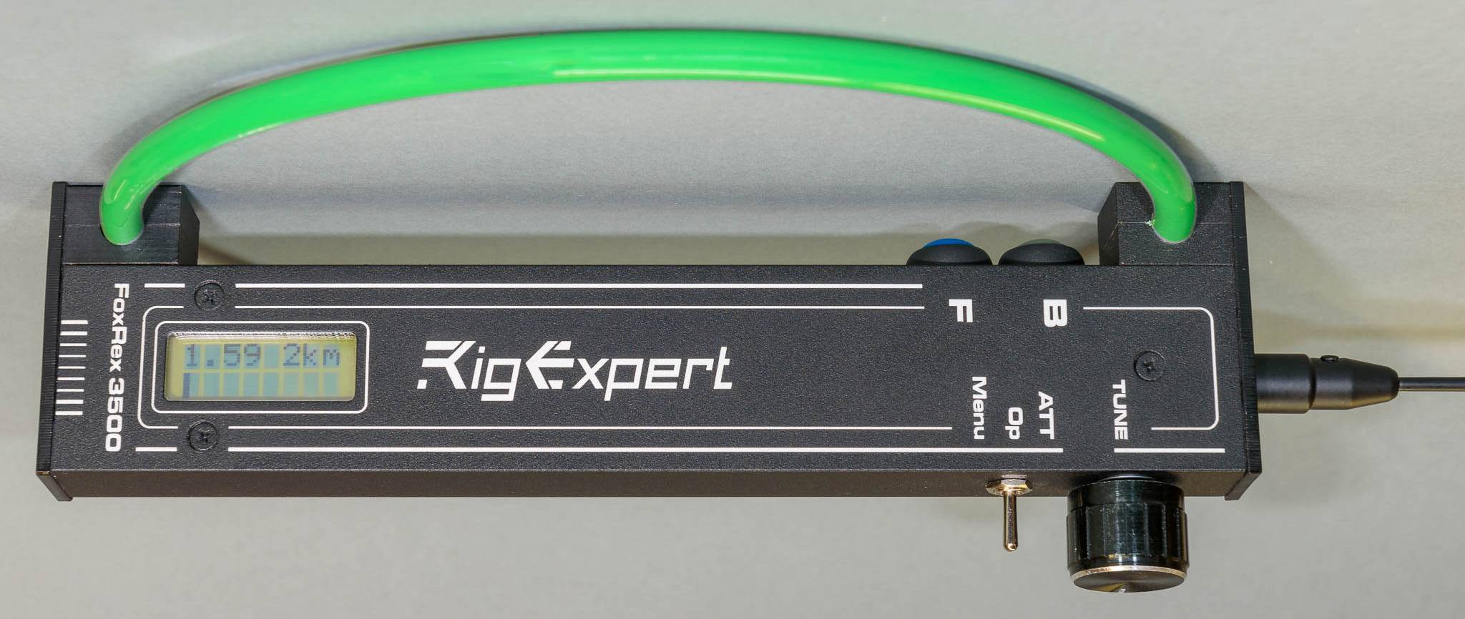

Alignment & Calibration

The receiver is shipped aligned and calibrated. If you want to do a re-alignment you should be sure that you know what you are doing.
Note: The position of the variable Cs is difficult to see, but it is possible: under the head of the screw you can see a half ring, this shows the position of the rotor. The stator is on the side with the two slanted corners. Maximum capacity results when the half-ring points to the side with the slanted corners.
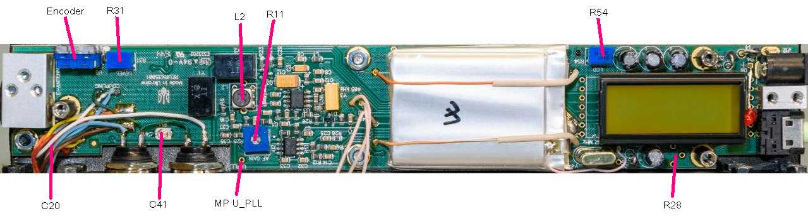

Set contrast pot R54 for best readability of the display. Switch between displays with the toggle switch, adjust R54 so that the display changes as quickly as possible.
To set the frequency control, connect a voltmeter to measuring point U_PLL. Adjust C41 so that the measured tuning voltage is within 1.5-3.5 volts (if necessary 1.2-4.0 volts) over the entire tuning range (3.49-3.66 MHz).
The further adjustment of the receiver is only possible during the day when the band is quiet.

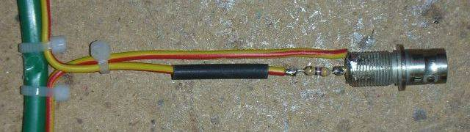
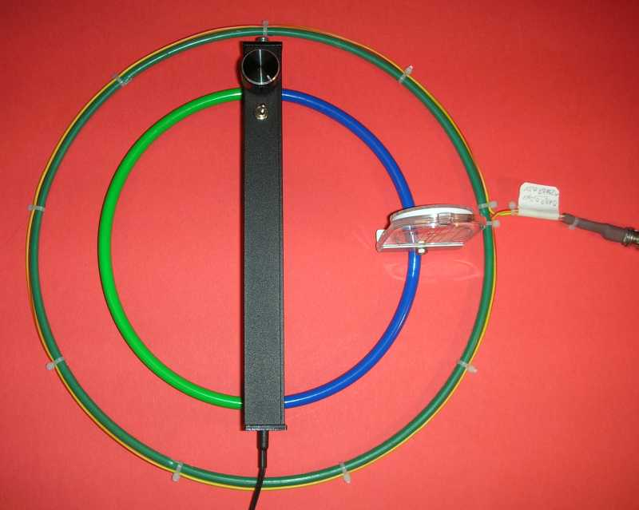

Left and above: Coupling loop for receiver calibration

To align the receiver, a signal generator with a calibrated attenuator is required.
To couple its signal into the receiver I use a coupling loop with 30 cm diameter, as shown above. It is a plastic ring with a single winding. One end of the loop is connected to the inner contact of a BNC connector via a 47 ohm resistor, the other to the connector’s ground. The loop is placed flat on the (wooden) workbench, and the receiver in its center.
Set the signal generator level to 3 μV. Set the generator and receiver to approximately 3.570 MHz so that the signal becomes audible. Tune the antenna circuit with C20 (hidden under the colored wires) to maximum S-meter indication. Fully open the attenuator (turn the rotary encoder to the left). Set the generator level to 0.5 μV.
Tune IF filter L2 for maximum S meter indication. Set receiver gain with R11 so that the S-meter indicates ¾ full-scale.
Now several adjustments will be done in the calibration menu. Set the Frequency to ‘3770,0’ and Pfox to ‘dB only’. To start the calibration menu, turn the receiver off, switch to ‘Menu’, then turn the receiver on while the rotary encoder is pressed.
First, the language of the menu texts can be selected: German or English.
Select 'Cal VBat'. Measure the battery voltage with a DVM (solder tag at top of battery is +, case is -). Press+Turn to set the displayed voltage to the measured value. Thereby the inaccuracy of the reference voltage and the voltage divider R44 / R42 is compensated.
If the receiver is still open: it must be assembled and closed for the next calibration steps.
Set the transmitter and receiver to 3.570 MHz. In the calibration menu, select 'CalF'. Press+Turn to vary the receive frequency in 100 Hz steps. Adjust so that the AF signal is in the 800-1000 Hz range. If you tune to the wrong sideband, you will get a much weaker signal, so try both sides of zero-beat.
Select 'Cal Att Start’ and click. Couple the signal generator as described above and set to 0.5 μV. The S-meter bar should now fill ¾ of the bar-S-Meter (see adjustment ‘ receiver gain’ above). Click. Increase the generator level by 5 dB, adjust the attenuator by turning so that the S-meter shows ¾ again, click. (The attenuator adjustment range is 0..511.) Repeat this 22 times, until 160 mV and 110 dB are set and stored.
Select 'BatAlarm'. Here the threshold for the Low Battery Voltage Warning can be set from 5.8V to 8.0V. RigExpert recommendation: 6.5 V
In the menu item ‘Auto Off’ you can set how long the receiver shall wait after the last operation (rotary encoder, toggle switch) and disconnection of the headphone until it shuts itself off. Recommended setting is 30 minutes, at 0 minutes it will not turn itself off.
Finally, the menu item 'Save Cal' must be clicked to save all calibration values ​​to the EEPROM, otherwise they will be lost after power-off.
After saving the calibration values I would recommend to go through the calibration menu once more and write down the stored values. This allows you to reenter the calibration values if you should accidentally loose them while experimenting.
The menu item 'EEPROM Reset' restores all calibration values and Memories to the virgin state. Use only in real emergencies. After ‘EEPROM Reset’ you must re-calibrate the receiver, or reenter the calibration values (if you wrote them down).
The following final adjustment requires a trip to the fresh air.
To set the forward/backward ratio, a test fox at least 100m away and with a perfectly vertical antenna wire is required. R31 is set to the best minimum in the backward direction. It is important that you hold the receiver at the same height as you will later in the competition, usually at chest height.
The actual forward/backward ratio observed during a fox hunt changes from bearing to bearing. It depends on several factors, above all the height of the receiver over ground and the earth conductivity. But it should allow a clear forward/backward decision in all situations, except when the distance to the fox is less than 10 to 20m.

Re-Programming

In this section I describe how new software (= firmware) can be loaded into the receiver. Anyone trying this should know what he is doing. This description is therefore intended for real experts with Atmel experience.
The software of the receiver can be found on my website, the change history under http://www.df1fo.de/80mSMD/80mSMDFragen&Antworten.html#Code
The assembler source has the filename fjrx85.asm. It must be assembled with TARGET = 1 in order to support the rotary encoder installed by RigExpert.
To get access to the programming connector, the circuit board has to be removed as described above. The connector J10 is simply 2x5 holes in the board. It is directly under the battery, so there is no room for pins. To make it even more complicated, J10 does not follow the Atmel AVR ISP pin layout convention. See the following table:
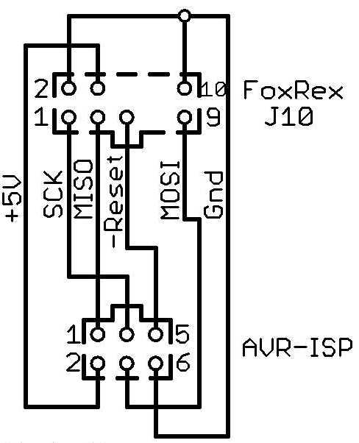
FoxRex 3500 | ISP  6 pins | ISP 10 pins | Signal-  name
4  2, 10  9  3  1  5  6, 7, 8 | 2  6  4  1  3  5  - | 2  4, 6, 8, 10  1  9  7  5  3 | +5V  Gnd  MOSI  MISO  SCK  Reset  Unused
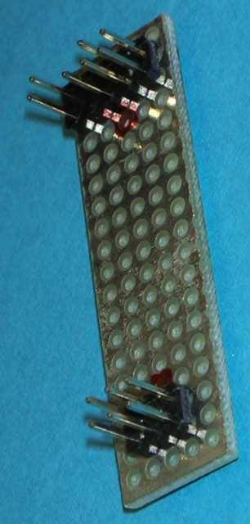

The circuit diagram shows an adapter FoxRex to 6-pin Atmel, looking at the solder side of both connectors. The photo shows my implementation on a piece of perforated board.

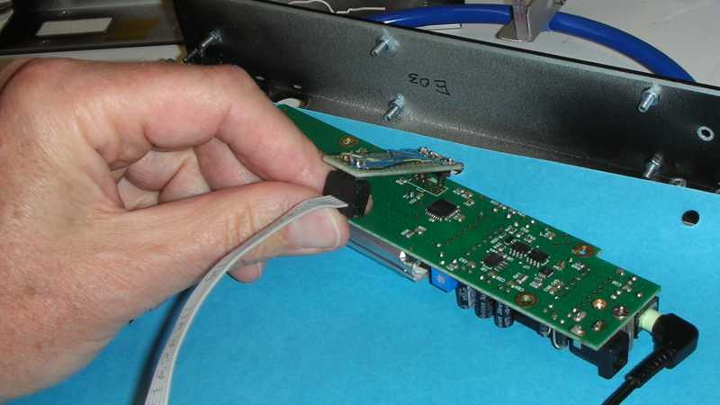

The AVR-ISP is plugged into the 6-pin header, and the 10-pin header is plugged into the J10 holes and tilted with slight pressure, so that the pins get in good contact. It helps if the outer row of pins is about 1 mm shorter than the inner one.
If everything was done correctly, flash and fuses can now be read out and reprogrammed.
However, I strongly advise not to change the fuse settings - it makes no sense and too much can go wrong!
Headphone, Volume Control


I do not like the RigExpert-supplied headphones, the soviet tank driver model.
(Eastern European fox hunters believe that this rubber thing is world’s best ARDF headphone!)
I prefer light headphones that are open, so that I can hear warnings from horseback riders or mountain bikers. Also the volume of the original headphone is much too high for my taste.
The earphones shown on the left are available in Germany for 15 €, they are comfortable to wear in a competition, and the volume, connected to the FoxRex, is good for me. Also they are small enough that you can take a second pair as backup with you.

The wiring of the earphone jack in the FoxRex is different from my receivers: in the FoxRex, the Right and Left phones are connected in parallel, whereas I - to achieve more sensitivity and reduce power consumption – connect them in series. This has the side effect that headphones with a mono plug (popular in Germany) cannot be used with the FoxRex, but work fine with my receivers.
Finally, RigExpert, for whatever reason, has omitted the volume control pot R28 shown in the circuit diagram.

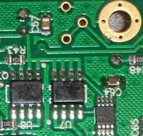
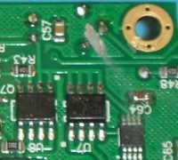
To make my receivers and headphones interchangeable, I have changed the headphone output of the FoxRex to my 'house standard'.
There are three holes for R28 on the board. As you can see on the left the pot is replaced by a bridge on the board.
I have cut the bridge and installed a potentiometer (Piher PT 6-S 1,0 kOhms), see picture on the right.

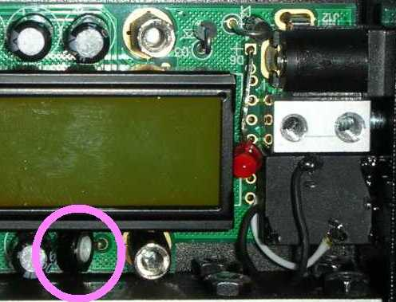
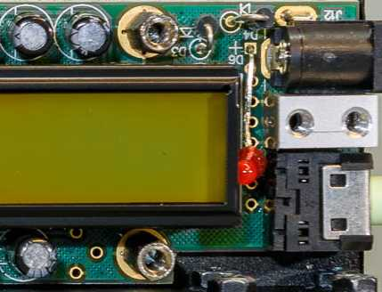
The same scene from above, left without R28, right with R28 (pink circle). The potentiometer must be soldered slightly tilted, so that you can adjust it without removing the hex bolt.

Changing the wiring of the earphone jack (parallel to series) was not so easy. I have removed the original connector, and installed my proven model (Reichelt EBS35). It is no longer soldered into the board, but screwed to the plastic plate, and therefore easy to change if necessary. The knurled nut must be slightly sunk. The socket is connected to the board with two short wires. See photo on the right.
Now the tank driver headphone does not work anymore. It is a mono headphone and the contacts 'tip' and 'ring' are bridged in the plug. But since I will never use it anyway...

Compass

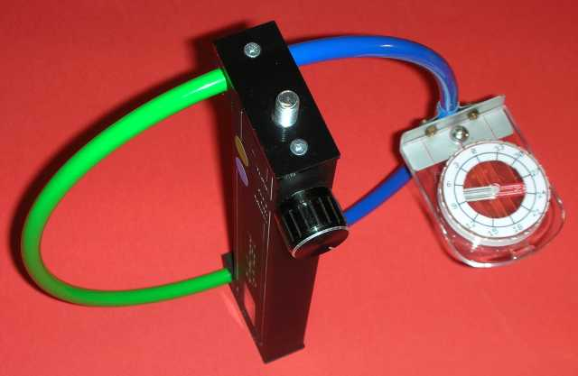

Many fox hunters install a compass on their receiver, so that they can read the direction to the transmitter in degrees.
The picture shows my solution: the compass is mounted on the loop. The ring is made of magnetically neutral stainless steel, my mounting bracket of aluminum, the screws of brass or stainless steel. I hold the receiver in the left hand, so the compass is on the right.

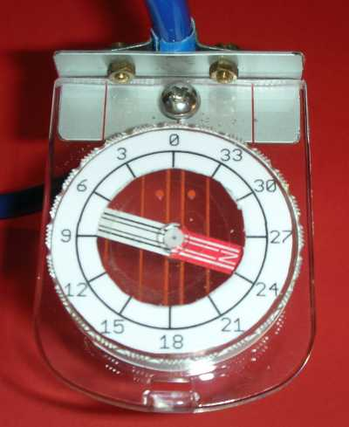
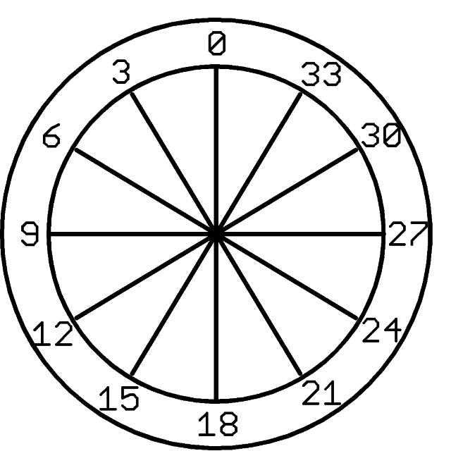

I use a Moscow Compass 11C (www.ol-shop-conrad.de ~25€). If you want to read the headings to the fox directly, an inverse scale must be glued on, see the example above.
The red end of the compass needle indicates the heading of the receiver’s forward minimum.

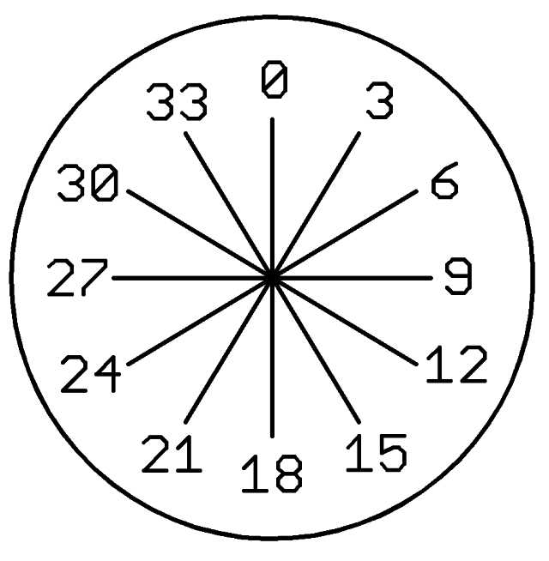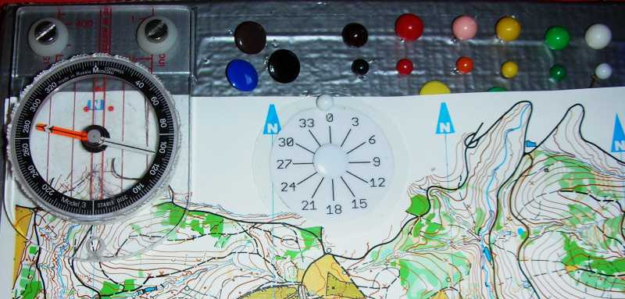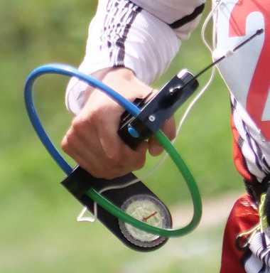

On my map board I have a compass rose, see the middle of the photo above. That helps me to remember where 240 ° is. And there is compass on the map board, so that you can quickly adjust the board to North-up.
Newer versions of the FoxRex 3500 (2nd manufacturing batch) come with a compass (?), see photo on the right.

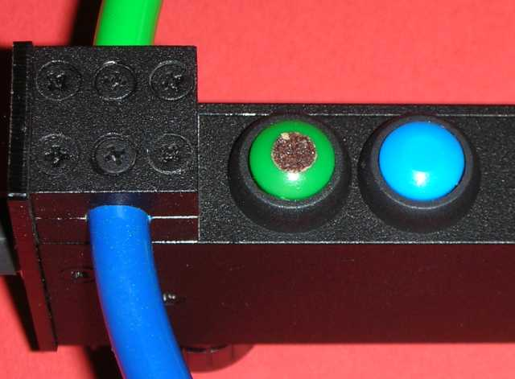
Forward-/Backward-Confusion

Since you cannot see the front and back buttons in normal operation, their different colors are not really useful. If you confuse the buttons, the penalty is 10 minutes – 5 minutes of running in the wrong direction, another 5 minutes to backtrack.

To make it safer, I have marked the button, which is the backward button for me, with a piece of rough sandpaper. I hold the receiver in my left hand and turn it outward to determine F/B (there are three other possibilities), so green is backwards for me.

Further Hints
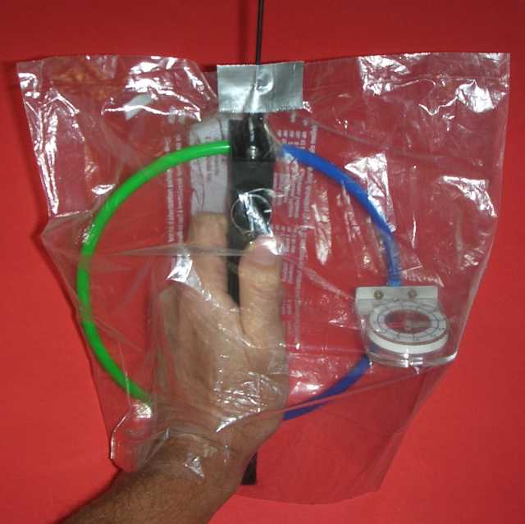
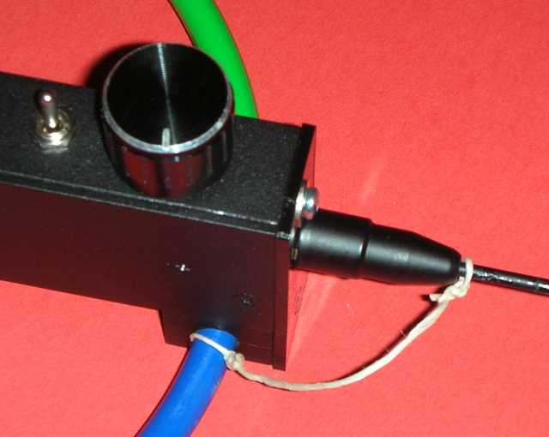
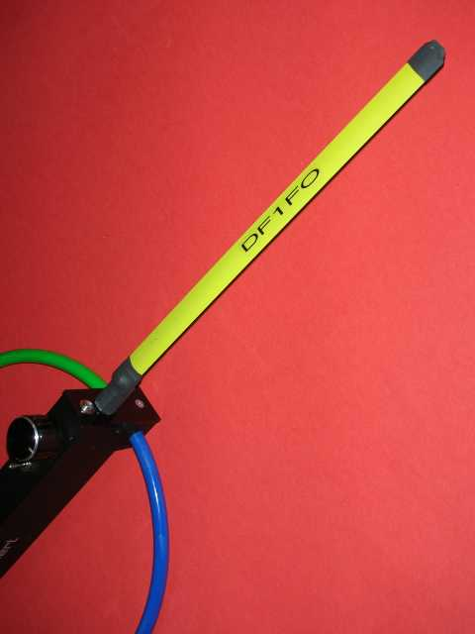
The FoxRex 3500 is, like most ARDF receivers, not really rainproof. In heavy rain, moisture can penetrate the receiver and result in failure of the electronic circuits - frequency control or attenuator fails, display goes blank or the display window fogs in from the inside, receiver cannot be turned off...
There are two solutions to the problem:
- Seal all cracks in the housing with adhesive tape, or
- Put a plastic bag over the receiver.
I prefer the bag method, and use a 30 cm wide bag, see photo. The antenna is pushed through a small hole and sealed with tape.
In international competitions you have to impound your receiver long before your start time. If it starts to rain and hours later you pick up your receiver, it may be laying in the middle of a puddle! Therefore put your receiver in a watertight bag if there is any chance of rain.

The E-antenna of the FoxRex can be removed for transport. The experienced fox hunter knows that it is guaranteed that he will eventually stand in the parking lot or even in the forest and realize that he has forgotten the E-antenna. Therefore my recommendation: Tie the antenna to the receiver with a piece of string. It can still be unscrewed for transport, but cannot be forgotten.
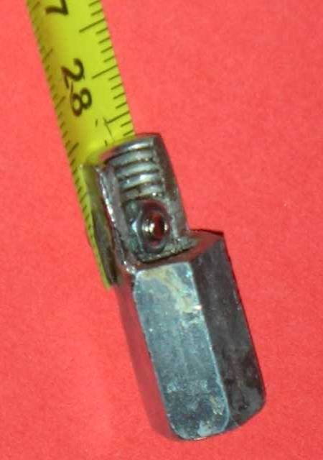
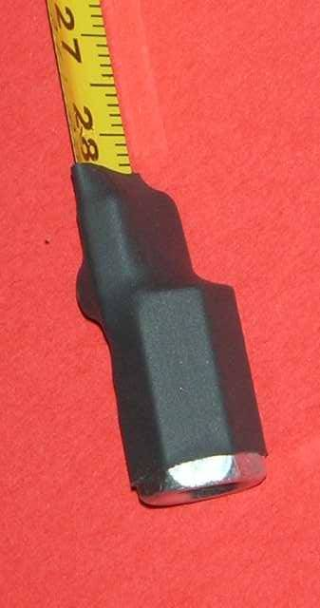
Alternatively, the E-antenna can be replaced by a piece of tape measure. You do not have to unscrew it, it just folds in. In a hardware store I found a 'hexagon nut M8x30', the photos show how I attached the tape measure with an M3 screw. This E-antenna should have exactly the same length as the original rod antenna.

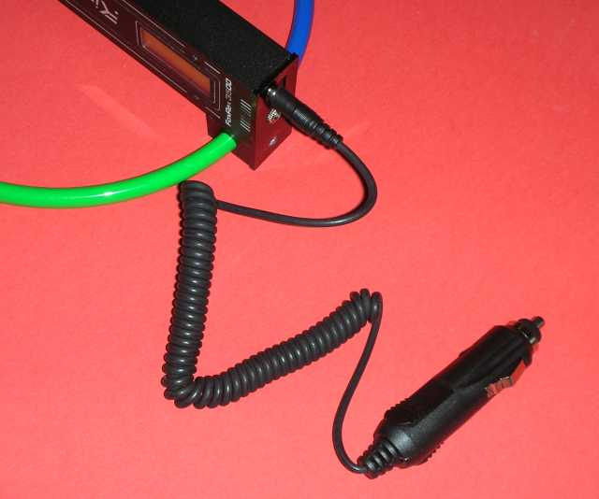

As an alternative to the 12V power supply, the FoxRex can also be charged from a 12 Volt outlet in a car. In my cable collection I found the right cable, see photo. But you can also make one yourself. The plug must be the usual type 2.1 x 5.5 mm, shaft length 9 mm or more. Accidental wrong polarity does not harm the receiver, it has a protective diode in series with the charging input.

Some remarks on the distance estimation

The FoxRex estimates the distance to the transmitter based on field strength, some user settings and assumptions. The field strength is known to FoxRex thanks to the 'calibrated' attenuator. The output power of the transmitter is specified by the user in the settings menu, an additional correction constant can be specified in the calibration menu. For the conversion of the field strength into distance the FoxRex assumes a loss of 30dB per 10x distance. When you use the receiver for a while, you will find that the distance estimation is often amazingly good, but at other times more confusing than helpful. This is due to two factors:
Radiation power of the transmitter: Usual ARDF transmitters have 1-3 W output power and approximately 8m long vertical antennas. As I have described in http://www.df1fo.de/DOC/80MidiTX.doc, only about 5%, i.e. 50 - 150 mW, are actually radiated, the remainder is lost in the antenna matching network and ground. For such typical foxes set Pfox = 1W or =3W. Ideally all 5 foxes have the same radiated power, and experienced course setters will get close to this ideal. But there are also many ways to get significantly different (and therefore confusing) radiated power: Antenna wire is thrown over the next branch or bush (sometimes 2m, sometimes 5m high), ground is a tent peg lying on the ground, one transmitter stands on a gravel pile, another in the swamp (extremely different earth losses). In such irregular situations only one thing is certain: when you get closer to the transmitter, it becomes stronger. But the strongest transmitter does not have to be the nearest one.
Signal loss per distance: The signal loss per distance cannot be less than the free field loss of 20dB / 10x. It is higher in the real forest. This is due to ground loss - the (ground) wave travels along the boundary earth-air - and due to the field damping by the (conductive) trees. In many practical experiments, I have observed from 25dB / 10x attenuation for very wet, good conductivity ground, and up to 40dB / 10x for dry sandy ground. Therefore, the 30dB / 10x assumption of the FoxRex is an average. However, the resulting errors are get less, the closer you come to the transmitter, and under 300m it is minimal. So this confuses less than different radiated power - see paragraph above.
If you have lost trust in the distance estimation, the following rule of thumb can be helpful:
The automatic attenuator switches every time you have reduced the distance to the transmitter by 1/3.
So if from ‘dadit’ to ‘dadit’ you have run 100 m, it will be another 200 m to the transmitter.
Your Feedback

Your comments, corrections, suggestions and questions on this document are always welcome. Please email to
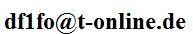


And if you need help directly from RigExpert,
this is the responsible design engineer:

Oleg Shuman, UT5UML
Senior Engineer
RigExpert Ukraine Ltd.
support@rigexpert.com

https://rigexpert.com/

Photo taken at the ARDF World Champs 2018 by Lee Namkyu (HL1DK)
Did you notice? No soviet tank driver headphone!

