An advanced 2m ARDF-Receiver

Nick Roethe, DF1FO

Overview

This paper describes a microprocessor-controlled 2m-ARDF-receiver. The receiver is considerably more complex than most of the simple ARDF-receivers from Eastern Europe or China. In return it offers many advance features:

Highlights

- High sensitivity
- Narrow crystal-filter for good selectivity
- PLL-controlled frequency
- Stores up to 4 frequencies
- Instantaneous S-Meter with Peak-Hold
- Acoustical S-Meter
- Attenuator with calibrated 5dB steps from 0 to 120 dB
- Automatic Attenuation when S-Meter reaches full-scale
- User interface: rotary encoder and 2*8 Character LCD
- Estimation of distance to transmitter
- Display of current fox and remaining transmit time
- Warning n seconds before end of fox transmit time
- Stopwatch shows elapsed time
- Display of battery voltage, low voltage warning

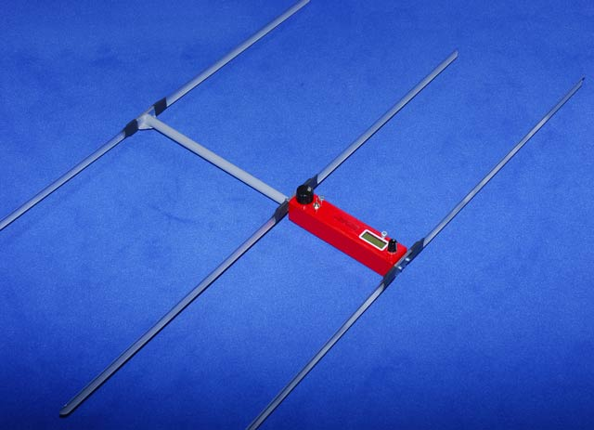

Receiver with 3-Element-Yagi

This is the English translation of my original paper in German ‘Ein komfortabler 2m-Peilempfänger’. Some less important details have not been translated. Please excuse my bad English – any corrections / improvements / suggestions are welcome.

Circuit Description

Refer to the schematics on the following two pages.

The analogue part of the receiver is a double conversion receiver with 10,7 MHz and 455 kHz intermediate frequencies and an AM-demodulator.

The antenna signal is amplified by the preamp T1. The preamp is turned off for strong input signals, this reduces the signal level by about 40 dB. T2 is the first mixer and oscillator. Its frequency is 10,7 MHz below the input frequency and controlled by the PLL-circuit TSA6057. The PLL has a frequency resolution of 1,25 kHz. The cascaded crystal filters QF1/QF2 are responsible for most of the selectivity of the receiver..

Next is an AM-receiver circuit TCA440. It contains the 10,7 MHz IF-amplifier, crystal controlled 2nd oscillator, 2nd mixer, and the 455 kHz IF-amplifier. The gain of the TCA440 can be controlled over a range of more than 100 dB. The output signal of the AM demodulator D2 contains an AC-component, the modulation, and a DC-component proportional to the level of the input signal.

The AF-amplifier LM386 drives a headphone of medium to high impedance.

The circuitry around the processor Atmel ATMega 8-16 is harder to understand and will therefore be described more detailed.

The processor clock is set by Q2 to 5 MHz. The processors clock signal is also used as reference clock for the PLL.

Pin PC0 turns the preamp on or off (Pin is low resp high-Z).

Pins PC4 and PC5 drive the I2C-Bus to the PLL. PC4 is also used to detect if the receiver is on.

Pins PC1 and PC2 are analogue inputs. They are used to measure the battery voltage and the DC-Signal from the demodulator.

Pin PB3 is the (analogue) output of a pulsewidth-modulator. It controls the gain of the TCA440.

Pin PB1 is the output of a programmable oscillator, that generates the AF-signal for the acoustical S-meter and other tone signals. This signal is combined with the AF-signal from the demodulator.
Pin PB2 is normally high-Z. However when the acoustical S-Meter is on PB2 goes to low-Z and mutes the demodulator output through C46.

The receiver is controlled through a rotary encoder on pins PB0, PB4 and PC3, and a 3-position switch on Pins PD6 and PD7. The LC-Display with 2*8 characters is controlled by Pins PD0-PD5.

Finally the processor is connected to a 10-pin standard Atmel ISP connector for ‘In System Programming’.

The close proximity of a very sensitive receiver and the processor results in some ‘digital’ noise in the receiver. However this noise is very weak and can be heard only at minimum attenuation, therefore it does not limit the capabilities of the receiver. The only exception is the 29th harmonic of the 5 MHz crystal at 145,000 MHz. It makes the receiver less sensitive at this frequency. This is not a problem in Region 1, because this is a repeater input frequency and not used for foxhunts.

Another effect worth mentioning is that the PLL briefly unlocks when the frequency is changed. This makes searching for a (unknown) fox frequency a bit slow. Again not a big problem, because normally the frequencies are known.

Translation of some key words in the schematic on page 3:
Vorstufe Ein/Aus Preamp on/off

Regelspannung Gain control
NF-Verstärker AF amplifier

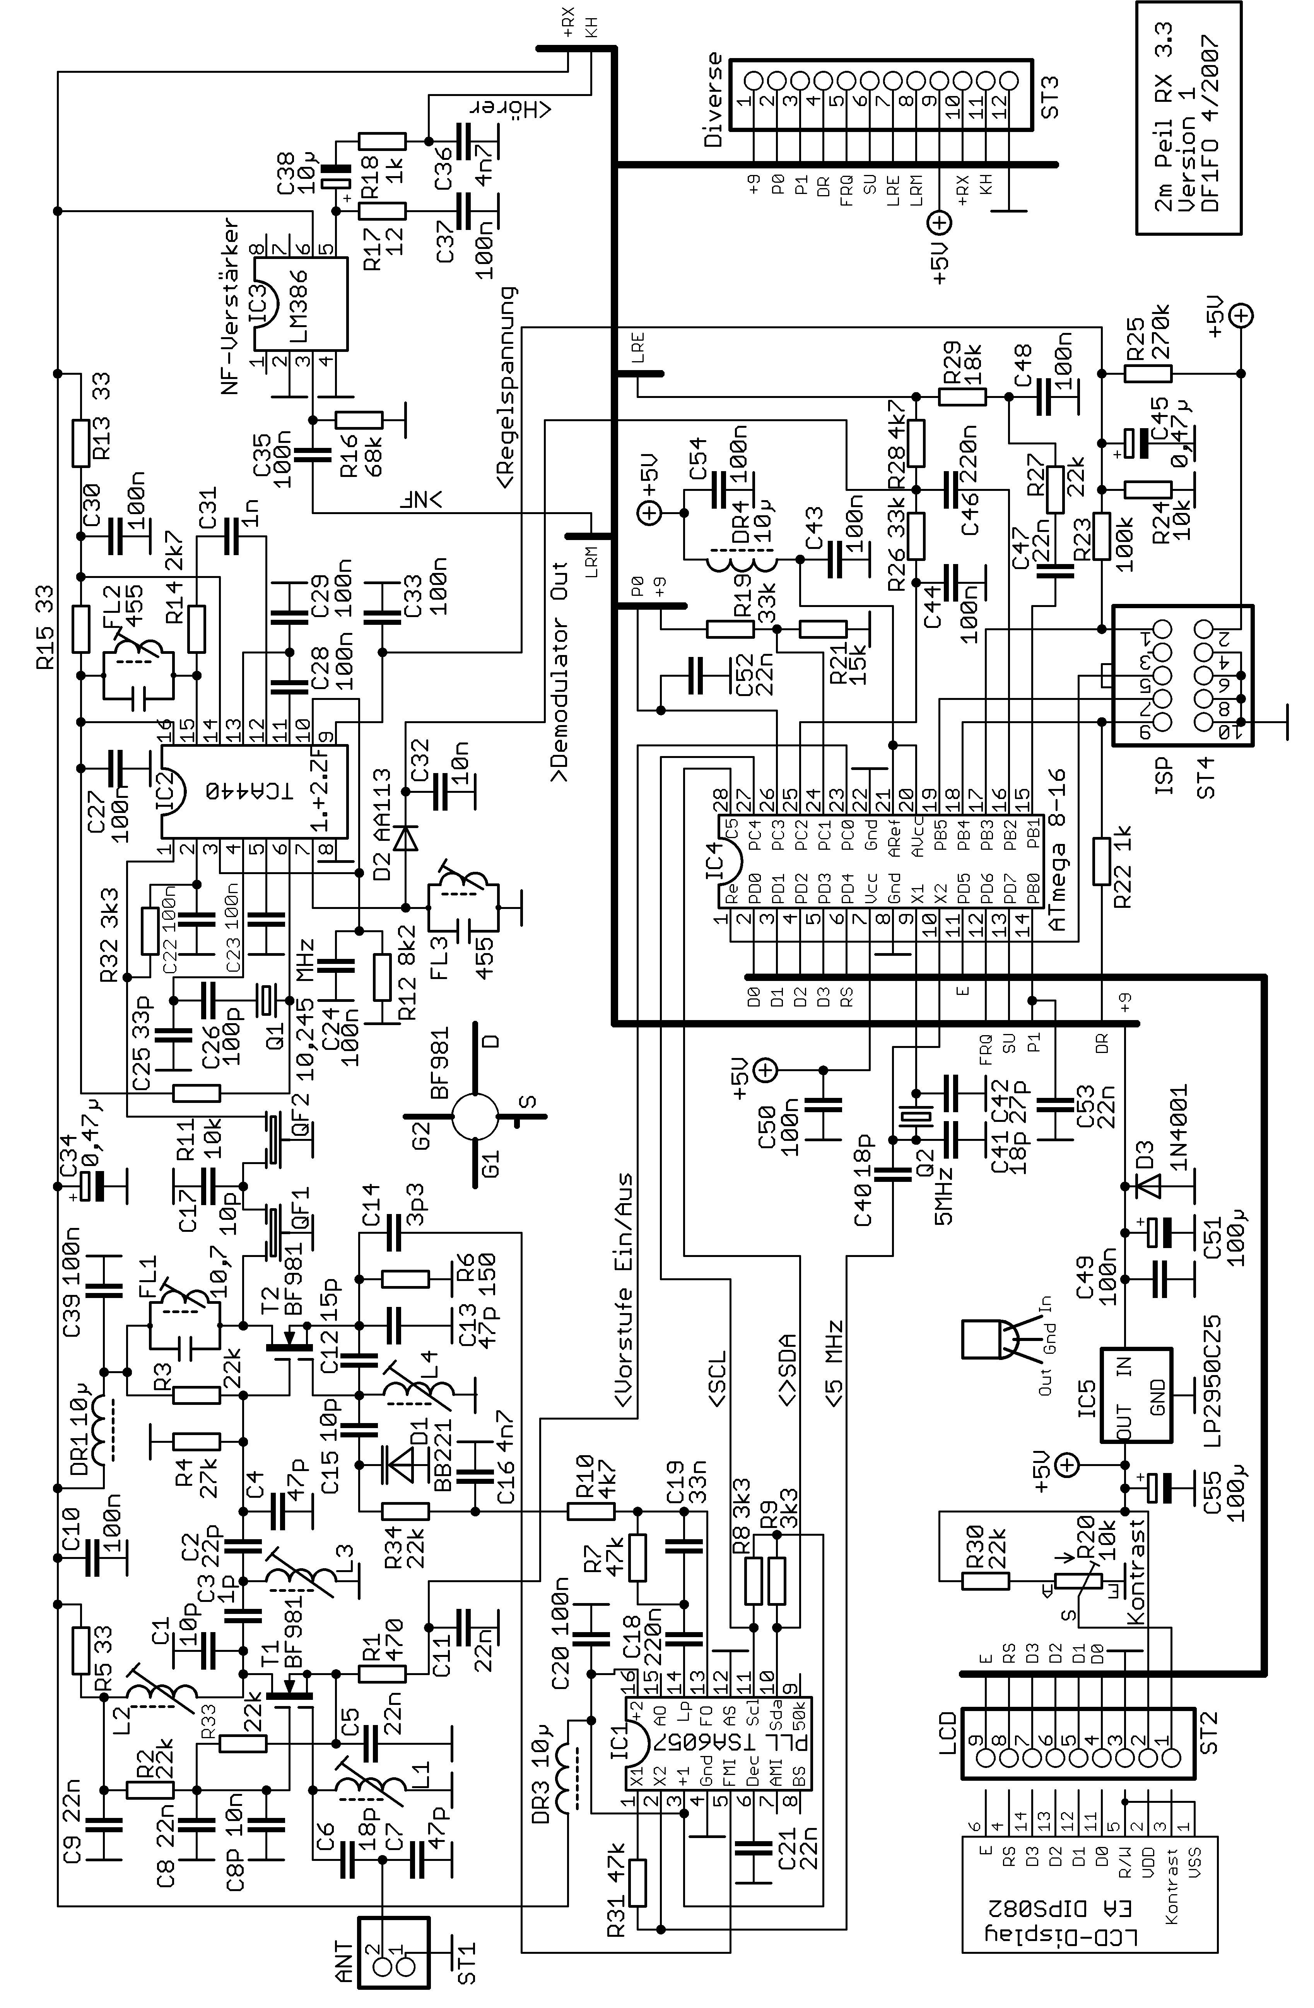
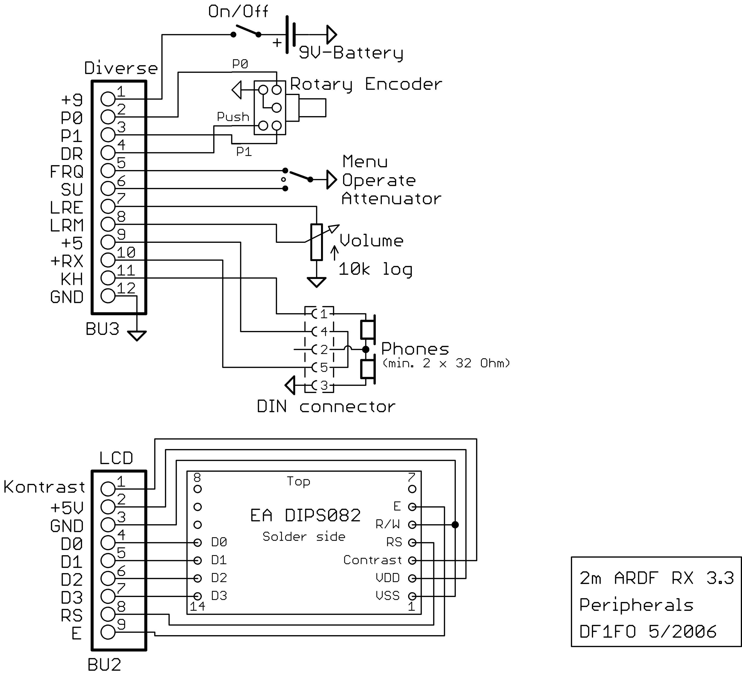

Notes:
The On/Off-switch can be combined with the volume control pot.
Menu/Operate/Attenuator is a 3-position toggle switch, the Attenuator-position is momentary and returns to Operate.
For headphones with 3,5mm-plug I have special jacks with an isolated switch:
+-------------------+
| O 2 | 3,5 mm Jack, solderside view
+--+ O 10 O a| Connect 3 <> GND, 2 <> KH, m <> +5, a <> +RX
| O 1 O m|
+--+ O 11 O r|
| O 3 |
+-------------------+

Specifications

Measured with Rohde&Schwarz SMS2 at 144,525 MHz, 80% AM 1kHz

Frequency Range 143,9 – 146,1 MHz (optional 143,9 – 148,1 MHz)
Input Impedance 52 Ohm unbalanced
Sensitivity for 6 dB S+N/N 100 nV
Input Signal for 75% S-Meter-Indication 300nV – 300 mV
Attenuator Range 120 dB in 5 dB-Steps
Bandwidth +/- 7 kHz for –3 dB, +/-20 kHz for –40 dB
Mirror frequency rejection @ – 2 * 10,7 MHz >50 dB, @ – 2 * 455 kHz >70 dB

Operating Voltage 5,5 – 10 V
Operating Current 55 mA

Total cost of material w/o Antenna about 120 €

Operation
The On/Off-switch is combined with the volume control pot. Volume is normally set to a middle position and remains there until the receiver is switched off. When the receiver is turned on the stopwatch starts at 0 and the foxtimer with fox # 1, and the active frequency is loaded. The actual receiver (the analogue part) is powered only when the headphone is plugged in. Pulling the headphone reduces power consumption to 10 mA while keeping all timers and settings active.

The receiver is controlled by a rotary encoder and a toggle switch with the three positions Attenuator-Operate-Menu.

Switch in Operate Position

The LCD shows the number of the current fox, its remaining transmit time in seconds, the estimated distance to the fox and a 32-step bar-S-Meter. One to four dots in character position 2 show the selected frequency number, and an asterisk in position 5 indicates that the automatic Attenuator is off.

- Turning the encoder sets the attenuation in 5 dB-steps. When the signal reaches full-scale on the S-Meter, attenuation will automatically increase 5 dB. This is indicated by a tone signal. A reduction of the attenuation must always be done manually, by turning the encoder or clicking the toggle switch.
- A click on the encoder switches the audio signal between normal reception and acoustical S-Meter.
- Pushing and turning the encoder switches between the (up to 4) stored frequencies.
- A click of the toggle switch to the attenuator position opens the attenuator to the 40/10/0 dB position
- Pressing the switch for 1 s turns the automatic attenuator on/off.

An alarm sounds at a set time (e.g. 10 s) before the end of transmission of each fox.
When the battery voltage is low, another alarm will sound 10 sec after the start of transmission of fox 1.

Switch in Menu Position

After switching to Menu the display will show for a few seconds the current frequency, the stopwatch and the battery voltage. Turning the encoder selects one of four menu items: entering the up to four frequencies, starting/stopping the stopwatch, starting the foxtimer, and starting the setup-menu. Both menus and the frequency entry mode are left by setting the switch from the Menu position back to Operate.

The table on the following page shows all menu items and related operations. For a deeper insight into how to use all these functions: just play with the receiver.

Once you are on the run all settings in the menus have been done and you will stay in the 'Operate'-mode. As you get closer to a transmitter the attenuator will automatically decrease receiver sensitivity. Just run for the maximum. The display shows S-meter, estimated distance to transmitter, # of current fox and remaining transmission time. The only adjustment you have to do is to open the attenuator when you need more sensitivity. This can be done in small steps by turning the encoder, or in big steps by clicking the attenuator switch.

Calibration Menu

There is one more menu: the Calibration menu. It allows to adapt the processor to the receiver hardware and some user preferences. It is started by putting the switch to Menu and pressing the rotary encoder while the receiver is switched on.
It offers the following functions:

- Select Language Deutsch/English/Nederlands
- Reset EEPROM to standard values.
- Calibrate battery voltage measurement
- Calibrate receiver frequency
- Calibrate attenuator in 13 steps 0..120 dB
- Select frequency range 144-146 (IARU Region 1) or 144-148 (Region 2,3)
- Select low battery warning threshold 5,8 – 8,0 V
- Calibrate distance estimation –5..+5
- Save changed data to EEPROM. All changed parameters must be saved with this function!

The calibration menu is left by switching to Operate.

Operation Overview

Operation 2m-ARDF-Receiver DF1FO Software Version 4.4

Switch Position | Function |  | Display
Operate | < > Attenuator +/- 5 dB  * Acoust. S-Meter On/Off  <<*>> Frequency No. +/- (*1)  a Open Attenuator to 40/10/0 dB  A Auto-Attenuator On/Off |  | Fox-Timer  Distance  S-Meter  1-4 Dots: Frequency No.  * = Auto-Attenuator Off
Menu | < > Select Item |  | Frequency  Stop-Watch  Battery-Voltage.
___________________|
V Main Menu (Exit with Switch -> Operate)
Menu Item | Function
Change Freq. | * Start ==> | < > Freq. +/- 10 kHz  <*> Freq. +/- 1,25 kHz (*2)  * Next Freq. No
ClkStop/Start | * Stop-Watch Stop / Reset and Start
ClrTimer | * Restart Fox-Timer (*3)  <*> Change current Fox-#
Setup menu | * Start Setup Menu ==> | < > Select Menu Item
__________________________________________|
V Setup Menu (Exit with Switch -> Operate)
N Foxes | <*> # of Foxes 1..10, set to 1 for Foxoring (*4)
T Fox sec | <*> Fox Transmission Time 1..99 sec
T Fox msec | <*> Fox Transmission Time +/- 20 msec
P Fox | <*> Fox Output Power 1 µW - 30 W, dB only (*5)
N Freq. | <*> # of frequencies used 1..4, special modes 12<>3, 1x2<>3 (*6)
T Alarm | <*> Alarmtime 1 - 30 sec before End, 0 = Off
Acoust. SM over | <*> Threshold 0/8 - 3/8, 0/8 = Acoust. SM always on (*7)

Encoder-Functions | Attenuator Switch
<> Turn  <*> Push + Turn  * Click | a Click  A Press >1 sec

(*1): Push and turn at least 2 steps within 0,5 sec
(*2): If the fox uses FM (rather than AM) set the receiver 5-6kHz above or below the nominal frequency
(*3): Restart Timer at start of transmission of any fox with *, then set current fox # with <*>
(*4): ‚Nfoxes=1’ = special mode for Foxoring: Fox-Timer is off, Alarm is off, display shows stopwatch
(*5): ‚dB only’ = no distance estimation, display shows attenuator dBs only
(*6): Special modes for foxhunts with two sets of foxes:
Mode 12<>3 : 3 frequencies <* switches between Frq.1 and Frq.2, *> switches to Frq.3
Mode 1x2<>3 : the same, but receiver stores and recalls selected Frq.1/2 for each fox
(*7): Acoustical S-meter goes off, when the bar-S-meter is below the threshold for 3 sec.

A few Notes on the Software

The receiver software is programmed in Assembler. It uses most of the 4096 words of the processors program memory. Only one interrupt is used, a 320 µs Timer. The interrupt handler serves the stopwatch and foxtimer and debounces the switch and encoder. All other functions are implemented on the main program level.

The LCD is loaded every 100 msec. If the LCD bus wiring is to close to the volume control wiring you will hear some 10Hz noise.
The DC voltage from the demodulator (= signal strength indication) is read in permanently. For the Bar-S-Meter the peak value of the last 300 msec is used to give a fairly stable indication. For the acoustical S-Meter the momentary value is used. Therefore finding the maximum is faster with the acoustical S-Meter.

The automatic attenuator reduces the attenuation by 5 dB when the S-Meter reaches full-scale (by 10 dB if it reaches 2 x full-scale). This is indicated by a 500/1000Hz double-tone. The receiver then waits for 200 msec for the effect of the new attenuator setting, before it increases attenuation by another 5 dB, if necessary. Increasing attenuation over the full dynamic range of 120db takes 12 * 200msec = 2,4 sec. In such a case turn the encoder to the right to speed things up.

The gain control voltage for the TCA440 is generated by a pulse width modulator. The right setting of the PWM for the 25 attenuator positions are found during the receiver calibration and stored in the processors EEPROM. To make the calibration easier only the n*10dB values are stored, the intermediate x5dB values are interpolated. The preamplifier T1 is turned off for attenuation values over 60dB. This reduces the signal level at the mixer by about 40 dB, and is compensated by increasing the gain of the TCA440.

The estimation of the distance to the fox is based on the following empirical data: a typical 1W fox in 100m distance gives a 3 mV signal from an HB9CV or 3 element antenna. As you get closer to the fox the signal increases by 20dB per 0,1x distance. Above 100m the signal decreases by 30db (!) per 10x distance. Above 1,5 km the variance of signal strength becomes too large to make a useful estimation. In this case the receiver will show the attenuator setting in dB instead of a distance estimation.

Any experienced foxhunter knows, that in real life the signal strength will seldom follow this ‘standard profile’. A mountain between receiver and fox decreases the signal strength considerably, a valley increases it. Still the experience of many foxhunters is, that an indication of ‘100m’ is much more meaningful than ‘80dB’.

By changing the PFox value in the setup-menu the receiver can be adapted to foxes of different strengths. I mostly use the 1 W setting. If your distance readings are mostly to close (to far), increase (reduce) the PFox value.

Assembly Instructions

Required Skills and Equipment

In this chapter I will describe the assembly, test and alignment of the receiver. These are not step-by-step instructions, you must have some experience in building VHF-equipment. You will have to go through the following steps:

- Get all components according to the Parts List
- Assemble and solder a very densely populated circuit board
- Design and build an enclosure and antenna (mostly the biggest hurdle!)
- Test, debug and align the receiver

For the alignment you need a lab power supply, multimeter and a 144 MHz signal generator with stable frequency, AM and calibrated output level from 0,3µV to 300 mV. If you do not have access to such a signal generator or in case of problems you can send me the PCB and I will align it.

You do not need any programming skills or experience with Atmel-processors.

Assembly of the Printed Circuit Board

The PCBs are professional quality, double sided, plated through, with solder mask and position print. There are two sizes available: the short version is 64*84 mm, and the long version is 35*152 mm. The two sizes allow wide variations of the mechanical design of the enclosure. Electrically both versions are 100% identical, and therefore the schematic and parts list are the same.
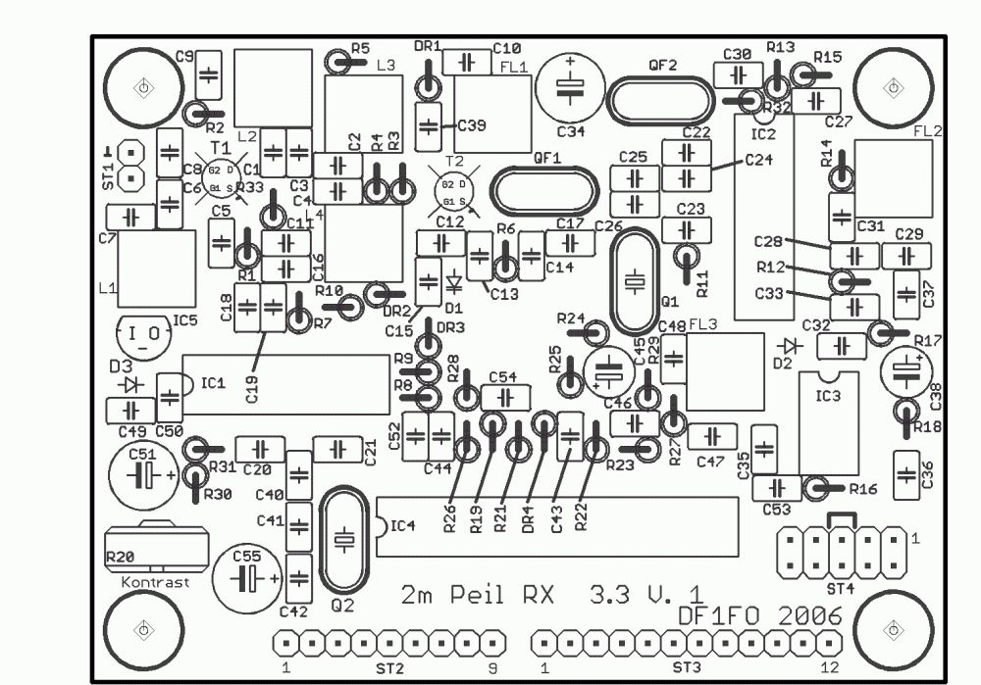 Placement for the short and long version

The connections to the antenna (ST1), display (ST2) and the other external components (ST3) are pluggable
Only 1 or 2 components are SMD, everything else is conventional pin-in-hole. Due to the high density you need a fine solder tip.

I recommend to use sockets for all ICs. From a reliability point of view that is detrimental, but it makes the debug and repair much easier.

A detailed parts list is at the end of this document.

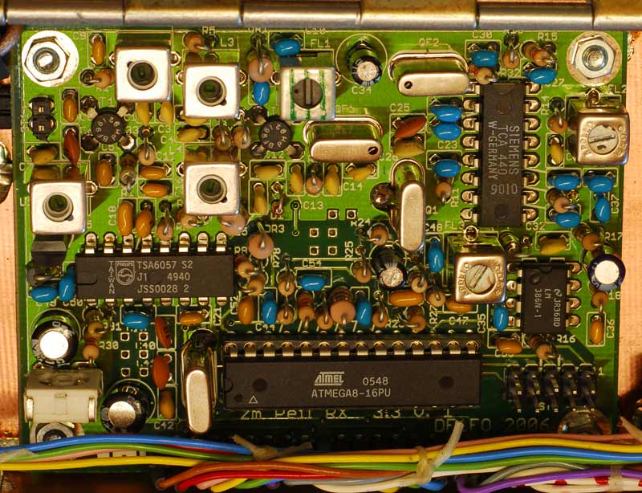 The assembled PCBs, long and short version

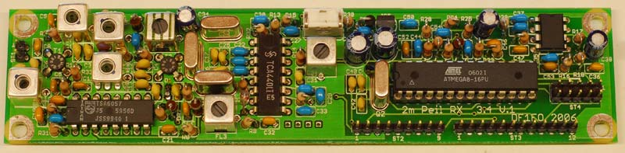

For the assembly of the PCB I recommend the following sequence:

- Have the circuit diagram, parts list and component placement print ready.

- Have all components ready, counted and sorted according to parts list.

- Drill the four mounting holes in the PCBs corners to desired diameter (e.g. 3,2 mm for M3).

- Do not use lead-free ROHs-solder! Use old fashioned solder with 38-40% lead (Sn60Pb40 or similar) and 1mm diameter!

- If you use the VariCap BB833 (SMD) for D1: install it first. Fill both holes in the PCB with a little solder. Position the diode so that the black side faces the ground terminal, hold in place and solder both connections.

- Install and solder resistors, capacitors, chokes and diodes. Start at the receiver input. All components are bent to fit the 2,5 mm pitch. Install 5 to 10 at a time, then solder and cut the leads very short (~1mm). This is a plated-through board, the solder joint is inside the hole, you do not need big mountains of solder on the solder side!.

- Transistors, ICs resp. IC-sockets.

- Crystals. The cans of the two crystals must be soldered to the ground pads on the PCB. Use a bigger solder tip and a lot of heat, and solder fast.

- Everything that’s left: L1-4, FL1-3, QF1-2, R20, ST1-4. The black dots on the crystal filters should face the common connection/C17 (for 10M12B, the 10M15A has no dots). ST1-4: the male connector goes on the PCB, the female on the wiring.

- The SMD-capacitor C8P is soldered on the solder side parallel to C8 (C8P prevents wild oscillations of T1 in the UHF range). Remove some of the solder from T1/Gate2 and the ground-side of C8. Position C8p and re-solder both sides.

- If your TCA440 is not from Siemens (stamped ‘Siemens’), but rather from HFO (a small round unreadable logo) solder a 22pf-capacitor on the solder side between TCA440 pin 12 and 13. This makes the IF-amplifier more stable.

- The holes with square solder islands are spare and remain unused.

- Inspect the solder side of the PCB and cut any wires that are longer than 1,5 mm.

- The following is optional: spray a thin layer of fluxer on the solder side, let it dry, then re-solder (re-flow) all solder joints. This takes only 30 minutes and reduces the risk of a bad/cold solder joint and resulting hard-to-find intermittent problems.

Mechanics

Introduction

The following points should be observed when you design the enclosure for your receiver board:

The enclosure must shield the PCB all around, so that the digital noise from the processor can not couple into the antenna. Recommended material for the enclosure is a die-cast aluminium box, aluminium profiles or PCB-material.

The PCB must have a distance from the enclosure of at least 3 mm on the solder- and component side, and 1 mm around the edges. The ground layer of the PCB must be connected to the enclosure by the mounting screws in the corners of the PCB.

All wiring (except for the antenna connection) must be kept away from the PCB-corner with the antenna connection and preamplifier. The wiring to the volume pot must have a few mm distance to the display wiring, or the two wires to the volume pot should be shielded.

The mechanics should be rugged, light and waterproof. Changing the battery should not require tools.

The receiver should be well balanced, so that you can carry it in your hand for two hours without problems. For normal operation the hand holding the receiver should also do all necessary adjustments of the receiver.

There is no optimal solution for all these (somehow conflicting) requirements. Also your mechanical skills and available tools and material will strongly influence your design. Therefore the two receiver designs described on the following pages, the Old German and the Russian version, are meant just as examples. In the gallery on my homepage you can find photos of many variations of these two basic designs, using all kinds of materials.

The Old German Version

This version is quite similar to Siggi Pomplun’s design that was very popular and wide-spread in Germany ten years ago. The receiver is built into a rugged die-cast aluminium box. It has a wooden handle and an HB9CV antenna is mounted directly on top. The antenna jack is at the back of the box, the display, volume pot, switch and rotary encoder in the front. Switch and rotary encoder can be operated with the thumb of the hand holding the receiver. The headphone jack is at the bottom of the handle. For easy access to the battery, the top is screwed to the box with thumb screws. The total weight of the receiver with battery is 460 g, the HB9CV antenna adds another 250 g..

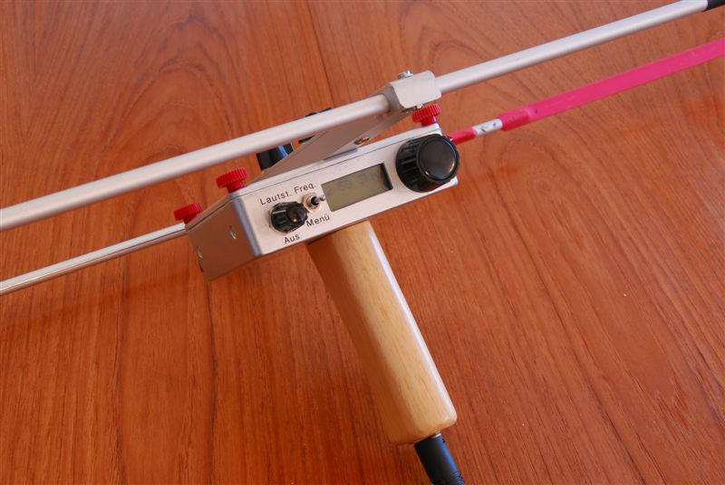 The Old German Version

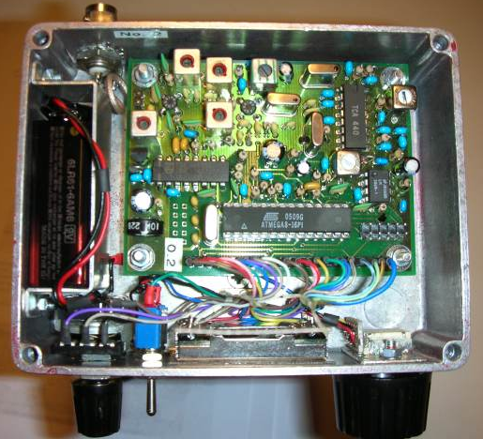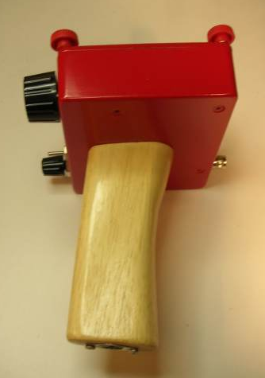

The display is mounted on a piece of perforated board with 2,54mm pitch. A bracket presses the board+display against the ‘front panel’. Each wire soldered to connectors BU2and BU3 is secured with a 4mm piece of heat shrink tubing to prevent short circuits.The coax cable to the antenna is thin Teflon coax. It is soldered directly to the ST1 pins on the solder side of the PCB. The ST1 pins on the component side are cut. This reduces noise pickup a bit.A piece of thin clear plastic prevents water to enter through the display window. The plastic is fixed on the inside of the box around the window with double-sided self-adhesive tape.

Building this receiver version is fairly simple, thanks to the die-cast box and the availability of commercial HB9CV antennas. Everything is easily accessible for assembly and service. Since you hold the receiver in front of you, you have no problem to find the controls and read the display.

The Russian Version

The advanced foxhunter mostly prefers the Russian Version. It uses a 3 element Yagi-antenna, the receiver is placed between dipole and reflector of the antenna, and the receiver is also the handle. This receiver can be carried very comfortably on the long arm. When in use it is normally held in front of your body, and in critical situations over your head. It is operated mostly blind, relying only on the sound signals. Therefore using this receiver version requires more experience and practice. The six DF1FO-receivers used in the 2007 Region 1 and 2 championships all were variations of the Russian version.

Receiver with antenna..

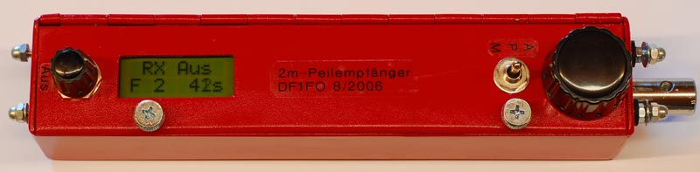 .. and without

The antenna is mounted directly to the receiver: the reflector at the back (in the photo: left), the dipole in front, and the director with a short boom in the far front. The enclosure size is 195mm x 41mm wide x 39mm high. The enclosure is made from 1,5mm PCB epoxy, soldered together. All edges are rounded to make it hand-friendly.

The top cover is connected to the enclosure with a piano hinge and gives access to the interior and battery.

The 3-Element-Yagi is the design of Joe Leggio, see home.att.net/~jleggio/projects/rdf/tape_bm.htm

The three elements are made from 25 mm steel tape measure. The length of the reflector is 106,5cm, the dipole is 2x46,5cm + 1 cm gap = 94 cm total length, and the director is 90,5 cm. The distance dipole-reflector is 20,5 cm, and dipole-director 32cm. The elements are rounded at the ends and spray-painted. They are mounted between two 2x8cm pieces cut from plastic tube with 40mm diameter.

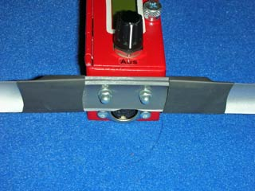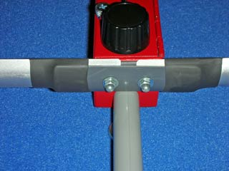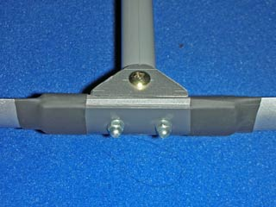

The photos show the middle section of the three elements and how I have mounted them. The boom is a piece of 16mm plastic tube.

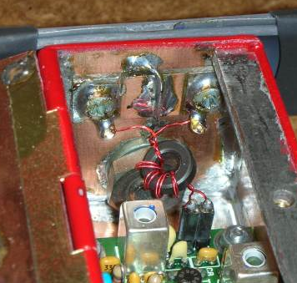 Balun and connection to dipole

The symmetrical dipole is connected to the asymmetrical receiver input through a guanella balun. 2 pieces of 0,4mm enamel-insulated copper wire are twisted 4x/cm and wound 5 times around an FT37-43 toroid. Not perfect, but easy and good enough.

The total weight of this receiver with antenna and battery is 540 g.

Batteries

I use 9V-batteries of the Alkali-Manganese-type. They cost less than 1€ and last for about 6 hours at room temperature and 4 hours at 5°C. If you want to use a rechargeable battery: the 9V-block-type does not have enough capacity. Alternatives:
- 6 rechargeable NiCd or NiMH-cells of size AAA with a nominal voltage of 7,2V.
- 7,4V LiIon accumulators, e.g. the NB-2L type used in Canon cameras.

Test and Alignment

This chapter describes the test and alignment of the assembled receiver.

Connect the receiver to a lab power supply. Turn the receiver on and connect the headphone. Slowly increase the supply voltage from 0 to 9 Volts. The supply current should go up to between 50 and 60 mA. The voltage at ST4/2 must be 5V
+/-0.25 Volts.

If the processor is unprogrammed: connect the ISP-cable to ST4. Change the following fuses: EESAVE=0, CKSEL=1111, SUT=11, BODEN=0, BODLEVEL=0. The Atmel AVR programmer will show the fuse-pattern D13F in its message field. Assemble the software FJRX.asm with AVR Studio and load it into the flash memory.

Set the contrast pot R20 for best readability of the display. Check function of the switch and rotary encoder.

To adjust the PLL connect a voltmeter to the tuning voltage at IC1/13. The voltage should be below 1V (if it is >4V the oscillator does not work). Tune L4 clockwise until the voltage is 1,5V, now the PLL is locked. Fine-tune L4 so, that the tuning voltage for the complete tuning range (143,9 – 146,1) is within the range 1,0..3,5V.

Set the receiver to 144,525 MHz and 10 dB attenuation. You should hear a little bit of noise. Connect a signal generator to the antenna input: 144,525 MHz, 30 µV, 80% AM 1kHz. Now you should hear the 1 kHz signal. If necessary adjust the signal generator frequency or level, or the attenuator setting. (If the S-Meter shows full-scale without an input signal the TCA440 is oscillating. Turn attenuator right until the S-Meter shows <1/4 full-scale.) Adjust L1..3 and FL1..3 for maximum S-Meter indication. They all should show a clear maximum.

The alignment of FL1 has a significant influence on the pass-band ripple of the crystal filter. This should be checked with a sweeper or network analyser: 10,675 – 10,725 MHz, -60 dBm/50 Ohm, feed into T2/Gate2. Measure level at IC2/7 . Adjust attenuator so, that the receiver does not saturate. Set FL1 for minimum ripple. A resistor of 22, 15 or 10 kOhms parallel to FL1 typically reduces the ripple. You should be able to get the ripple down to +/-1 dB. If you have no sweeper: ignore this paragraph.

Now you must start the Calibration Menu: switch to menu and turn on receiver while pressing the rotary encoder.

Select ‚Cal UBat’. Set supply voltage to 9,00 Volts. Push+turn until the display shows 9,0 Volt. This calibration compensates variations in the reference voltage and R19/R21.

Set signal generator and receiver to 144,525 MHz. Select ‘CalF’. The display shows the S-Meter and a frequency offset. Push+turn varies the receiver’s frequency in 1,25 kHz steps. Set the generator level so, that the S-Meter is between ½ and full-scale. Tune the receiver in both directions until the signal falls off to <50%. Set to the median between these two points (e.g. if the two points are –04 and +08, set to (–4+8)/2 = +02). This compensates the offsets of the 5MHz-crystal and the crystal filter.

Select ‚CalAtt.’ and click to start the attenuator calibration. Set the signal generator level to 0,3µV. Turn the rotary encoder, until the S-meter shows ¾ full-scale. Click, increase signal generator level 10dB, adjust to ¾ again. Repeat until 300mV input level (120dB) have been adjusted. One more click completes the attenuator calibration.

Select ‚FRange’. A click changes the frequency range from 143,9..146,1 MHz to ..148,1 MHz. See below.

Select ‚BatWarng’. Push and turn to set the ‘low battery warning threshold’ between 5,8V and 8,0V. Set to ‘7,0V’ for 9V Alkali-Manganese batteries, to ‘6,0V’ for 7,2V NiCD/NiMH/LiIon accumulators.

Finally all calibration values and settings have to be stored to EEPROM by selecting ‘Save Cal Values’ and a click.

To check the sensitivity of the receiver set the signal generator output to 0,1µV. Set receiver attenuator to 0 dB. The 1kHz signal should be audible between the noise. Fine-tune FL2 and FL3 for best signal to noise ratio. Turn signal generator output off. The S-meter indication should be between ¼ and ½.

After the calibration is completed you should go through the calibration menu once more and write down all values and settings.

The audio level should be sufficient with the volume pot in the middle position. If your headphone is less sensitive you can increase the audio level by reducing R18 to 330 Ohms. Or find a better headphone.

If you want to use the extended frequency range 143,9..148,1 MHz:
- Replace D1 (BB221) by a BB833 to cover the extended tuning range.
- Set the frequency range in the calibration menu accordingly.
- Do the basic alignment at 146,0 MHz instead of 144,525 MHz.
- Align the filter L2/L3 for a flat (+0/-3 dB) response from 144,0 to 148,0 MHz

If after you have gained some experience with the receiver you have found that the distance estimation is mostly too short or far, although the transmitter power has been set correctly, you can compensate this in the calibration menu, selection ‘CalDist’. Increasing/decreasing this parameter by 1 will change the distance estimation 1 step.

Now you are ready for the first foxhunt with your new receiver! For information on foxhunting see www.darc.de/ardf (in German) or www.homingin.com (in English).

Further Information

The latest version of this document in German and English is on my homepage www.mydarc.de/DF1FO .
Photos of other hams construction ideas can be found in the Galerie (gallery)
Questions&Answers in German can be found in Fragen&Antworten.
The design of circuit diagram and layout were done with Eagle 4.15 www.cadsoft.de .
The software was developed with Studio 4.
In AVR Studio 4, do the following settings:
- Project -> Assembler Options: Assembler Version 1, Wrap Relative Jumps On
- Tools -> Options -> Editor -> Tabwidth= 8
My AVR-programmer is the AT AVR ISP MarkII.
Datasheets for the ICs are on my homepage.
ATMega8 Info at www.Atmel.com -> Products ->Microcontrollers ->AVR 8-Bit RISC
Datasheet: -> Datasheets -> Atmega8
AVR Studio 4: -> Tools & Software -> AVR Studio 4

Acknowledgements

Many thanks to my beta-testers: my XYL Brigitte, Harald Gosch OE6GC, Wolfgang Böhringer DL9TE and Dieter Schwider DF7XU. With mild criticism, many good ideas and a lot of encouragement they contributed very significantly to this project.

Your Feedback

Your comments, corrections, criticism, ideas for improvements and questions are always welcome. Please email to mycall@darc.de (my call is DF1FO).
Parts List

Parts on the PCB
- PCB FJRX233 (64x84 mm) or FJRX234 (35x153 mm)
D1 VariCap BB221 (for 144-148 MHz range use BB833 (SMD!))
D2 AA113
D3 1N4001
DR1,3,4 Choke 10µH
FL1 Filter 10,7MHz, 7.5 mm, green
FL2,FL3 Filter 455kHz, 7.5 mm, black or white
IC1 TSA6057
IC2 TCA440 or A244D
IC3 LM386
IC4 ATMega 8-16 DIP
-- IC-Sockets 1 * 8pin, 2 * 16pin, 1 * 28pin narrow
IC5 LP2950CZ5
L1-L4 Inductor 53 nH Neosid BV5118.30
Q1 Crystal 10,245 or 10,240 MHz HC18U
Q2 Crystal 5MHz HC18U
QF1,QF2 Crystal Filter 10M12B or 10M15A
ST1 Header ANT 1*2 (all 2,54 mm pitch, male)
ST2 Connector LCD 1*9
ST3 Connector Diverse 1*12
ST4 Connector ISP 2*5
T1,T2 BF981 DualGate-Mosfet

Capacitors, pitch 2,5mm
up to 220nF ceramic,
over “ electrolytic
C1 10p
C2 22p
C3 1p
C4 47p
C5 22n
C6 18p
C7 47p
C8 22n
C8P 10n SMD 0805
C9 22n
C10 100n
C11 22n
C12 15p
C13 47p
C14 3p3
C15 10p
C16 4n7
C17 10p
C18 220n
C19 33n
C20 100n
C21 22n
C22 100n
C23 100n
C24 100n
C25 33p
C26 100p
C27 100n
C28 100n
C29 100n
C30 100n
C31 1n
C32 10n
C33 100n
C34 0,47µ/16V
C35 100n
C36 4n7
C37 100n
C38 10µ/16V
C39 100n
C40 18p
C41 18p
C42 27p
C43 100n
C44 100n
C45 0,47µ/16V
C46 220n
C47 22n
C48 100n
C49 100n
C50 100n
C51 100µ/16V
C52 22n
C53 22n
C54 100n
C55 100µ/16V

Resistors 1/4W:
R1 470
R2 22k
R3 22k
R4 27k
R5 33
R6 150
R7 47k
R8 3k3
R9 3k3
R10 4k7
R11 10k
R12 8k2
R13 33
R14 2k7
R15 33
R16 68k
R17 12
R18 1k
R19 33k
R20 10k var. PT10S
R21 15k
R22 1k
R23 100k
R24 10k
R25 270k
R26 33k
R27 22k
R28 4k7
R29 18k
R30 22k
R31 47k
R32 3k3
R33 22k
R34 22k

Other Parts, not on the PCB

Rotary Encoder STEC11B01
Knob 6 mm/25-30 mm diameter
LCD-Display 2*8 characters EA DIPS082
3-position Toggle Switch On-Off-(On) (=one side momentary)
Pot 10 kOhm log. with switch
Knob 6 mm/10-15 mm diameter
DIN-Jack 5-pin 180°, chassis mount
9V-Blockbattery with Battery Snap
Connectors 1*2, 1*9, 1*12, 2,54 mm pitch, female (BU1, BU2, BU3)

Mounting Hardware, Wire, etc.

Headphone (min. 2 x 32 Ohm) with DIN plug

Additional Parts for the ‚Old German Version’:

Die-Cast-Aluminium Box 119*94*34mm
Handle
BNC-Socket for Antenna
5 cm thin Teflon-Coax
Antenna HB9CV

Additional Parts for the ‚Russian Version’:

PCB-material for the enclosure
Toroid FT37-43 for the Guanella-Balun
12 cm 2xCuL 0.4mm twisted, for Balun
Material for Antenna

