Advanced 80m-ARDF Receiver – Version 4

Nick Roethe, DF1FO

This is a slightly abbreviated translation of the original document in German ’Ein komfortabler 80m-Peilempfänger Version 4’ from October 2010 .

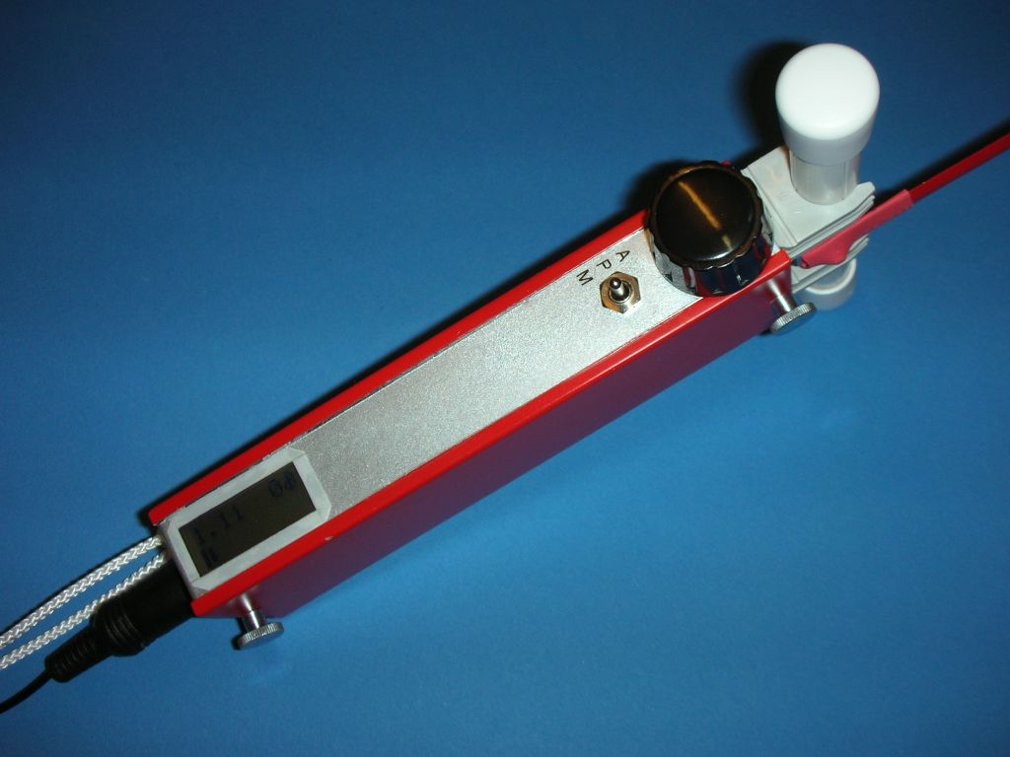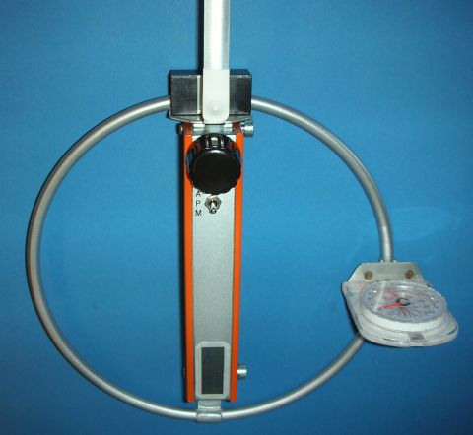
Receiver with Ferrite- or Loop-Antenna

Conceptual Overview

The 80m-ARDF-receiver described in this document consists of two parts:
- A single conversion receiver with 455 kHz IF and product detector.
- A controller and user interface using an Atmel-Microprocessor, LCD-Display und rotary encoder.
The operation is very similar to my 2m-receiver.

Highlights:
- User Interface is a rotary encoder and LCD-display
- Frequency controlled by processor
- Stores up to four frequencies
- Automatic attenuator
- Estimates distance to fox
- Shows current fox, time left for this fox, warns n seconds before end of transmission
- Stopwatch
- Shows battery voltage, low voltage alarm

The receiver is built into a tin-plate box of 16x5x3 cm. The ferrite rod or the loop antenna and the electrical antenna – a piece of tape measure – are mounted on the top. On the front side from top to bottom are the rotary encoder, a toggle switch (Attenuator-Operate-Menu) and the display. The Forward/Backward-switch sits on the back, the phone-jack at the bottom.

The receiver is held in the right or left hand. The thumb operates the rotary encoder and toggle switch, the index finger the Forward/Backward-switch. The magnetic antenna points in the direction in which you are running (minimum position). For the Forward/Backward-distinction the receiver is turned 90° away from you.

Technical Data:

Frequency Range: 3,490 – 3,660 MHz
Sensitivity: 200nV for 10dB S+N/N (coupled with DF1FO-loop)
300nV for 75% S-Meter indication
RF-Bandwidth @ -3dB: 3,530 – 3,600 MHz
Mirror frequency rejection: > 20 dB
IF/AF-Bandwidth: 1,3 kHz/-6dB, 4 kHz/-20dB, 8 kHz/-40dB
Attenuation range: 0 - 120 dB in 5 dB steps
Supply voltage: 5,5 – 10 V
Current consumption: 25 mA
Battery life: > 10 hours (9V Alkaline Manganese)
Weight: about 370g
Total cost of parts: about 90 €

Feedback

Your comments, corrections, criticism, improvements and questions are always welcome. Please send an Email to .

Translation of some terms used in the circuit diagram on the next page:
Abschwächer Attenuator  Abstimmspannung Tuning voltage  Drehgeber Rotary encoder  E-Antenne E-Antenna  Ein On  Ferritstab Ferrite rod  Lautstärke Volume  Messung Measurement  Platine PCB  Rück Backward | Schirmwand Shield  Sichtseite Front view  Steckseite Component side  UPegel Level indication  V/R-Verhältnis F/B-ratio  Verstärkung Gain  Vor Forward  Zeichen Characters  zum Zähler to counter
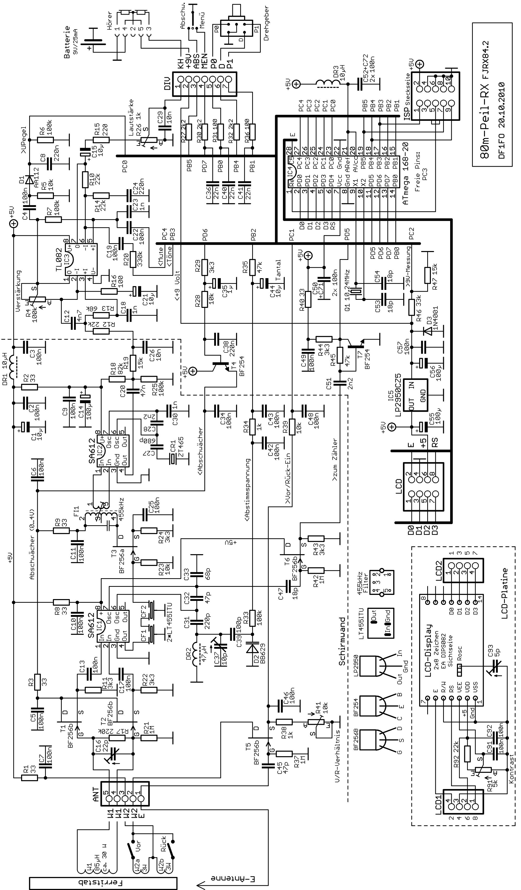
Circuit Description

See the schematic on the previous page and the translations on page 2.

The receiver is a single conversion super-het with an IF of 455 kHz, product detector and two stage AF-amplifier.

The antenna is a ferrite rod or a loop antenna. The antenna circuit W1/C16 is tuned to 3,57 MHz, and is wide enough to cover the frequency range used by standard 80m foxes.

For the Forward-/Backward-distinction the signal from an electrical auxiliary antenna is coupled into the magnetic antenna through W2a/b. Two push-button switches allow to test and compare both directions without turning the receiver. Alternatively a single (On)-Off-(On) toggle switch can be used instead of the two push-buttons. The F/B-ratio is optimized by cutting the length of the electrical antenna. R41 is used for a fine adjustment. The processor gets the information, that the F/B-antenna is active, through Pin PC1. This tells the processor to suppress the automatic attenuator and to enable an acoustic S-Meter function, to simplify the F/B-distinction.

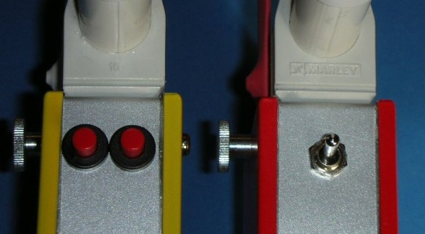 Push-button and toggle switch version

The antenna circuit W1/C16 is connected to a symmetrical Source-follower preamplifier. This stage matches the high-impedance antenna circuit to the symmetrical mixer input. It has no voltage gain, but about 10 dB power gain. And, as described below, it is also used as ab attenuator.

The next stage is an SA612 double-balanced mixer. It also contains the first oscillator needed to convert the 3.5 MHz signal to 455 kHz. The oscillator coil is a fixed inductance choke. Two cascaded ceramic filters provide the required selectivity. These were originally intended to be used in AM-receivers, and are therefore too wide. An AF-low-pass-filter improves the selectivity, see below. Next comes the single stage IF-amplifier T3 with a conventional LC-filter.

The receiver gain is attenuated for strong RF-signals by reducing the operating voltage of the FETs in the RF- and IF-amplifiers (T1, T2, T3). The processor sets this voltage through a pulse-width modulator, and the emitter follower T4 buffers it. With this method 120 dB attenuation can be reached easily (80 dB would be enough).

After the IF-amplifier comes the product detector IC2. It is also realized with an SA612. The BFO frequency is 458 kHZ, the upper limit of the ceramic filters pass-band. So only the lower sideband is received. The BFO-frequency is set by a ceramic resonator.

The AF-amplifier uses a TL082 Dual-Op-Amp. Its left half is a 3rd degree active low-pass-filter with a corner frequency of 1,5 kHz, and also amplifies the signal about 500x. The AF-low-pass is necessary because of the bandwidth of the ceramic filters of about 6 kHz. The gain is set with R4 to compensate gain variations of the RF part. The AF-signal at the output of the low-pass is rectified by D1, read by the processor through an A/D-converter on Pin PC0, and used for the S-Meter and the automatic attenuator. The right half of the TL082 has a gain of only 2x. It limits the AF-signal and drives the headphones. The processor generates (with a programmable oscillator) various tone signals. The signal is fed though PIN PB3 into the AF-amplifier. When the processor grounds output pin PC4, the AF-signal from the processor is muted, so that only the signal tones can be heard. The AF volume is set with R26 to match the headphones used.

The frequency is controlled directly by the processor. The signal of the first oscillator is amplified by T6 and T7 to logic level, and fed through pin PD5 to a 16 bit counter in the processor. It counts the periods of the oscillator signal for 50 msec, so the resolution is 20 Hz. This results in pulse counts of about 155k. The 16 bit counter wraps twice (every 65k). Then the difference between the actual frequency and the desired frequency is calculated. Depending on the direction of the offset output PB2 – normally High-Z – is switched to High or Low for a time period that is proportional to the frequency difference. These pulses are integrated and stored in C44, and the resulting voltage controls the oscillator frequency through the VariCap D2.

The attenuator voltage is generated by the processor with a 5 kHz pulse-width modulator. Its output is pin PD6.
A two-stage low-pass converts the pulse-signal to an equivalent voltage. The relationship between PWM-values and resulting attenuation is stored in the processor as part of the alignment procedure. The processor increases the attenuation by 5 dB, when the S-meter reaches full scale. So when the receiver is turned to the maximum direction, it automatically adjusts the attenuator to match the momentary field strength. The distance to the fox is estimated based on the attenuator setting (= field-strength) and the output power of the fox (see Setup menu).

The field strength, that an 80m-fox produces, depends heavily on the length and matching of the antenna, the length of the ground rod or radial, and the conductivity of the ground. If the person installing the foxes does a good job and you have a little luck, the distance estimations can be quite precise. But on a bad day it could be totally off, so don’t expect too much and remember: it is an estimation based on the available data, not a measurement.

The processor ATmega168, besides controlling the receiver, also handles the user interface. It consists of a rotary encoder, a 3-position-switch and a 2*8 LCD-Display connected to the processor. The processor also measures the supply voltage with an internal A/D-converter connected to pin PC2. The 10 pin connector ISP allows the in-system-programming of the processor.

The display has an internal clock of about 250 kHz. Its 14th harmonic is audible typically close to the most important fox frequency of 3,580 MHz. It is therefore shifted out of the receivers frequency range with C93.

The receiver is turned on by plugging in the headphones. The battery voltage must be between 5.5 and 10 Volts.
A low-drop voltage regulator brings it down to 5.0 Volts.

Mechanical Construction

The receiver is built into a standard tinplate box with interior measurements of 160*50*28mm. The box consists of a frame and two covers. The PCB has a size of 106 * 50 mm and is soldered into the frame. A piece of tinplate shields the RF part from the processor part of the board. It is shown in the schematic. The battery is held by a tinplate bracket soldered to the frame. The LCD display and some related components sit on a small 21 * 41 mm PCB. A reinforcement frame soldered around the display gives the ‘front-panel’ more stability.

I have spray-painted the frame in silver, and the covers in a color.

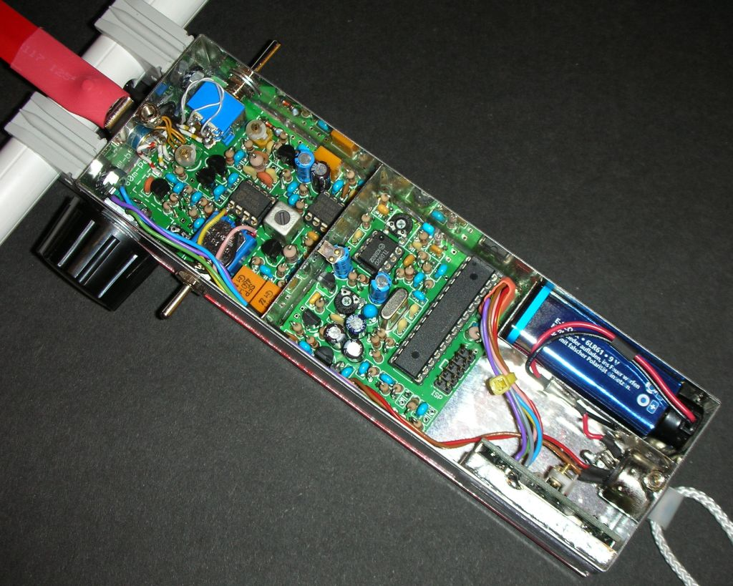

A total of four threaded studs are soldered to the middle of the short sides of the frame. The covers are screwed to them. For the component side cover I use thumbscrews for easy access to the battery.

This construction is mechanically stable, provides excellent shielding and accessibility. With the covers removed both sides of the PCB are easily accessible for measurements or experiments.

The shielding of the box and inside the box is very important, because two sources of noise are built into the receiver: the processor and the LCD display. I strongly recommend to stick to this proven design

The ferrite rod is protected by a piece of PVC tube and mounted on the receiver with matching holders.
The loop antenna consists of a ring of brass tube, with a 10-conductor cable inside.

Operation
The receiver is turned on by plugging in the headphones.

The toggle switch selects the mode: ‘Operate’ or ‘Menu’. By pushing the switch to the spring-loaded ‘Attenuator’-position the attenuation can be reduced.

Toggle switch to ‚Operate‘:

By pressing and turning the rotary encoder the frequency can be fine-adjusted in 100 Hz steps. (The basic setting of the frequencies of foxes and homing beacon are done in the Menu mode.) A double-click on the encoder switches to the next stored frequency, e.g. the homing beacon.

It is important, that the receiver is tuned to the correct sideband. If you press+turn (fine-tune) the encoder clockwise, the audio frequency of the signal should increase. Otherwise trun on through zero-beat, and the signal will get much stronger.

The direction to the fox is found by turning the receiver to the signal minimum. If the volume is too low to find the minimum, the attenuation has to be reduced. This can be done by clicking to ‘Attenuator’, this opens the attenuator in 3 steps: 50, 25, 0 dB. Alternatively the attenuation can be changed in 5 dB-steps by turning the encoder. Pushing ‘Attenuator’ long turns the automatic attenuator off or on again.

Even at full attenuation you will still hear a little bit of noise. This is due to the high gain of the stages after the last regulated stage.

To do the Forward-/Backward-distinction the receiver is turned to the maximum position, i.e. 90° from the minimum. The attenuator will automatically adjust to an S-meter indication between 50% and full scale, and the estimated distance is indicated. Now the forward- or backward-buttons are pushed. In one direction the signal strength will increase, and you will hear a tone generated by the processor. The frequency of the tone depends on the signal strength (‘F/B-Zoom’). In the backward direction the signal just gets weaker.

Toggle switch to Menu:

After switching to ‚Menu’ the display shows for 2 seconds the current frequency, stop watch and battery voltage. Then the ‘Menu’-mode is entered.

By turning the encoder one of the menu items or the Setup-menu can be selected. The menus and operation are very close to my 2m-receiver. All menus are left by switching to ‘Operate’. The table on the next page gives a detailed overview of the menus.

When entering the Setup-menu the first item shown is PFox. This makes it easy to adjust the assumed transmitter output power during a hunt. The following method for setting PFox works well, if all foxes have about the same characteristics: in a foxhunt according to IARU-rules the nearest fox is at least 750 meters away, and normally no more than 1 km. So set PFox at the start so, that the distance indicated for the strongest fox is 700m or 1km.

The functions in the Calibration-menu will be described in the alignment section of this document.

Operation Overview (Software-Version fjrx84 V1.6)

Switch | Function | Display
‚Operate‘ | < > Attenuator +/-5dB  <*> Frequency +/- 100 Hz  ** Next Frequency #  a Reduce Attenuation  A Auto-Attenuator On/Off | Fox-Timer  Distance  S-Meter  1-4 Dots: Freq. #.  * = Auto-Att. Off
‚Menu‘ | < > Select item | Frequency  Stop-Watch  Battery Voltage
_______________________|
↓ Main Menu (Exit with Switch => Operate)
Menu Item | Function
Change Freq. | * Start ==> | < > Freq +/- 1 kHz  <*> Freq +/- 100 Hz  * Next Freq. #
Clk Stop/Start | * Stopwatch Stop / Reset + Start
Tmr Start | * Restart Fox-Timer  <*> Change current fox # *1
Setup-Menu | * Start Setup Menu ==> | < > Select item
________________________________________________|
↓ Setup Menu (Exit with Switch => Operate)
N Foxes | <*> # of foxes 1..10 (1 = Foxoring,) *2
T Fox s | <*> Fox transmit time 1..99 sec
T Fox ms | <*> Fox transmit time +/- 20 msec
P Fox | <*> Fox output power 1 µW - 30 W, dB only *3
N Freq | <*> # of frequencies used 1..4
T Alarm | <*> Alarmtime 1 - 30 sec before end (0 = Off)
F/B-Zoom | * Acoustic S-Meter for F/B distinction On/Off
Rotary Encoder
< > Turn
<*> Push + Turn
* Click
** Double-Click
Switch to ‚Attenuator‘
a Click
A Push long
Calibration-Menu Start: Turn on RX with * and switch to ‘Menu’
Language  EEPROM Reset  Cal VBat  CalF  Cal Att Start  BatWarng  Cal Dis  FrqRange  Save Cal Values | <*> Select Deutsch/English/Nederlands  * Reset all Calibration and setup values  <*> Calibrate battery voltage measurement  <*> Adjust frequency offset +/- 0..9,9 kHz  * Calibrate attenuator in 13 10dB-steps  <*> Adjust battery alarm threshold 5,8..8,0 V  <*> Adjust distance estimation –5..+5  * Frequency range 3,49-3,66 / 3,49-3,81 MHz  * Store calibration values to EEPROM

(*1): Restart timer at start of transmission of any fox with *, then set current fox # with <*>
(*2): For ‘Foxoring’ set NFoxes = 1, this turns off fox timer and alarm, display shows stopwatch instead of timer
(*3): ‚dB only’ = no distance estimation, instead the current attenuation in dB is shown
Building the Receiver

Mechanics

The tin-plate box consists of four parts: two L-shaped half-frames and two covers. Before the half-frames are soldered together, several holes have to be drilled or cut.

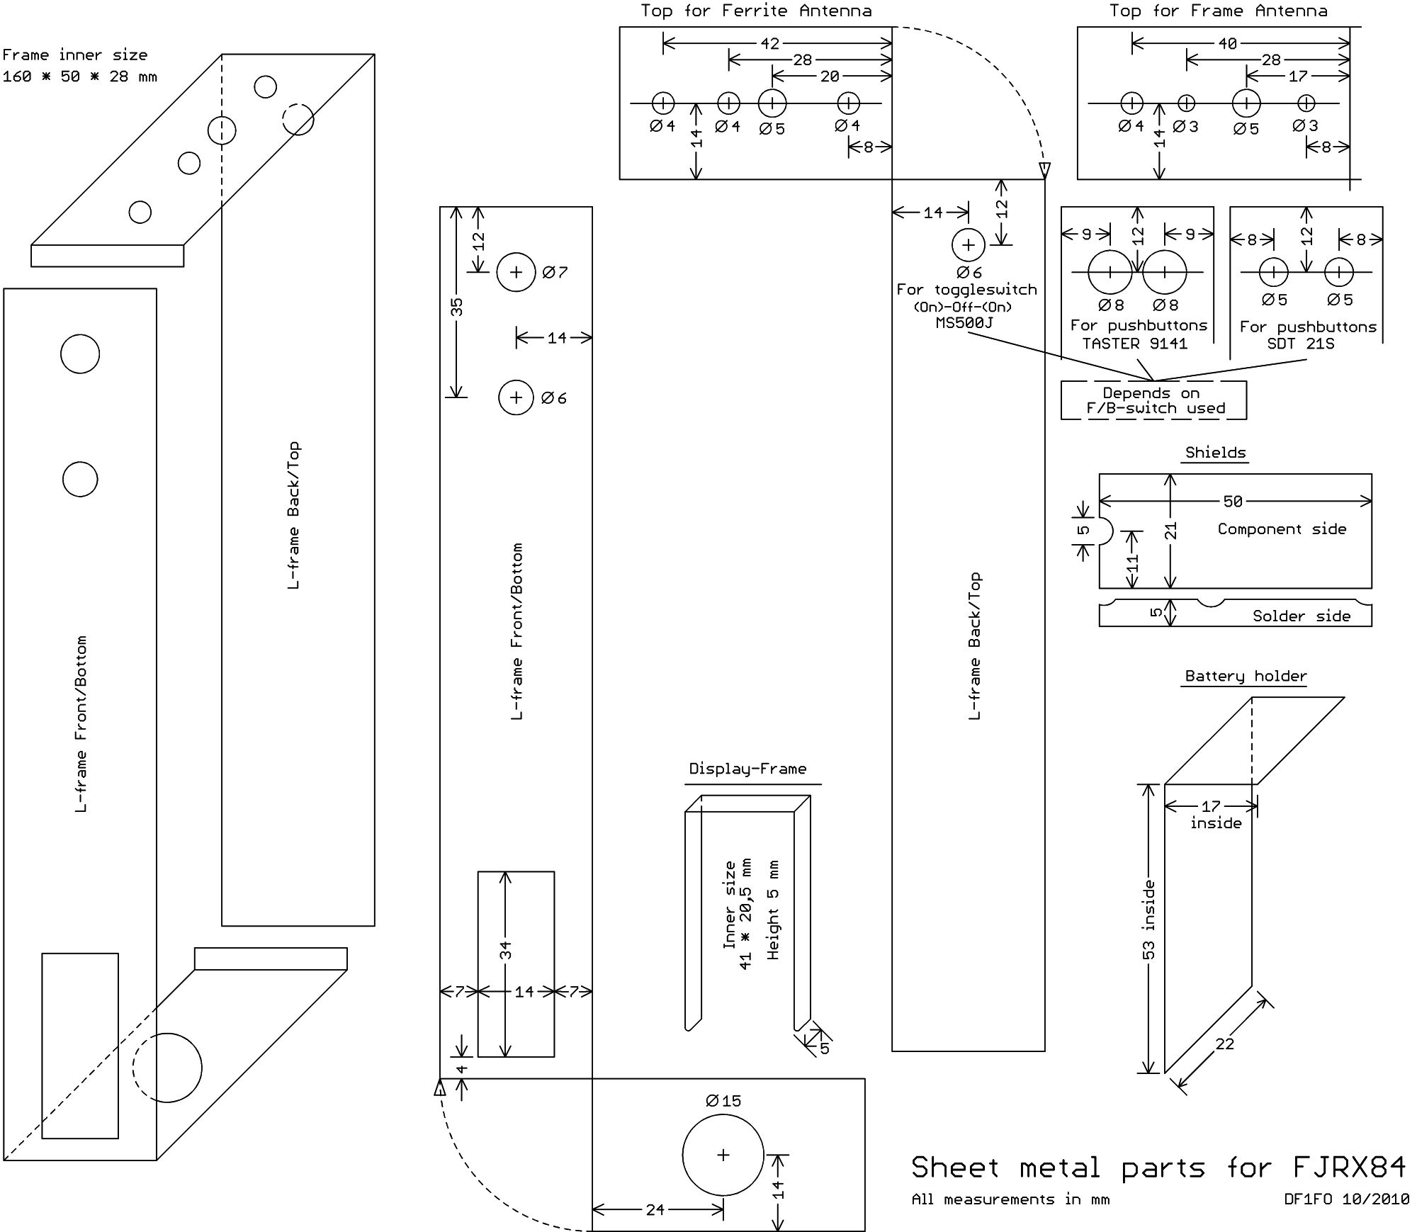

Working with the 0,5 mm tin-plate requires some extra care. Use only good new drills and hold the half-frames well, otherwise they may coil around the drill. I use drills only for the holes up to 7mm. For the bigger holes and the display window I drill a 7 mm hole and do the rest with a set of good quality files. Depending on the F/B-switch used one of the three drill patterns shown above has to be chosen. Also the patterns are a bit different for the two antenna types – ferrite or loop antenna.
The frame is very weak in the area of the display window. Therefore I solder a 5 mm high U-shaped reinforcement frame around the display. I use a strip of 1 mm brass plate, 5 mm wide and 105 mm long. It is fitted so that it positions the display in the center of the display window. There should be a 0.5mm gap between the display and the frame bottom – this will be needed for the display PCB. The display reinforcement frame is soldered to the front frame.

The DIN-jack for the headphones is soldered to the frame. Its two mounting holes are countersunk for better solderability, the jack is held in place, and soldered to the frame with plenty of solder. Instead of the DIN-jack a standard 3,5 mm headphone jack could be used. In this case a small toggle switch must be mounted beside the phone jack (to turn the receiver on/off).
Now the PCBs are prepared. The display board is filed down to the edges of the copper ground plane to a size of 21 * 41 mm.
The receiver board must also be filed down to the edges of the copper plane. Now the board is carefully fitted into the frame, this will require some more filing. The frame is stabilized by installing the solder side cover. The four 5 mm studs give the correct position of the boards solder side – 5 mm from the solder side cover. The board should fit snuggly into the frame - without bending the frame apart. In the front/top-corner of the PCB a little extra has to be filed away because of the overlap of the frames. If two push-buttons are used as Forward-/Backward-switch, the area of the PCB marked ‘V/R’ and with a dash-dot-line must be cut out.
The battery bracket is made from a 22 mm wide strip of tinplate with 70,5 mm length. It is bent so that the battery compartment has an inner size of 17 * 53 mm. This should leave some room around most batteries, but sizes differ. The battery bracket is positioned flush with the solder side cover, this leaves 6 mm free on the component side for the battery cable.
Now the half-frames, the receiver board and the battery bracket can be soldered together with a few solder points. Once more check the position of everything and then solder everything together all around.
A shield is installed between the RF and the microprocessor part of the board. On the component side it is a piece of tinplate of about 21 * 50 mm. It is fitted and a half-round cutout is made for the wires to the encoder and toggle switch. Then it is soldered in on three sides. On the solder side the shield is about 5 * 50 mm. There are wires on the PCB connecting through the shield. The shield must be tapered at the ends and in the middle so that these wires are not shorted. Fit the shield and solder it in.
The four 5 mm M3 studs for the covers are soldered to the middle of the short sides of the frame, flush with the edge of the frame. This requires three hands or some ingenuity. The covers are marked ‘Top Solder Side’ and ‘Top Placement Side’, and two holes each are drilled that match the position of the studs.

Now the assembly should look like this:

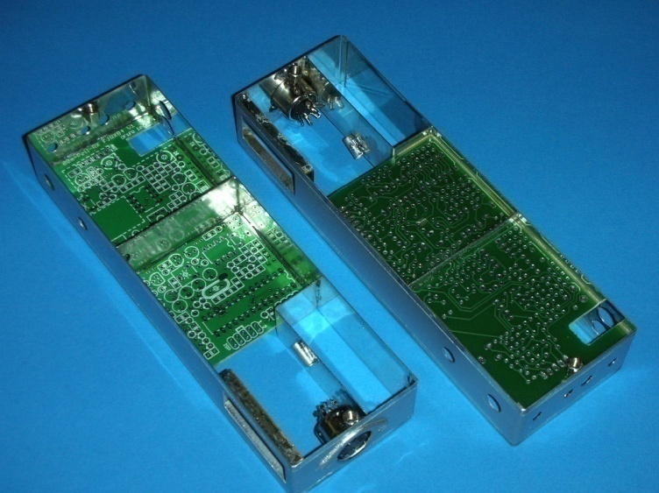

Next the frame can be spray-painted. Before painting, wash off all resin and fat with alcohol and roughen the surface with sandpaper. Mask off the edges of the frame that will be covered by the covers (about 3 mm on both sides of the frame), so that they remain blank for a good contact. Also mask off the inside of the receiver, so that the paint gets only to the outside of the frame. Put an old plug into the phone-jack.
The switches and rotary encoder are installed. If the ‘Taster 9141’ is used as Forward-/Backward-switch: fit it with a little epoxy glue.

E-Antenna

The E-antenna consists of a piece of tape measure of about 22 cm * 12 mm, a bracket, an isolated feed-through, and two screws and nuts. For the feed-through I use a transistor isolation nipple and an M5 nylon nut. The bracket has
3 mm holes 10 mm from the corner. The heads of the screws are soldered to the bracket to make the installation easier.

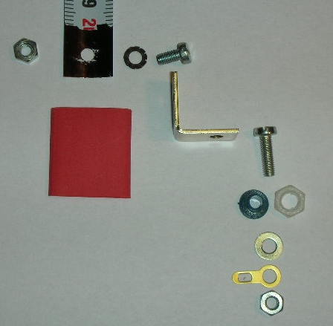
Mounting hardware for the E-Antenna

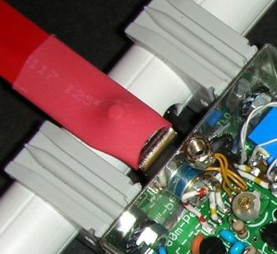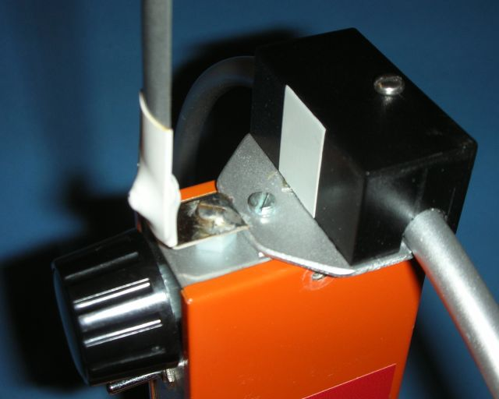
E-Antenna and Ferrite Antenna E-Antenna and Ferrite Antenna

Ferrite Antenna

The sensitivity of the receiver depends heavily on the ferrite rod. The first basic rule is: the bigger (longer and thicker) the rod, the better the sensitivity of the receiver. The second basic rule is: many rods look good, but the ferrite material is not suited for 3.6 MHz use and the sensitivity is bad.
If you have a collection of ferrite rods with unknown data, you should test them before deciding which one you will use for the receiver. To test them you will have to put W1 on the rod, it should have 80 to 90 µH. Connect it to the receiver, peak C16, receive a defined test-signal (from a signal generator with magnetic antenna in a defined distance), and compare the results.
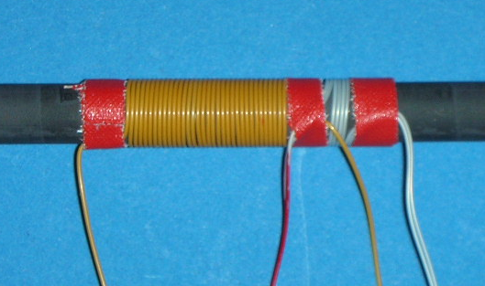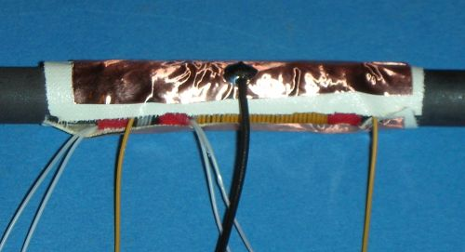
The windings on the ferrite rod are not critical. I am using thin isolated wire with 0.5 mm outer diameter (wire-wrap wire AWG30). Other thin solid or flexible wire can be used as well. W1 should have an inductance of 80 to 90 µH, the required number of turns is between 20 and 40, depending on the ferrite material and size of the rod you are using. W2 has 3+3 turns wound in parallel. Three 3mm wide strips of self-adhesive tape hold the ends of the windings. There are no windings under the tape, so the windings have 3mm distance from each other (left figure). The windings are secured with a thin layer of 2 component epoxy glue (‘Uhu Plus’).
The windings are then covered with one layer of self-adhesive tape (Tesaband), and a piece of copper foil completes the sandwich (right figure). The foil is a static shield against the transmitters E-field. The foil overlaps the windings on both sides by 5 mm, but has a 3mm gap. The gap prevents a magnetic shortening of the antenna, and also allows feeding through the connections to the wirings. A flexible wire is soldered to the shield, and will later be connected to ground.
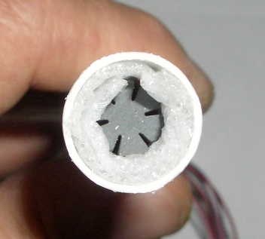
The ferrite rod is protected by a piece of PVC tube with 16 mm outer diameter. The wires are fed through a 4 mm hole 5mm off the center of the tube. The rod is centered and protected at both ends with foam material. A 20 mm piece of shrink tubing is shrunk over the 7 connecting wires.
Two 16mm brackets for the antenna tube are mounted on the receiver with M4 screws and nuts. Some brackets are a bit too wide and collide with the covers, so it might be necessary to file off the corners of the brackets.
Only after the receiver (and antenna) have been tested and work ok, the following should be completed: The ends of the PVC tube and the feed-through of the wires are filled with silicone rubber. The ends of the tube are covered with caps.
The PVC tube is glued to the brackets, so that it cannot move around accidentally and rip off the wires. This requires special plastic glue. I use ‘Pattex Blitz Plastik’, cyanoacrylate glue with a special activator for plastic.

Loop Antenna

While Germany is ‚Ferrite Rod Country‘, many receivers from Eastern Europe use a Loop Antenna. Because it is getting very difficult to find good ferrite rods, I have developed a loop antenna version of my receiver. It offers following advantages:
- all required materials easy to find
- receiver sensitivity at least as good as with the best ferrite rods (much better than with bad ones)
- mechanically more robust (ferrite rods are brittle and break easily)
- mounting a compass is easier (ferrite disturbs the earth magnetic field)
The disadvantages are that it is not easy to bend a brass tube into a perfect ring, and that the size of receiver with the antenna is larger.
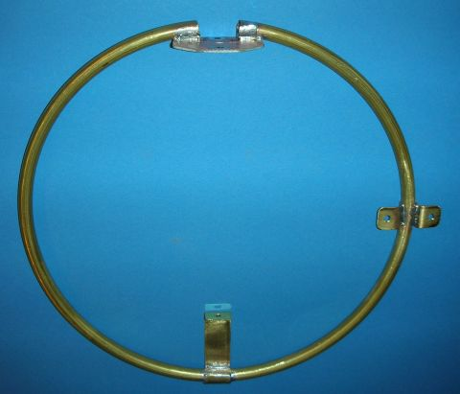
The loop antenna consists of a ring of 8mm diameter brass tube. Inside the tube is a cable with 10 conductors.
The diameter of the ring is 22 cm from center to center of the tube, The ring is connected with the bottom of the receiver with a 20mm wide strip of brass plate. At the top the ring has a 20mm gap. The two ends of the tube are soldered to a connection plate, which is screwed, together with a distance plate, to the top of the receiver. Electrically the ring is connected to the receiver only at the bottom, the top ends must be insulated. This is achieved by two solder islands on the connection plate
The photo also shows a compass mounting bracket soldered to the ring. (If you hold the receiver in your right hand, the compass should be installed on the left).

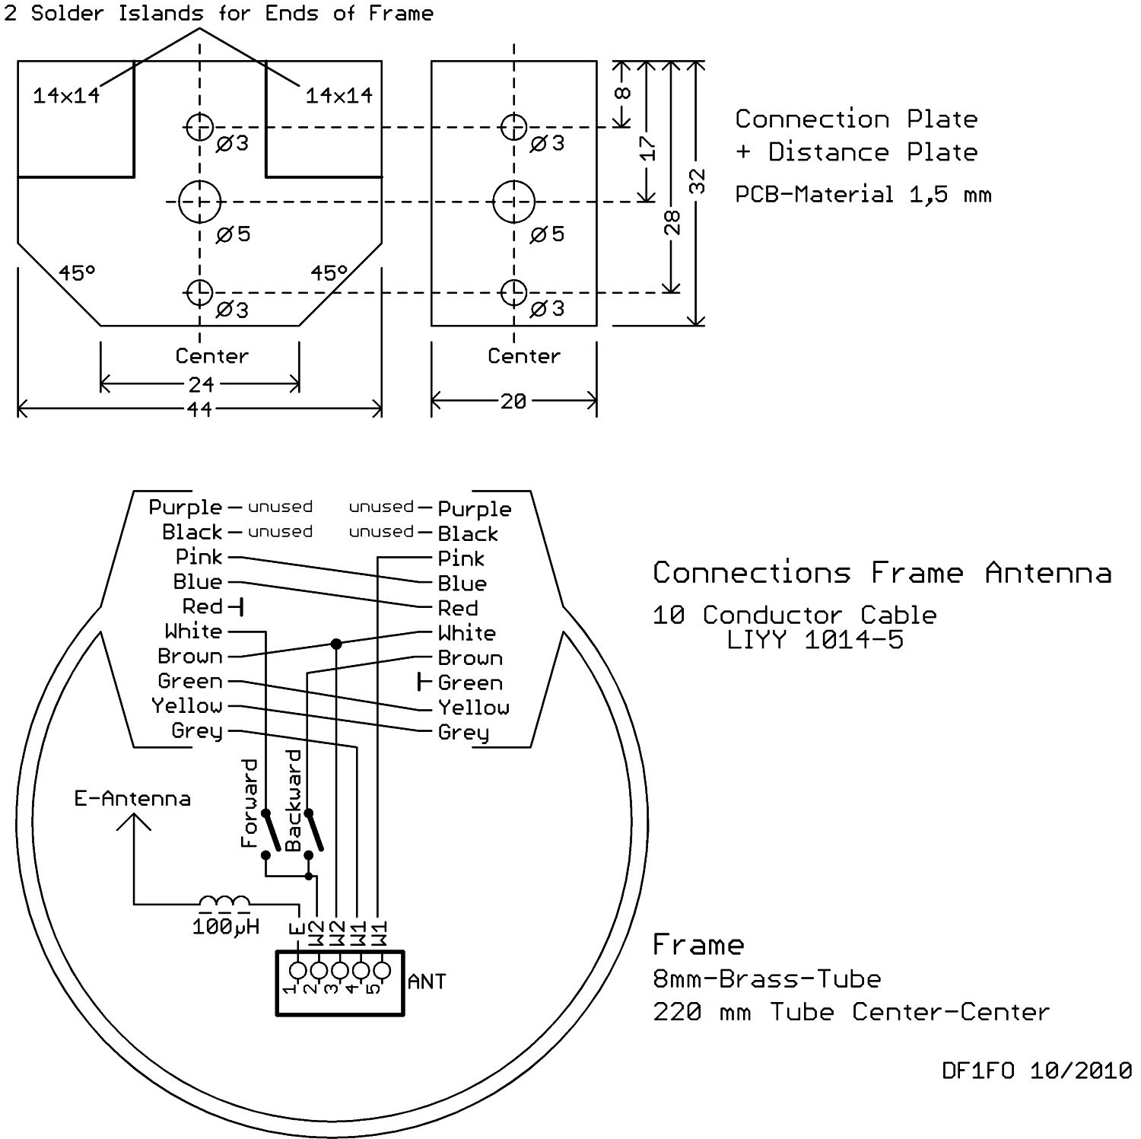
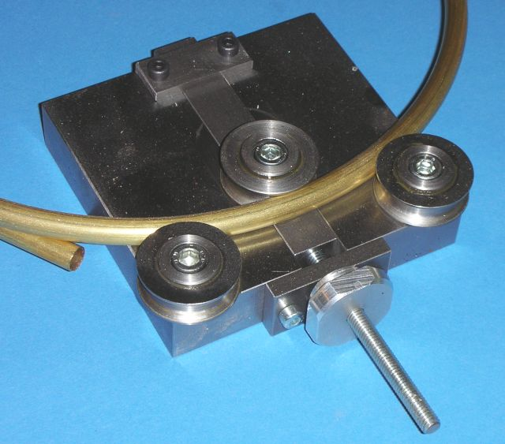
For bending the brass tube I use the tool built by Dietmar Henke, DJ3NJ, shown on the left.
The tube ends, because it is round, do not sit flat on the connection plate. I therefore place strips of brass plate bent into a ‚U‘ between tube and plate and solder everything together.
I have also built a receiver with an octagonal loop. The tube could be bent into this shape with an inexpensive bending tool (about 10 Euros at a hardware store). The octagon has 8 sides of 80mm each, the total width and height is about 19 cm center-center. Electrically this loop works just as well as the perfectly round version.
The mechanically completed loop is spray painted silver.

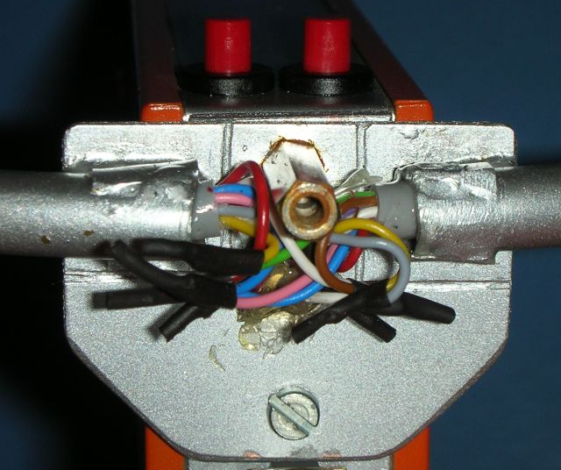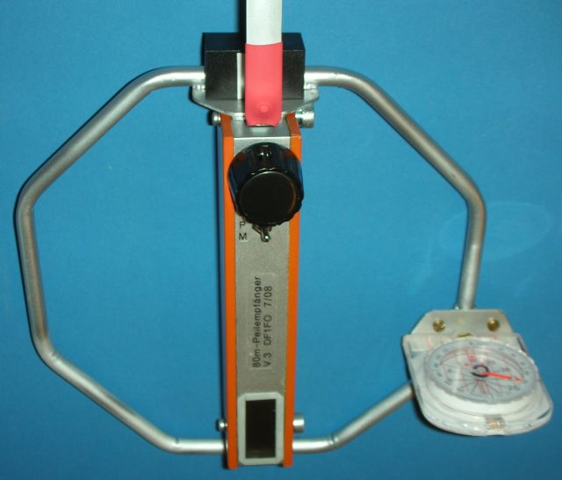
The loop is mounted on the top of the receiver with two M3-screws. They also do the ground connection between the connection board and the receiver. The bracket at the bottom of the plate is connected with receiver with an M3-flathead screw. Make sure, that the battery still fits into the battery holder.
The 10-conductor cable is pushed into the tube, some vaseline might help. This cable has two conductors, purple and black, in the center, and the other 8 conductors around them in the sequence shown. The connection scheme shown minimizes the influence of the conductor-to-conductor capacitances. The two ground connections (red, green) are soldered directly to the connection plate, the unused conductor end are insulated individually. The 5 connections to the receiver are fed through the 5mm hole.
Once the receiver has been tested and works ok you can seal the ends of the tube and the feedthrough hole with epoxy glue. The connections are covered with a plastic box 42x22x21mm. It has two U-shaped cut-outs for the loop, and is screwed to an M3 threaded stud.
Finally two small changes of the receiver are required for the loop antenna. Because the loop antenna has less inductivity, a 68pF capacitor must be soldered in parallel to C16. And because we need a bit more signal from the E-antenna, a 100µH-choke is placed between the E-antenna and the receiver input.
You should not mount the loop antenna, before you have completed the assembly of the receiver board – or you will be fighting with it all the time.

Loop Antenna Materials:
Brass tube 8x0,5mm, 1m long <Hardware Store, Conrad 297330>
10 conductor cable <Reichelt LiYY1014-5>
Plastic box 42x22x21 mm <Reichelt Teko L40>
10µH Choke <Reichelt L-MICC 100µ>
PCB Material 1,5mm, some brass plate or tin plate, mounting hardware
Display

The mechanical preparation of the display board has been described above.

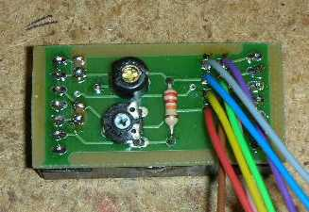
The components C91-93 and R91-92 are placed on the solder side – the side without placement print. For the 8 connections to the receiver board 8 pieces of flexible wire are soldered in. The wires are 60 mm long, and 2 mm of insulation is removed at each end. After soldering to the board all wires are cut very short on the placement side to avoid any shorts to the display.
Now to the preparation of the display: looking at the pin side you will see that part of its metal frame are 4 holders that are bent in and hold the board. Solder the holders to the golden islands on the board.

On one side of the display you can see a group of SMD resistors, and on the other side a single resistor. This single resistor sets the oscillator frequency. Solder a thin wire (about 0.2 mm) to the end of this resistor that points to the center of the display.

Now the display is placed on the display board, the thin wire goes through the square island near C93. The 14 display pins and the thin wire are soldered to the board. Finally the display frame is soldered to the ground plane on the board at the four corners.

The display assembly is mounted temporarily behind the display window. When the receiver is tested ok the display can be secured by soldering it to the display frame with 2 solder dots.

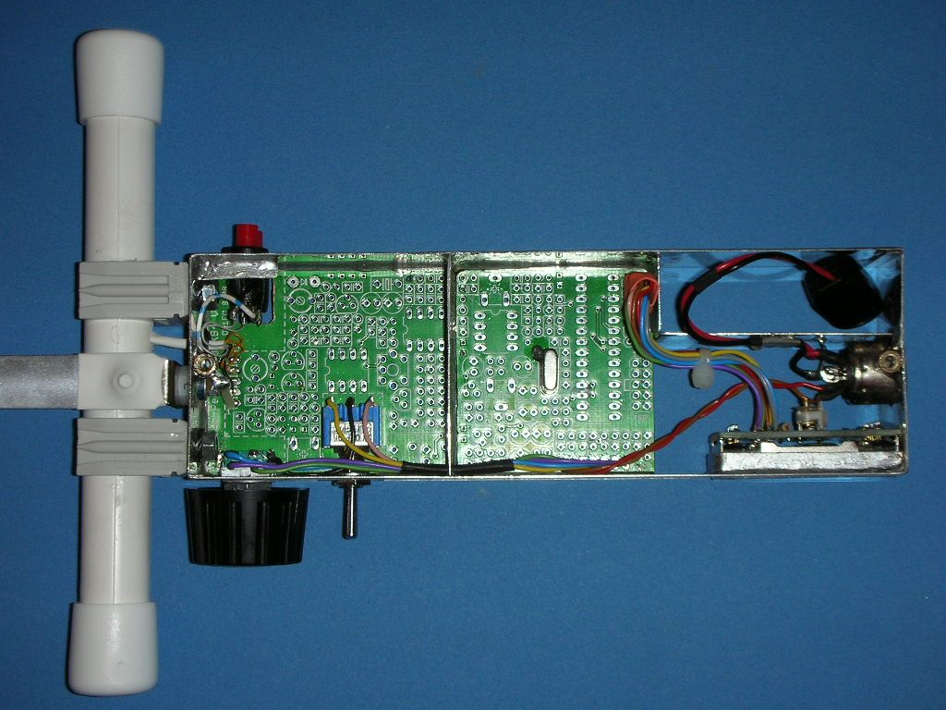

Placement
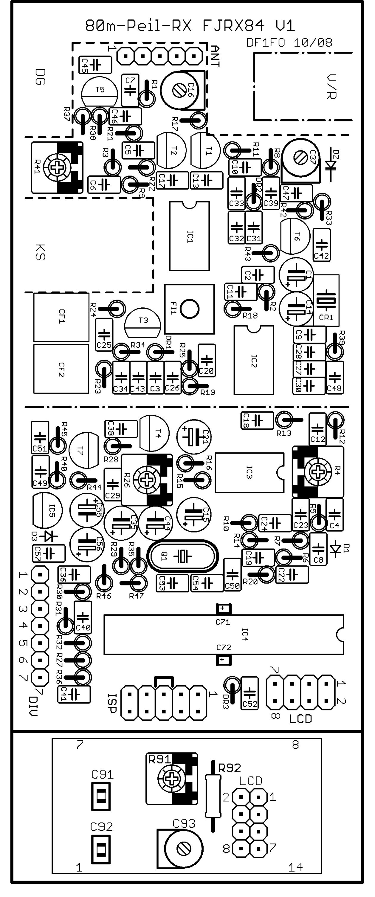
The board is double-sided, plated through, with solder stop mask and placement print

If you use 2 push-buttons for Forward/Backward: cut out the area marked with dash-dot-line

The SMD-Diode D2 is placed on the component side

Receiver board

Shield

C71 and C72 are SMD-Cs and are installed on the solder side between IC4 Pin7/8 resp. 21/22

----------------------------------------

Display board
Only the display is on the component side, all other parts are on the solder side!

Wiring and Board Assembly

All wire connections are made according to the circuit diagram. I use 0.14 mm² flexible wire. The battery leads are fed through a conductor sleeve soldered to the battery bracket for strain relief, and soldered to the headphone jack. The display wires are soldered to a 2*4 pin female connector that plugs into a 2*4 header on the receiver board.

Some other remarks on the wiring:
- For the toggle switch ‚Attenuator‘ is up, ‚Menu‘ down, and ‚Operate‘ center
- For the display a 2*4 male connector is soldered into the board, for ISP a 2*5 male connector
- All other connections are soldered directly (without connector) into the board.

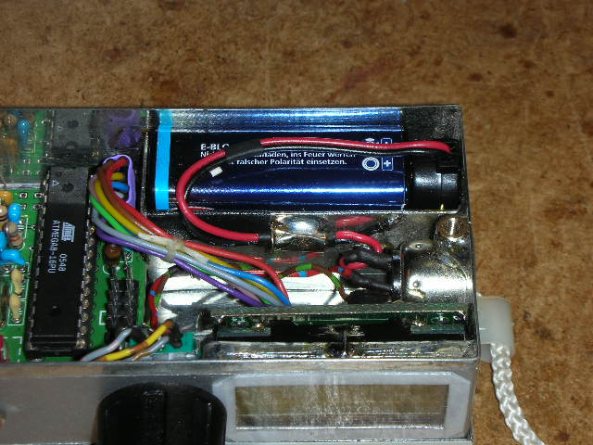

The input-stage-FETs T1/T2 should be matched to have similar source voltages. Therefore they have to be tested before assembly: connect Drain to +5V, Gate to Ground, and Source to a 3.3 kOhm resistor to Ground. Measure the voltage Source to Ground. Find 3 Transistors, for which the difference of this voltage is within 200 mV.
The other FETs are not critical.

Now the board is assembled starting from the antenna side. A few hints:

- The detailed parts list is at the end of this document.
- Use classical solder with 38-40%Pb and resin core. (No ROHS-solder!)
- The square solder islands are spare for later changes and not used.
- The very small round islands are vias and remain free.
- Sockets are used for all ICs, the ICs are plugged after assembly is complete.
- D2 is SMD, it is soldered to the component side of the board.
- The can of crystal Q1 is soldered to the island on the board with one solder dot.
- Capacitors C71 and C72 are SMD, they are soldered on the solder side between pins 7+8 resp. pins 21+22 of IC4.

To improve the shielding effect of the covers a contact is soldered to the middle of the shields on placement and solder side. I use contacts cut from a relay, bend them 90°, and position them so, that they make good contact with the covers (see photo on page 6).

To protect the display from rain and scratches a piece of clear plastic (from a blister pack) is installed in front of the display window with double-sided adhesive tape.

The three positions of the toggle switch are marked ‚Attenuator/Operate/Menu’ or just ‘A/O/M’. Everything else is self-explanatory.

Test and Alignment

All variable resistors are set to the center position. C16 and C37 are set to 50%, C93 to minimum C.
Plug in a headphone.
The receiver is connected to a regulated power-supply, a voltmeter on Pin 2 of the ISP connector measures the regulated voltage. Increase the supply voltage from 0 to 9 V, the regulated voltage should go up to close to 5.0 V and the supply current to about 25 mA (with a programmed processor).
If the processor is unprogrammed: plug a programming adapter to the ISP connector, load AVR Studio 4 and the assembler source code fjrx84.asm, program flash, and program the fuses as described in the source code.
Turn the receiver off and on again, you should hear a Morse ‚HI‘ ( .... .. ) in the headphones. This indicates that the processor is running and its EEPROM is still blank.
Adjust the display contrast with R91 for best readability. Test the function of toggle switch and rotary encoder.
To align the frequency regulation connect a voltmeter to the end of R35 that connects to C44 (it is accessible on the component side). Adjust C37 so that the measured tuning voltage for the total frequency range of 3,49-3,66 MHz is within 1,5-4,0 V.
If the frequency regulation does not lock: check the counter input signal at IC4/11 with an oscilloscope. There should be 3 MHz square wave signal with an amplitude of at least 3 V. The duty cycle should be about 50% at the 2V threshold. The duty cycle can be corrected by changing R45.
Now the receiver should be receiving on the 80m band. The frequency can be up to 10 kHz off, this will be corrected later.
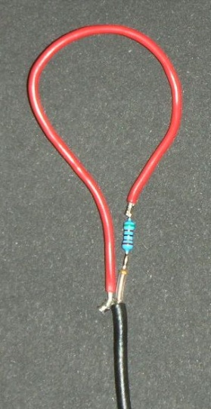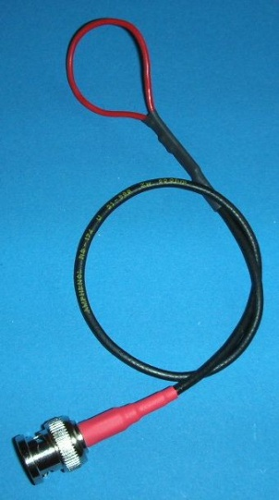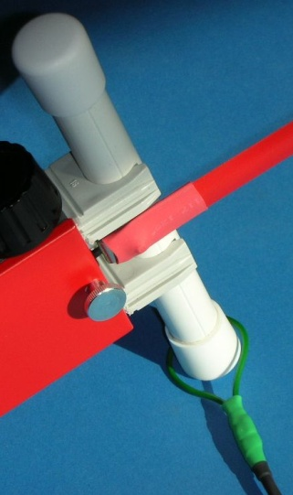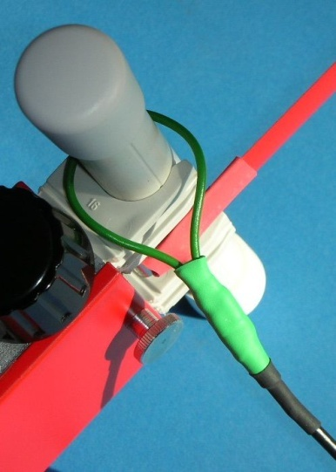
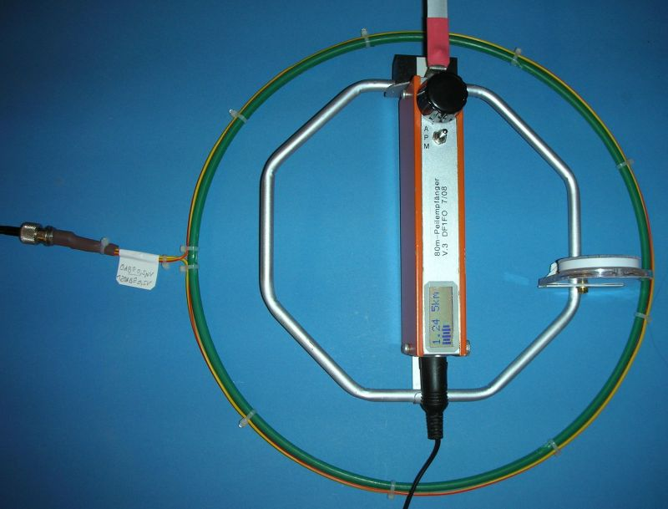
Coupling Loop Completed Loop Loose Coupling Close Coupling
Above: Coupling Loop for Ferrite Antenna

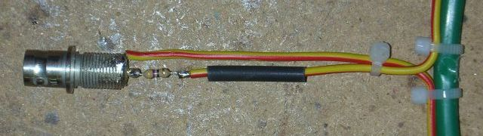
Left and below: Coupling Loop for Receivers with Loop Antenna
The further alignment of the receiver must be done during the day, when the band is quiet.
For the further alignment you need a signal generator with a stable CW output signal in the 80m band and a calibrated output attenuator with an output level range of 300nV to 500 mV.
To couple the signal generator into a receiver with a ferrite antenna prepare a coupling loop. It consists of a piece of thin coax, 12 cm of flexible wire, a 47 Ohm resistor and some shrink tubing, for details see the photos above.
For a receiver with a loop antenna prepare a coupling loop with a diameter of 30cm. I have used a plastic ring from a garden market. One end of the loop is connected to the center pin of a BNC jack through a 47 Ohm resistor, the other end to the shield of the jack. In operation the loop is placed flat on a (wooden) table, and the receiver in the center of the loop
Couple the generator signal (loosely) into the receiver. Set the signal generator level to 1 mV and the frequency of generator and receiver to about 3,570 MHz, so that the signal is audible in the receiver. Tune the antenna circuit with C16 to maximum S-meter indication.
Now replace the power supply by a 9V-battery and put the two covers in place to reduce receiver noise. Set attenuator to minimum by turning the rotary encoder to the left.
Ferrite Antenna: Push the coupling loop as far to the middle of the ferrite rod as the brackets allow (close coupling). Set the generator to 0,3 µV.
Loop Antenna: Place the receiver in the center of the coupling loop. Set the generator to 0,5 µV einstellen.
Tune FI1 to maximum S-Meter indication (the peak is pretty wide). Adjust R4 so that the S-Meter shows ¾ full scale.
Adjust R26 for a comfortable volume at 25% S-meter. The volume has to be pretty high, because you will be looking for the minimum volume at most times. The relative volume of the signal tones can be changed by changing R20.
Measure the BFO-frequency with a frequency counter connected with a high-impedance probe to IC2/7. The frequency should be 457,8 kHz. If it is more than 500 Hz off, change C27.
The display has an internal clock frequency of 250 kHz. It generates harmonics every 250 kHz. The 14th harmonic is typically close to 3580 kHz. In addition there are weaker signals (subharmonics) every 50 kHz. The signals can be heard in the receiver, when the covers are off. The clock is moved down by carefully increasing C93, so that the strong signal is outside the reception range, and weaker signals are at 3510, 3560 and 3610 kHz. With the covers installed, these signals should be barely audible.
Now start the Calibration menu by turning on the receiver with toggle switch to ‘Menu’ and rotary encoder pressed.
Select the desired Language of the menu texts: German, English or Dutch.
Select ‘Cal Vbat‘. Measure the battery voltage with a digital voltmeter. Press+turn to adjust the voltage indication in the display to the value shown by the DVM.
Set the signal generator and receiver to 3,570 MHz. Select ‘CalF’. Press+turn to tune the receiver to the generator signal. The audio frequency should be 800 Hz to 1 kHz.
Install the covers. Select ‘Cal Att Start‘ and click. Couple the signal generator (closely) to the receiver as described above. Set the signal generator to 0,3 µV for ferrite antenna, 0,5 µV for loop antenna. The S-meter indication should be ¾ (this was adjusted before with R4). Click, increase generator level by 10 db, adjust attenuator by turning so that the S-Meter is back at ¾. Repeat 11 times until 300mV resp. 500mV/120dB is reached. Click once more to complete the attenuator calibration.
Due to variations of the FETs it is possible, that the full attenuation of 120 dB (in the top range) cannot be reached. Since such a high attenuation is not needed in real life, set the attenuator to max (255) and forget it.
Select ‘BatWarng‘. Here the battery voltage warning level can be changed. For standard 9V batteries leave it at 7 Volts.
Ignore ‘CalDis’ for now, we will come back to it later.
Select ’FrqRange‘. The frequency range of the software can be extended to 3.8 MHz. However this is not supported by the oscillator hardware, so don’t change it.
Select ‘Save Cal Values’ and click to store all settings to the EEPROM. From now on you will hear a different power-on tone-sequence, and changes in the setup-menu will be retained over power-off. If in the future you change any parameters in the calibration menu, you must always save them with ‘Save Cal Values’.
Finally you should go through the calibration menu once more and write down all values, so that you can re-enter them if they are lost (which of course shouldn’t happen).
For the following two adjustments you have to go outside.
To align the Forward/Backward ratio you need a fox with an exactly vertical antenna in a distance of at least 100 m. Cut the tape-measure-E-antenna 1 cm at a time, until you have a clear minimum in the backward-direction. Fine-adjust the minimum with R41. The resulting length of the tape measure is typically between 12 and 20 cm for a ferrite antenna, and 20 cm for a loop antenna. If the minimum is in the forward instead of the backward direction, swap the connections between W2 and the F/B-switches. It is important, that for this adjustment the receiver is held in the same position as in an actual foxhunt – typically in front of your breast, not your eyes.
The actual Forward/Backward ratio seen during a hunt depends on the height of the receiver over ground and the conductivity of the ground. But under all circumstances you should be able to clearly distinguish the forward and backward directions.
Select ‘CalDis‘. Here a distance correction factor can be set, if the distance estimations are always too short or too far. You need a typical fox with typical antenna/ground in a distance of about 100m. PFox must be set correctly in the setup-menu, typically to 1W. Turn the receiver to the maximum direction, the attenuator adjusts automatically. Push+turn to set the indicated distance to the actual distance of 100m. Save setting with ‘Save Cal Values’.
Now you are ready for serious fox hunting. Good luck and have fun!

Further Information

The most up-to-date version of all documentation and software is on my homepage www.mydarc.de/df1fo

AVR-Code-Development: AVR-Studio 4 (www.atmel.com -> search for ‚AVR Studio 4‘)
Free registration required
Make the following settings in Studio 4:
  - Project -> Assembler Options: Assembler to „Version 2“
  - Tools -> Options -> Editor -> „Tabwidth“ 8
The Software is written completely in Assembler and available on my website: fjrx84.asm

AVR-Programmer: AT AVR ISP (Reichelt)

Circuit Diagram, layout and drawings were made with Eagle 4.15 (www.cadsoft.de)

Data Sheets for SA612 and TL082 can be found at www.alldatasheets.com

Data Sheet for ATMega168 (400 pages): www.atmel.com -> search for ‚ATMega168‘

Appendix: Parts List

Most parts are available from Reichelt. In <..> Reichelt order number or name of other supplier.

Parts on the Receiver PCB
CF1,2 # LT455ITU (Ceramicfilter 455 kHz) <DF1FO or Helpert>
CR1 # ZT465 (Ceramic-Resonator 465 kHz) <DF1FO or Conrad 540154>
FI1 # 455 kHz-Filter 7x7 mm black <DF1FO or Helpert>
D1 AA112 (Germanium Diode) <AA 112>
D2 # BB629 (VariCap Diode) <DF1FO>
D3 1N4001 <1N 4001>
DR1,3 # 10µH Miniature Choke <DF1FO or Conrad 535729>
DR2 # 47µH <DF1FO or Conrad 535761
IC1,2 SA612 (Mixer) or NE612/SA602/NE602 <NE 612 DIP>
IC3 TL082 (Dual-Op-Amp) <TL 082 DIP>
IC4 # ATmega 168 DIL (Processor) <Programmed: DF1FO>
- IC-Sockets 3 * 8-pin, 1 * 28-pin narrow <GS 8P, GS 28P-S>
IC5 LP2950CZ5 (Low-Drop-5V-Regulator) <LP 2950 CZ5>
Q1 10,24MHz Crystal HC49U <10,2400-HC49U-S>
T1,2,5,6 BF256b (FET) <BF 256B>
T3 BF256a (FET) <BF 256A>
T4,7 BF254 (HF-Transistor) <BF 254>
ISP Connector 2*5 male <SL 2X10G 2,54 (cut)>
LCD Connector 2*4 male

Cs: up to 220nF ceramic, from 1µF electrolytic
C1 10µ/35V  C2 100n  C3 100n  C4 100n  C5 100n  C6 100n  C7 100n  C8 220n  C9 100n  C10 100n  C11 100n  C12 4n7  C13 100n  C14 100µ/16V  C15 10µ/35V  C16 22p Trimmer  C17 100n  C18 1n  C19 100n  C20 47n  C21 10µF/35V  C22 100n  C23 1n  C24 220n  C25 100n  C26 10n  C27 680p | C28 2n2  C29 10n  C30 1n  C31 220p  C32 47p  C33 68p  C34 100n  C35 1µ/35V  C36 22n  C37 10p Trimmer  C38 220n  C39 100p  C40 22n  C41 22n  C42 100n  C43 100n  C44 10µ Tantal  C45 47p  C46 100n  C47 18p  C48 100n  C49 100n  C50 100n  C51 2n2  C52 100n  C53 18p  C54 18p | C55 100µ/16V  C56 100µ/16V  C57 100n  C71 100n SMD  C72 100n SMD  R1 33  R2 33  R3 33  R4 100k Trimmer  R5 10k  R6 100k  R7 100k  R8 33  R9 33  R10 22k  R11 3k3  R12 22k  R13 68k  R14 22k  R15 220  R16 100  R17 220k  R18 82k  R19 15k  R20 330k  R21 1M | R22 3k3  R23 10k  R24 3k3  R25 100k  R26 1k Trimmer  R27 2k2  R28 10k  R29 3k3  R30 2k2  R31 100  R32 2k2  R33 100k  R34 1k  R35 47k  R36 100  R37 1M  R38 1k  R39 10k  R40 33  R41 10k Trim.  R42 1M  R43 3k3  R44 3k3  R45 47k  R46 33k  R47 15k

Parts on the Display PCB
C91,92 100n SMD 0805
C93 5p Trimmer
R91 5k Trimmer
R92 22k 1/4W
X1 DIPS082 (Display 2 * 8 Chars.) <LCD MO82 DIP>
- Connector 2*4 female <BL 2X10G 2,54 (cut)>
Antenna
Ferrite rod, see text
PVC-Tube 16 mm, 2 Caps, 2 Holders <Hardware store>
Or Loop Antenna, see text
E-Antenna with isolated feed-through, see text
Other Parts
PCBs FJRX84 (Receiver and Display) <DF1FO>
Toggle Switch for F/B SP (On)/Off/(On) <MS500E>
or 2 Pushbuttons <TASTER 9141 or SDT 21S>
Rotary Encoder <STEC 11B01>
Knob 6mm, 28mm diameter, with cap <KNOPF 28-6 SW, DECKEL 28M SW>
Toggle Switch Mode SP (On)/Off/On <MS500D>
DIN-Jack 5-pole 180° for headphone <MAB 5S>
Battery-clip for 9V-Battery <CLIP HQ9V>
9V-Battery <Aldi, Penny>
Tinplate box 52 * 162 * 30 mm <DF1FO>
4 Threaded studs M3 * 5 mm <DI 5MM>
2 Thumb screws M3 * 6 (for top cover) <Conrad 998845 or 521859>
2 Screws M3 * 4 (for solder-side cover)
Some pieces of tinplate, wire, solder, some bits and pieces...

Shopping List: Rs and Cs with Reichelt order number (* = Value)
Ceramic C  <KERKO *>  3 18p  2 47p  1 68p  1 100p  1 220p  1 680p  <X7R-2,5 *>  3 1,0N  2 2,2N  1 4,7N  2 10N  3 22N  1 47N  23 100N  <Z5U-2,5 *>  3 220N | SMD C  4 X7R-G0805  100N  Variable C  1 TRIMMER  23508  1 TZ03 10P  1 TRIMMER  23209  Electrolytic C  1 RAD 1/63  3 RAD 10/35  1 TANTAL 10/16  3 RAD 100/16 | Resistor <1/4W *>  6 33  3 100  1 220  2 1,0k  3 2,2k  6 3,3k  4 10k  2 15k  4 22k  1 33k  2 47k  1 68k  1 82k  4 100k  1 220k  1 330k  3 1,0M | Variable R  <PT 6-L *>  1 1,0k  1 5,0k  1 10k  1 100k

The following parts are available from DF1FO:
PCBs FJRX84 12.50 € (for set of 2)
Tinplate box 4 €
2 Ceramic Filters LT455ITU 3 € (for 2)
Ceramic Resonator ZT465 0.50 €
VariCap Diode BB629 0.50 €
455 kHz-Filter 7x7 black 1.50 €
3 Chokes (2x10µH, 1x47µH) 1.50 € (for set of 3)
ATmega 168, programmed 4 €
Complete Set ‘Special Parts FJRX84‘ as above 27.50 €. I do not offer kits.
Please send questions or orders by Email to

