80m-ARDF-RX for Maximum Bearing

Nick Roethe, DF1FO

Minimum or Maximum Bearing?

80m direction finding receiver can find the direction to the transmitter in two different ways:
- Minimum bearing, which is sharp, but requires an additional forward/backward determination,
- Maximum bearing, which is wide, but unambiguous.
In Germany minimum bearing is used exclusively, but in other countries (Eastern Europe, Australia) the maximum method is quite popular.

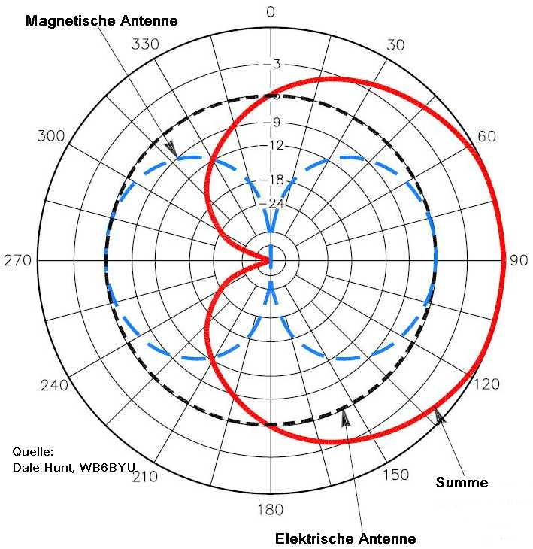

Diagram | Formula Antenna Voltage | -1dB Beam Width | -3dB Beam Width
Figure-8 | U_{a} = U_{amax} * |sin(α)| | ± 27° | ±45°
Cardioid | U_{a} = U_{amax} * (sin(α)+1) / 2 | ± 38° | ± 65°

Maximum- and Minimum ARDF receivers

The diagram above shows in blue the figure-8 directional diagram of the magnetic ferrite or loop antenna, in black the omnidirectional diagram of the electrical antenna, and in red the cardiod diagram, that results from the phase-correct addition of the magnetic and electric antenna voltages.
A Minimum-receiver uses primarily the figure-8 diagram, the cardioids diagram is used only temporary to resolve the forward/backward ambiguity. A Maximum-receiver uses primarily the cardioid diagram, the figure-8 diagram is used only for very exact bearings.
Discussion Minimum Bearing

While running only level differences of more than 3 dB are clearly distinguishable. In the minimum direction the antenna has to be turned just a few degrees to get such a level difference, whereas it takes +/- 65° in the maximum direction. Therefore the minimum bearing gives much more precise results, at least under ideal conditions.
In reality there are two limitations:
- For weak signals (e.g. foxoring) the minimum drowns in the noise floor.
- Real ground and surrounding can make the minimum less deep, wider or even deviating from the true direction.
The main disadvantage of the minimum bearing is its forward/backward ambiguity, resulting in a two step bearing process. It is time consuming, and under the stress of a contest even experienced foxhunters make mistakes, resulting in bearings 90° or 180° off. This is even more true for beginners.

Discussion Maximum Bearing

The problem of the Maximum receiver is the width of the maximum. Therefore these receivers must have an ‘acoustical S-Meter’. It produces a tone with a frequency that is controlled by the antenna voltage. This makes level differences down to less than 1 dB audible. At -1 dB the beam width is still +/- 38°. By turning the receiver to the left and right of the maximum and finding the middle between the slopes with a little experience the error can be reduced to +/- 20°.
The not very precise but fast and unambiguous maximum bearing is advantageous where seconds count, e.g. on the last few hundred meters to the fox and in Sprint contests. It is also the better method where signals are very weak, especially in Foxoring contests. Another advantage especially for my receivers is, that while heading for maximum the distance estimation is always up to date.
For very precise bearings, especially in Classic contests, the minimum bearing is clearly superior.

FJRX85 as Maximum Receiver

In order to get practical experience with a Maximum receiver I have built a prototyp. I have modified the design of my 80m-SMD-receiver FJRX85 as follows:
- The loop antenna is turned by 90°, so that the receiver in the ‘natural’ hand position (Display facing the user) points in the maximum direction.
- The electrical antenna is activated with a toggle switch instead of the push buttons. The two positions of the switch are marked ‘Max’ and ‘Min’.
- In Switch position ‚Max‘ (cardioid) an acoustical S-Meter is activated.
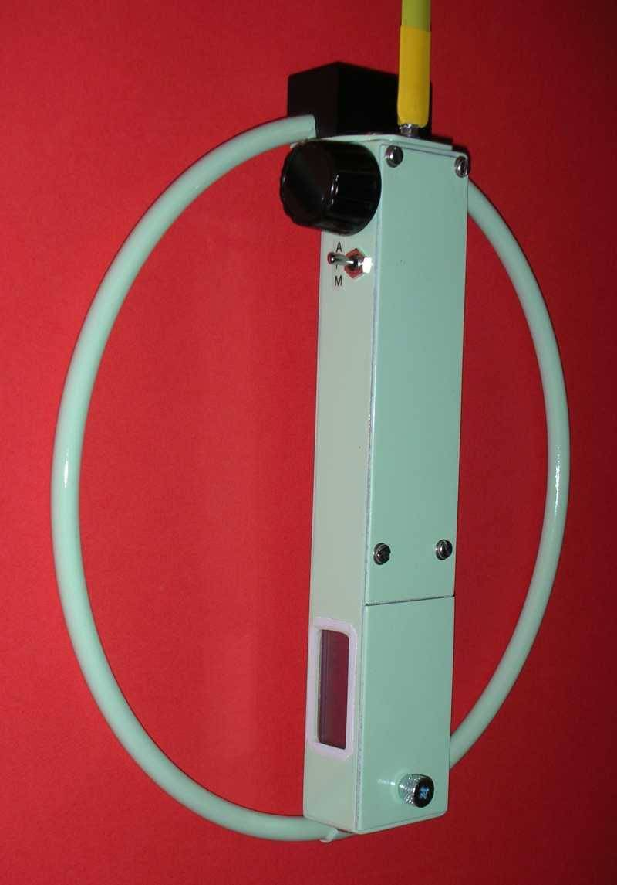
- In switch position ‚Min‘ (figure-8) precise minimum bearings can be taken.
Just to test the principle it admittedly would have been sufficient to install the toggle switch parallel to or instead of the F/B-push button.

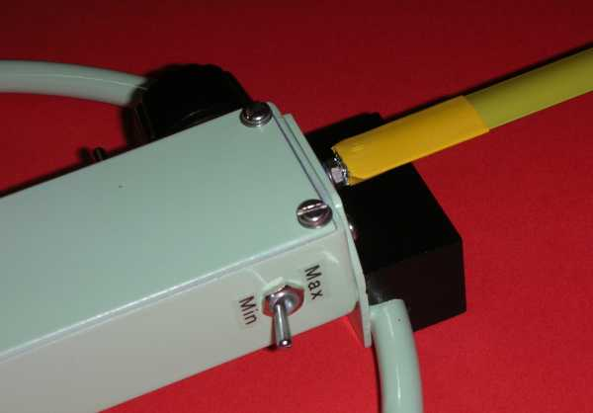

Software Changes

The current software version is ‚1.A‘. The most important addition is the acoustic S-Meter.
The former menu F/B-Zoom -> Off / On has been replaced by AcoustSM -> Off / F/B-Zoom / Maximum.
The acoustical S-Meter is activated when the selected mode is Maximum and the toggle switch is in the ‘Max’ position. It turns on at ¼ S-Meter, its frequency rises from 300 Hz to 3 kHz at S-Meter full scale. In the lowest attenuator position (maximum sensitivity) the tone sets in only above ½ S-Meter. The automatic attenuator works in both switch positions. In the ‘Max’ position the receiver sees a 6 dB higher input voltage, therefore in this case the distance estimation is reduced one step.
(For clarification: the Mode F/B-Zoom is totally different. After pressing the F/B-buttons the attenuator setting is frozen, and the receivers compares the input level after pressing the button to the maximum level in the 600 ms before. If the level is higher, a tone is generated with a frequency proportional to the level difference. If not, no tone. That makes it easier to find the forward direction.
There are some more improvements in the new software version:
- The automatic attenuator is less sensitive to static pulses.
- The click when pressing the F/B-buttons is suppressed.
- The Pfox menu has additional settings 0,3µW, 0,1µW, 30nW for weak Foxoring transmitters.
This version, of course, can also be used with Minimum receivers.

Test Results

Since October 2016 I use only this Maximum receiver for all types of 80m foxhunts (Classic, Sprint, Foxoring). If I need a precise bearing, especially in ‘Classic’ foxhunts, I first take a rough Maximum bearing, and then a Minimum bearing. It took a while, but now I am used to it.
The toggle-switch Min-Max is spring-loaded and returns to the Max-position. So the receiver is always in Max-mode, unless the switch is actively pressed down.

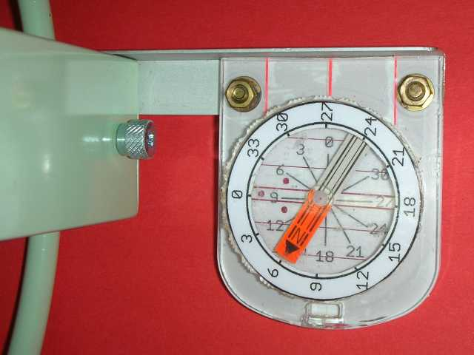

The compass mounted at the bottom of the receiver has two scales: an inner scale for the Maximum bearings, and an outer scale, rotated by 90°, for the Minimum bearings.

