Advanced 80m-ARDF-Receiver using SMD-Components (Version 5)

Nick Roethe, DF1FO, 

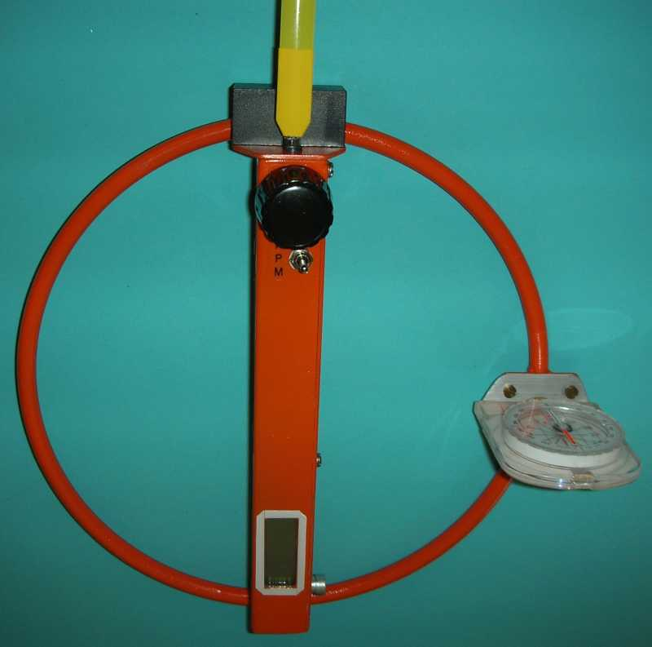

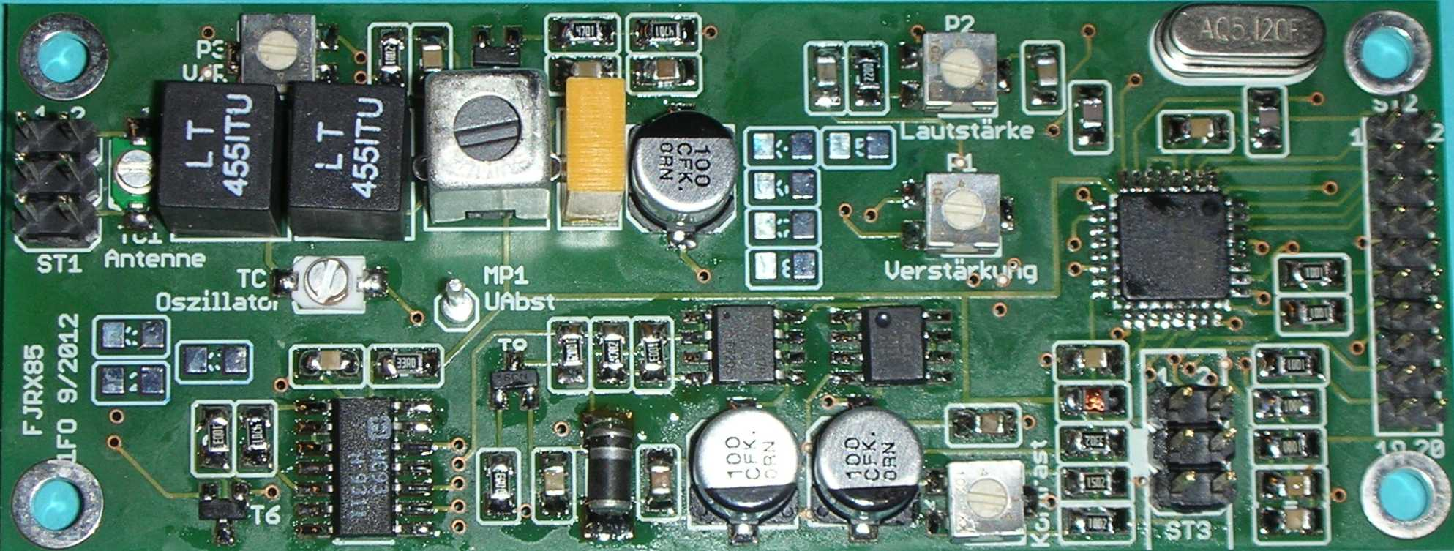

Overview

The receiver described in this document is an SMD-version of the previous (Version 4) design, as described in fjrx84eng.doc.
This is an incomplete version of the original documentation in German fjrx85.doc. I wrote this translation mainly for a Canadian friend who understands my previous designs very well, and I have translated only what is necessary and useful for him.
This receiver version uses a 4-layer PCB with the same size (35x90 mm) and connector (2x10 pins, 2mm pitch) as my 2m-SMD-receiver. It is housed in a 21x4x2,5 cm box made from PCB epoxy material.
Using SMD components brings two main advantages:
- smaller size, and
- less noise radiated from the processor to the antenna.
Main changes to Version 4 are:
- an electronic battery switch, and
- a divider reducing the Atmel VCO counter input frequency to ½.
The divider makes it possible to reduce the Atmel clock to ½, resulting in less power and less noise. The LCD display is clocked with the VCO frequency divided by 16 to eliminate the LCD clock ‚birdies‘ of the previous design.
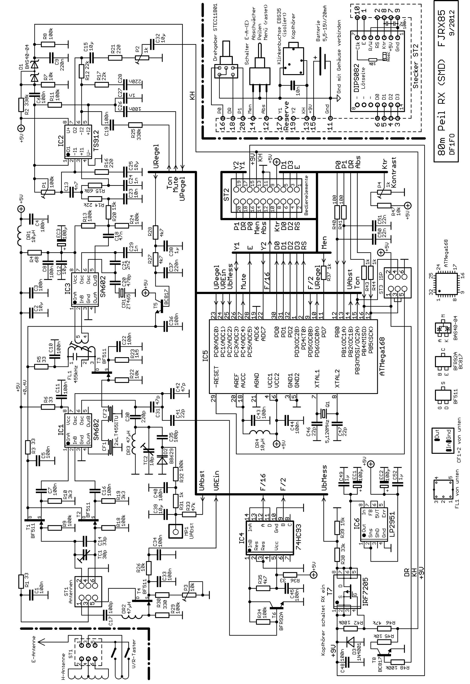
Translation of some terms used in the schematic

Abschwächer Attenuator
Drehgeber Rotary Encoder
Kopfhörer schaltet RX ein Headphone turns on RX
Gnd mit Gehäuse verbinden Connect Ground to Enclosure
Peilen Direction Finding
Schalter Switch
UAbst Tuning Voltage
UbMess Battery Voltage Measurement
UPegel Level Indicator Voltage
URegel Gain Control
von unten Bottom view
V/R-Taster F/B-Buttons

Circuit Description

See the schematic on the previous page.
Most of the receiver circuitry is identical to the Version 4 receiver, except that SMD components are used, and will not be described here. The differences are:
The AF amplifier now uses a rail-to-rail dual Op-Amp TS912 for less AF distortion.
The 74HC93 divides the VCO frequency by 2 to about 1,5 MHz for the counter in the Atmel and by 16 to about 200 kHz as external clock for the LCD display. The Atmel clock crystal now is 5,12 MHz instead of 10,24 MHz.
Transistor T7 turns on the receiver when the headphone is plugged. When it is unplugged, T8 keeps the receiver on. To turn if off the rotary encoder button must be pressed (signal DR). If you forget that, the receiver will turn itself off an adjustable time (10 to 70 minutes) after the last operation of the rotary encoder.

Circuit Board Layout
The PCB has 4 layers and a size of 35 x 90 mm. The top side carries the processor, power supply, all non-SMD-components and all adjustable Rs and Cs. The RF- and AF-stages are on the bottom side of the PCB. Wiring Layer 3 is a ground plane and shields the analog from digital side of the board
Top, Digital/Power
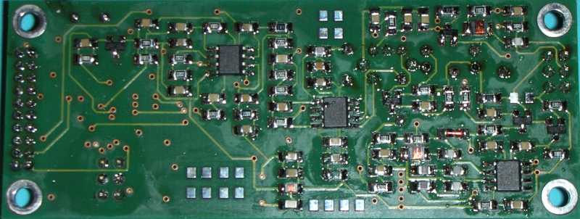 Bottom, Analog

Mechanical Construction
The receiver enclosure is made from epoxy PCB material, its outer dimensions are 208x41x25mm. The PCB is mounted with four M3 x 5mm threaded studs. The following pictures give an overview of the design.
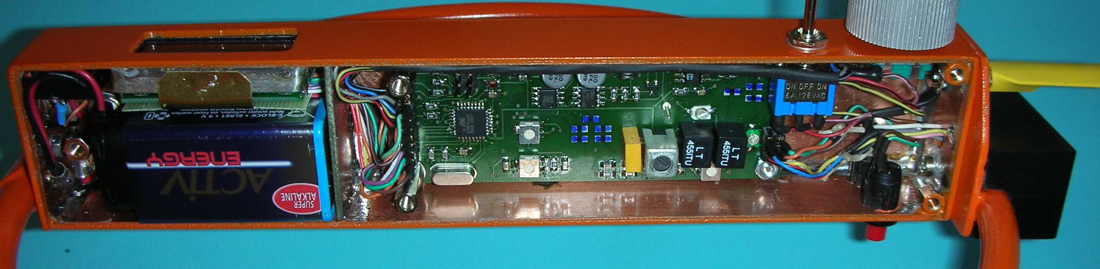
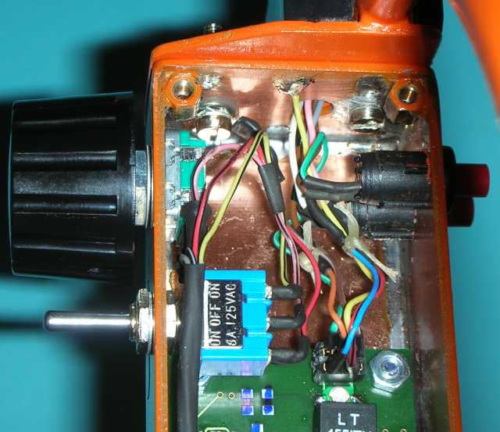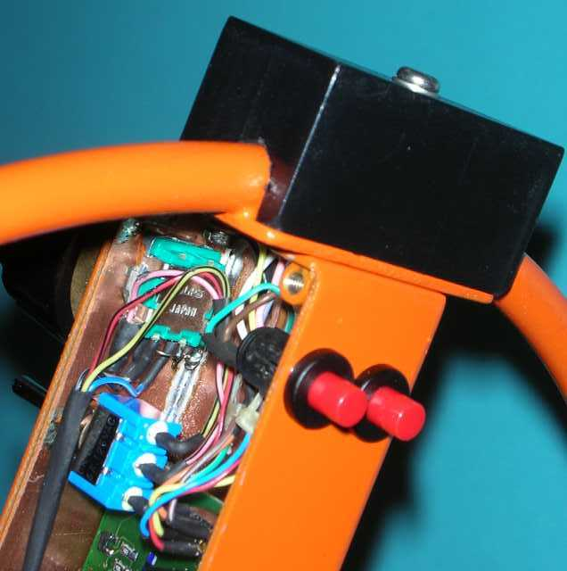
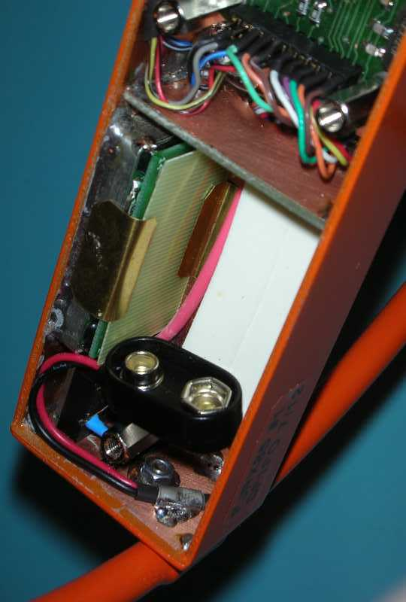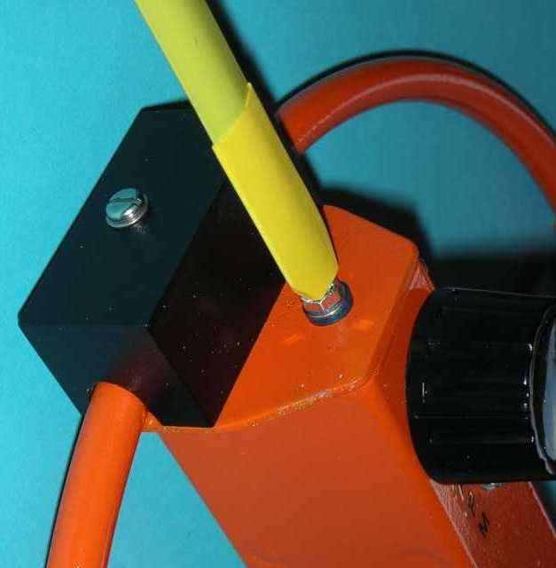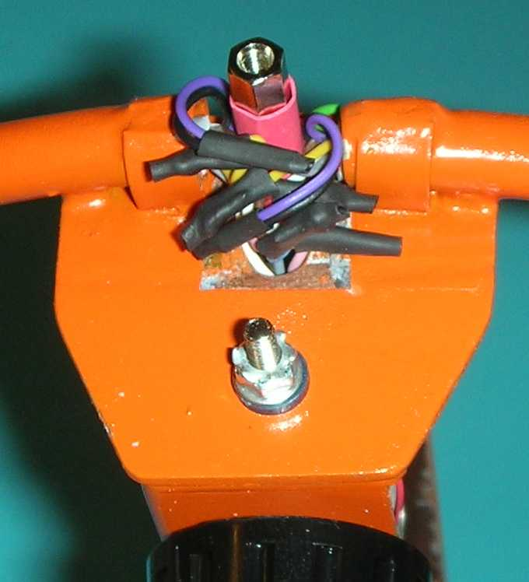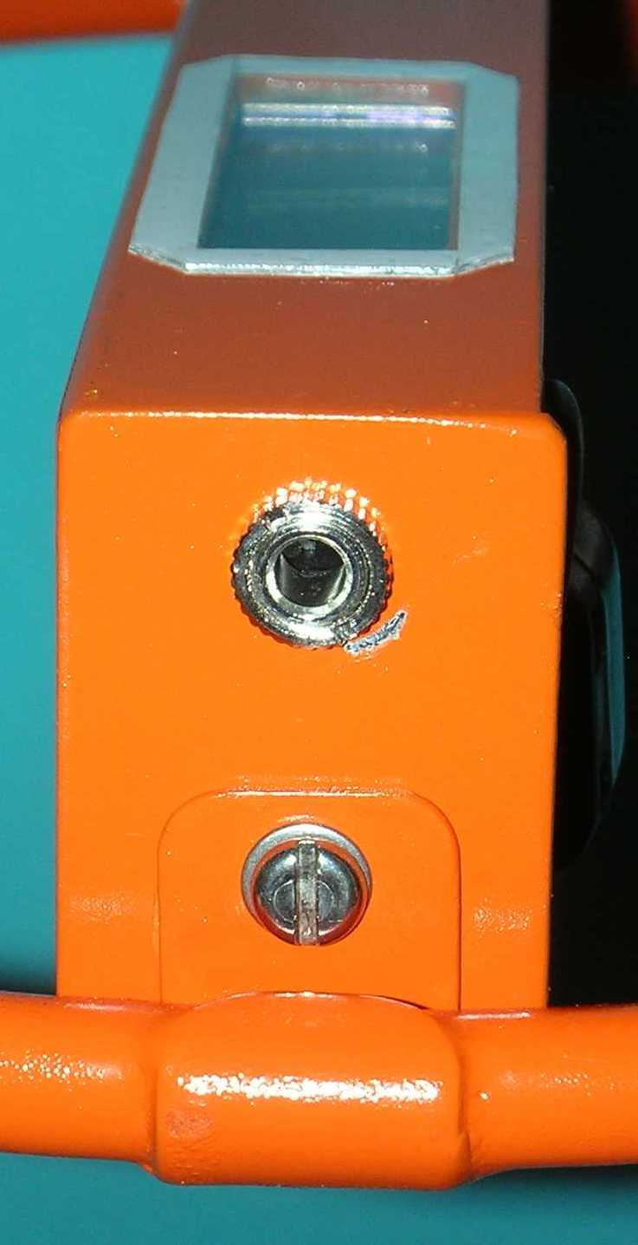

Operation Overview (Software-Version FJRX85 V1.A)

Switch | Function | Display
Operate | < > Attenuator +/-5dB  <*> Frequency +/- 100 Hz  ** Next Frequency #  a Reduce Attenuation  A Auto-Attenuator On/Off | Fox-Timer  Estimated Distance  S-Meter  1-4 Dots: Frequency #  * = Auto-Attenuator Off
Menu | < > Select Menu Item | Frequency  Clock (h:mm)  Battery Voltage
_______________________|
↓ Main Menu, Exit with Switch => Operate, Displays Memory Name
Menu Item | Function
Change Freq. | * Start ==> | < > Frequency +/- 1 kHz  <*> Frequency +/- 100 Hz  * Next Frequency #
Memory | <*> Switch between the 6 Memories (*1)  * Show Memory Overview: N_Fox, T_Fox, P_Fox
Clk Start | * Restart Clock at 0:00
Tmr Start | * Restart Fox Timer  <*> Change current Fox # (*2)
Setup Menu | * Start Setup Menu ==> | < > Select Menu Item
________________________________________________|
↓ Setup Menu, Exit with Switch => Operate, Displays Memory Name
N Foxes | <*> # of Foxes 1..10 (1 = Foxoring) (*3)
T Fox s | <*> Fox transmit time 1..99 sec
T Fox ms | <*> Fox transmit time +/- 20 msec
P Fox | <*> Fox output power 1 µW - 30 W, dB only (*4)
N Freq | <*> # of frequencies used 1..4, 12**A3, 1x2**A3 (*5)
T Alarm | <*>Alarmtime 1 - 30 sec before end of transmission (0 = Off)
AcoustSM | <*> Acoustic S-Meter Off / F/B-Zoom / Maximum (*6)
NearTone | <*> Proximity Warning for distances 300..30m, Off (*7)
Rotary Encoder
< > Turn
<*> Push + Turn
* Click
** Double-Click
Switch to ‘Attenuator’
a Click
A Push Long
Calibration Menu Start: Turn on RX while * and switch at Menu
Language  EEPROM Reset  Cal VBat  CalF  Cal Att Start  BatAlarm  Cal Dist  Auto Off  Save Cal Values  Change Names | <*> Select Deutsch/English  * Reset all Calibration and Setup values  <*> Calibrate battery voltage measurement  <*> Adjust Frequency Offset +/- 0..9,9 kHz  * Calibrate Attenuator in 23 5dB-Steps  <*> Adjust Battery Alarm Threshold 5,8..8,0 V  <*> Adjust Distance Estimation –5..+5 (x 5 dB)  <*> Adjust Auto Power Off time 0-70 minutes (0=Off)  * Store calibration values to EEPROM  * Change Start-Name + Memory Names 1..6 (*8)

The previous page gives a complete overview of all menus. The user interface, 3-position switch, rotary encoder, LCD-display and most of the menus is the same as on all my previous receivers. There are a few new menu items: Select Memory, Activate Proximity Warning, Change Memory Name. Also new is the ‘Locked’ mechanism described below. The Battery Alarm now sounds for the first time 12 secs after power-on, and then every 10 Minutes.
The following footnotes explain some of the more complicated details:
(*1) Memory
The receiver has 6 Setup-Memories, that can be used to store the basic settings for different kinds of contests, e.g. Classic, Sprint, Foxoring. Each of the Memories stores all settings from the Setup-Menu and the up to 4 Frequencies. Every Memory has a name of up to 8 characters. The Memories will be initialized to standard values at the first power-on of the receiver (or by ‘EEPROM Reset’), but from then on will always remember the last setting for this Memory. Changing to another Memory restarts the fox timer!
(*2) Synchronizing the Fox-Timer
Standard: Competitor starts with start of transmission Fox 1. RX is turned on at Start, Fox-Timer is synchronous.
Manual synchronization, Menu item ‚TmrStart‘: Start Timer with * at start of transmission of any fox, then adjust Fox # with <*>.
(*3) N Foxes = Foxoring
For Foxoring set N Foxes to Foxoring. This turns off Fox Timer and Alarm, the display shows the Clock
(*4): P Fox = ‘dB only’
The distance estimation is turned off, the display shows the current attenuator value in dB, NearTone is off.
(*5) N Freq Special Modes 12**A3, 1x2**A3
These two special modes can be used for (Czech style) fox hunts with two sets of foxes on two separate frequencies, plus a beacon on a third frequency.
Mode 12**A3: ** switches between F1 and F2,
** + A-Button switches to F3
Mode 1x2**A3: the same, but the receiver remembers for each of the foxes the frequency last selected
(i.e. F1 or F2) and restores it at start of transmission
(*6) Acoustic S-Meter
Here three different modes of operation of the Acoustic S-Meter can be selected:
F/B-Zoom: The Forward/Backward-Distinction based on loudness is sometimes difficult. The F/B-Zoom makes it easier: when the F- or B-button is pressed, the receiver compares the signal-strength to the value before it was pressed. If the signal got stronger, the receiver generates a tone. Its frequency increases with increasing signal strength delta. When you hear this sound, the button currently pressed shows to the fox.
Maximum: When the Min/Max-switch is in the Max-position, resp. when the F/B-buttons are pressed, the acoustic S-Meter generates a tone with a frequency that depends on the S-Meter indication. The tone sets in at ¼ S-Meter with 300 Hz, and rises to 3 kHz at fullscale. This mode is needed for maximum receivers.
Off: no acoustic S-Meter
(*7) Proximity Warning Near Tone
The Near Tone is an acoustic indication of the distance to the fox. It is based on the estimated distance as shown in the display. It sets in at an adjustable distance of 300m to 20m. The warning is a short low tone every 4 sec. As you get closer this becomes a double and finally triple tone. In the menu item Near Tone the distances for single and triple tone are set and shown, and also Near Tone can be turned off .
(*8) Names-Editor
The Names-Editor is started in the Calibration menu item ‘Change Names’ with * . Now you can edit the Start Name, that will briefly be shown in the display after power-on. With * you can switch on through the 6 Memory names and finally leave the Names-Editor. To edit a name select one of the 8 characters with < >. It flashes and is also shown in the right top display position. You can change it with <*> . Available characters are: Blank 0..9 A..Z a..z
EEPROM ?
After the first power-on you will see ‘EEPROM ? A^=Reset‘ on the display, indicating that the EEPROM is invalid. Press the switch to the Attenuator position until the display shows ‚Total Reset‘. All Memories and calibration Values will be reset to initial values.
Should you see this display in normal operation (that should not happen!): try to turn the receiver off and on again.
Locking the Receiver

The receiver can be locked against accidental operation. It is locked and unlocked with A + * (push attenuator switch and push rotary encoder long). When locked the automatic attenuator is always on, and the menus are not available. The locked state is indicated by a key in the display.
I use this feature when I give the receiver to a newcomer: I do all necessary settings and lock the receiver before I hand it over. The following table shows the operation in the locked mode:

Switch | Function | Display
Operate | < > Attenuator +/- 5 dB  ** Next Frequency #  a Reduce Attenuation | Fox-Timer  Estimated Distance  S-Meter  1-4 Dots: Frequency #
Menu | None | Frequency  Clock (h:mm)  Battery Voltage
Rotary Encoder
< > Turn
** Double Click
Switch to ‘Attenuator’
a Click

Building the Receiver - Assembly of the Circuit Board

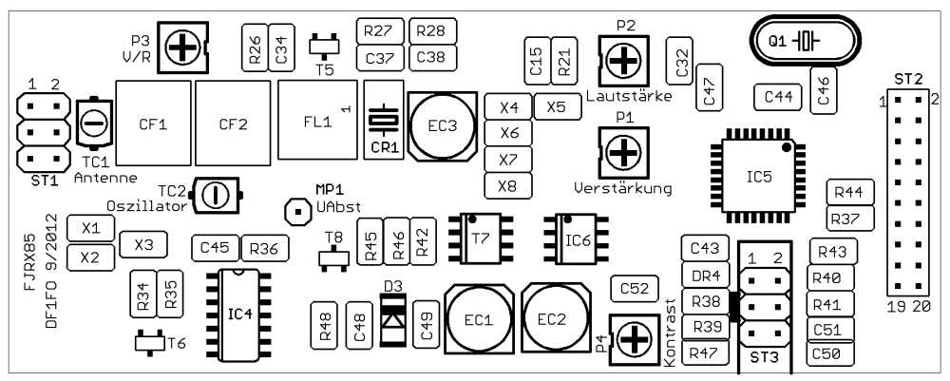 Top
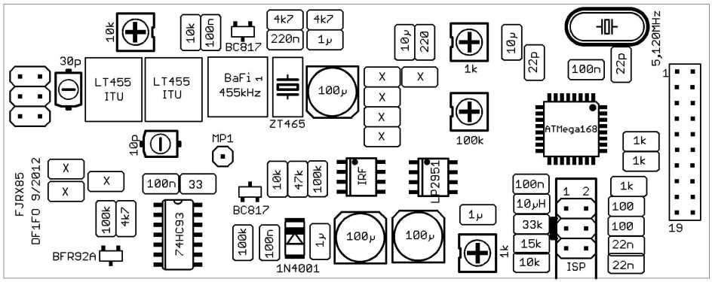
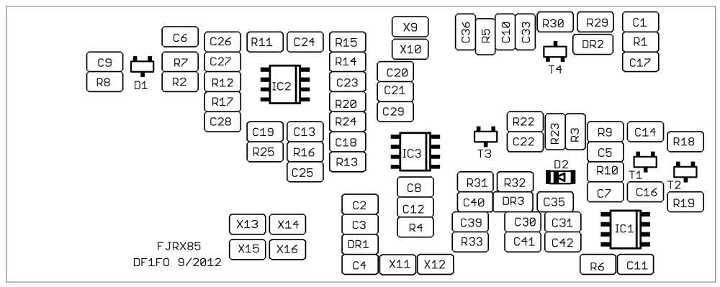 Bottom
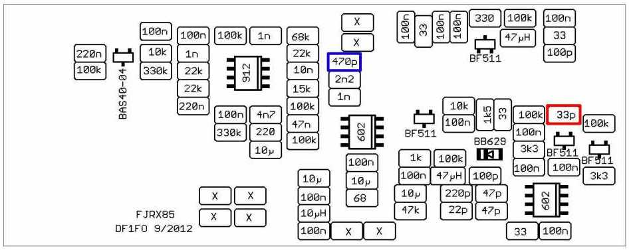
X = Spare positions, unused
C14 / 33p = loop antenna only, not for ferrite antenna C20 / 470p = must be matched to ceramic resonator
Enclosure and Antenna

Please refer to the German Version 5 documentation for detailed plans of the enclosures I have built for the loop and ferrite antenna version of this receiver. Details of the antenna construction can also be found there or in the English documentation of the Version 4 receiver. They all use the same antenna designs.

Display
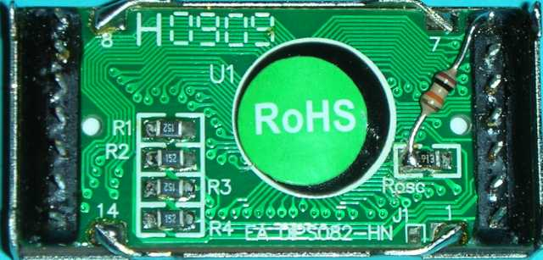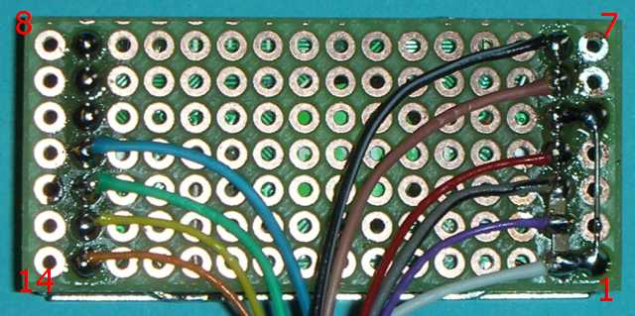
Before the Display is installed a 10kOhm miniature resistor is soldered between pin 7 and the left end of Rosc. This allows the external clock, connected to Pin 7, to override the internal oscillator. Then the display is soldered on a piece of perforated board. two 100nF SMD-Cs are soldered between Pins 1+2 and 2+3, and Pin1 is connected with Pin 5, as shown in the schematic.

Connector ST1
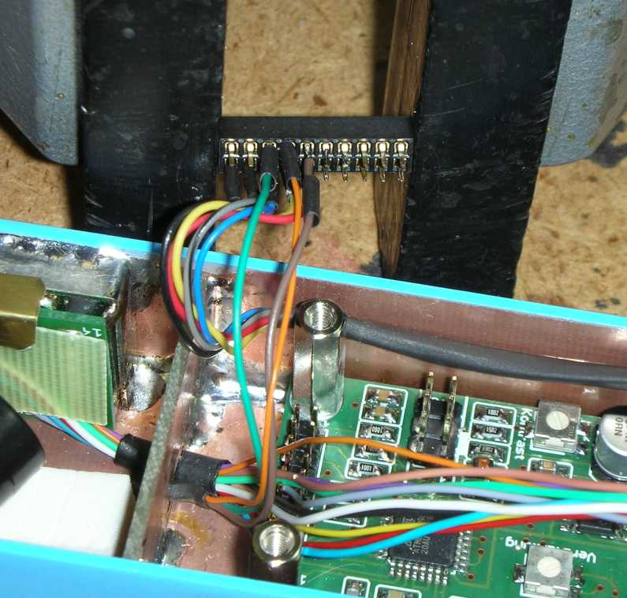
Please be careful when soldering wires to the 2x10 connector. Solder tends to flow into the connector by gravity, if it is plugged onto the PCB. Better hold it horizontally for soldering, as shown in the photo.

Test and Alignment

Set all variable resistors to the center position.
Connect the receiver with headphone plugged to a variable power supply. Measure the 5V voltage at ISP Pin 2. Slowly increase the supply voltage from 0 to 9 V. Now the 5V should be within +/- 100mV, and the supply current less than 20 mA.
If the processor is un-programmed: plug the ISP-cable to ST3. Program the Fuses as described in FJRX85.asm. Assemble the source file FJRX85.asm and program the Flash memory.
This design uses the 6-pin ISP-connector, most of my previous design used the 10-pin. If you have a 10-pin programmer you will need an adapter cable as follows:
6 Pins | 10 Pins | Signal
2  6  4  1  3  5 | 2  4,6,8,10  1  9  7  5 | +5V  Gnd  MOSI  MISO  SCK  Reset

If this is the first power-on after programming the processor you will now see the message ‚EEPROM ? A^=Reset‘. Press the switch to the Attenuator position until you see the message ‚Total Reset‘. Now all Calibration values and setup memories are reset to initial values.
Set P4 for best readability of the display.
Check the function of toggle switch and rotary encoder.
To adjust the VCO range connect a Voltmeter to TP1. Set TC2 so that the measured tuning voltage for the complete tuning range 3,49-3,66 MHz is within 1,2-4,0 Volts.
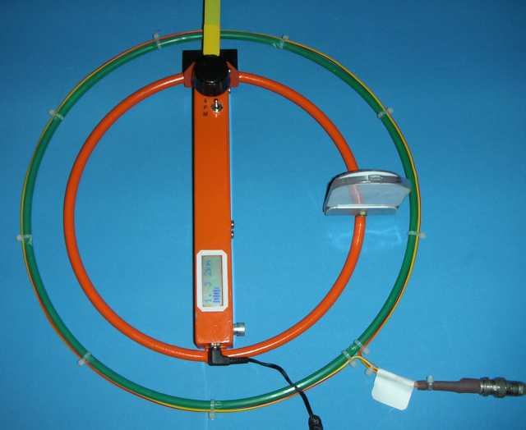

Left and below:
Coupling loop for receivers with loop antenna
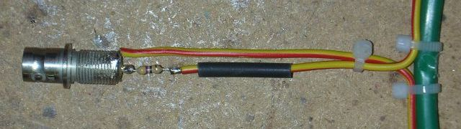

Now you have to couple the signal from a stable signal generator into the receiver antenna. I use a coupling loop with 30 cm diameter as shown above. A 47 Ω resistor in series with the loop matches it to the generator.
Set the generator level to 3 µV, and generator and receiver frequency to 3,570 MHz. You should now hear the signal, otherwise try to adjust the receiver frequency. Tune the antenna with TC1 for maximum S-Meter indication.
Now install the 9V battery. Open the attenuator fully to 0dB. Set generator level to 0,5 µV.
Adjust IF-Filter FL1 for maximum S-Meter indication. Adjust gain with P1 for ¾ S-Meter indication.
Adjust the AF level with P2 so that the signal is clearly audible even at only ¼ S-Meter indication. This setting depends on the headphone used.
Measure the frequency of the BFO as follows: Set the generator to 458 kHz and 10 mV level. You will hear a beat frequency. Adjust the generator frequency to zero beat. It should now be 457,8 kHz +/- 500 Hz.
If it is further off adjust the BFO frequency by changing C20. (+/- 100 pF gives about -/+ 1 kHz).

Start the Calibration menu (Power-on with switch in Menu position and encoder pressed)
Select Language: Deutsch or English.
Select ‚Cal Vbat’. Measure battery voltage with Voltmeter. Adjust (push+turn) the voltage shown in the display to this value.
Set receiver and generator to 3,570 MHz. Select ‚CalF’. Adjust this parameter so that the audio signal has a frequency of about 800 Hz.
Select ‚CalAtt Start’ and click. Couple generator as described above, set level to 0,5 µV. You should now have ¾ S-Meter indication (see gain adjustment above). Click, increase generator level by 5 dB, set encoder for ¾ S-Meter. Repeat this step 22 times until 110 dB attenuation and 160 mV generator level have been reached. Click once more to leave CalAtt.
Select ‚BatAlarm’ and adjust the battery alarm threshold to the desired voltage. For 9V batteries set to 7,0 V.
Select ‚Auto Off‘ and set the desired time for automatic power-off (after the last operation of the rotary encoder and only if no headphone is connected!). Recommendation: 30 minutes.
Select ‘Save Cal Values’ and click to store all calibration values into the EEPROM.
Menu item ‘Change Names’ has been described above – see ‘Names Editor’.
In case of big problems: Menu item ‚EEPROM Reset‘ sets the receiver back into the initial state.
Finally there are two adjustments that can only be done outside and with a real transmitter,
To adjust the F/B-ratio you need a fox with an absolutely vertical antenna in a distance of about 100 m. Hold the receiver in the same height as in a real foxhunt. Set P3 for the best minimum in the Backwards-direction. If the adjustment range of P3 is not suffixcient, change the length of the electrical antenna. If the minimum is in the forward instead of the backward direction swap the wires to the F/B-buttons.
My prototypes have a weak birdie on 3,565 MHz. At this frequency the difference between the processor clock (5,12 MHz) and the 3rd harmonic of the VCO frequency divided by 2 (4,66 MHz) is the receivers IF.

Parts List
Parts on the PCB Supplier and part number in <..> brackets.
- Printed Circuit Board FJRX85 <E. g. Multi CB>
CF1,2 LT455ITU (Ceramic Filter 455 kHz) <Helpert (*1)>
CR1 ZT465 (Ceramic Resonator 465 kHz) <Conrad 540154>
D1 BAS40-04 SOT23 <Reichelt BAS40-04 SMD>
D2 VariCap Diode BB629 Mini-MELF <Oppermann Electronic>
D3 1A-Diode 1N4001 MELF <Reichelt 1N 4001 SMD>
DR1,4 Choke 10µH 0805 <Reichelt L-0805F 10µ>
DR2,3 Choke 47µH 1008 <Reichelt L-1008F 47µ>
EC1-3 Electrolytic Capacitor 100µ/16V SMD <Reichelt VF 100/16 K-D>
FL1 Filter 455kHz black 7x7mm <Helpert (*1)>
IC1,3 Mixer SA602 SO8 <Segor>
IC2 Dual-OpAmp TS912D SO8 <Reichelt TS 912 D>
IC4 4 Bit Binary Counter 74HC93 SO14 <Reichelt SMD HC 93>
IC5 Processor ATMega168-20 TQFP32 <Reichelt ATMEGA 168-20 TQ>
IC6 Voltage Regulator LP2951 SO8 <Reichelt LP 2951 ACM>
MP1 Solder Post 1mm <Reichelt RTM 1-100>
P1 Trim-R 100k <Bürklin 64E7598>
P2,4 Trim-R 1k <Bürklin 64E7586>
P3 Trim-R 10k <Bürklin 64E7592>
Q1 Crystal 5,120MHz HC49U-V <Bürklin 78D1386>
ST1,3 Connector Antenna/ISP 2x3 2,54mm male <Reichelt SL 2x10G 2,54 (cut)>
ST2 Connector 2x10 2mm male <Reichelt SL 2x10G 2,00>
T1-4 n-FET BF511 SOT23 <Reichelt BF 511 SMD>
T5,8 AF-Transistor BC817-40 SOT23 <Reichelt BC 817-40 SMD>
T6 RF-Transistor BFR92A SOT23 <Reichelt BFR 92A SMD
T7 Power-FET IRF7205 SO8 <Reichelt IRF 7205>
TC1 Trim-C 30p (green) <Reichelt TZC03 30P>
TC2 Trim-C 10p (white) <Reichelt TZC03 10P>
X1-X16 Spare positions, unused

All Cs SMD 0805  Ceramic C1 100n  C2 10µ  C3 100n  C4 100n  C5 100n  C6 100n  C7 100n  C8 100n  C9 220n  C10 100n  C11 100n  C12 10µ  C13 4n7  C14 22p (*2)  C15 10µ  C16 100n  C17 100p  C18 47n  C19 100n  C20 470p (*3)  C21 2n2  C22 100n  C23 10n  C24 1n  C25 10µ | C26 100n  C27 1n  C28 220n  C29 1n  C30 220p  C31 47p  C32 10µ  C33 100n  C34 100n  C35 100p  C36 100n  C37 220n  C38 1µ  C39 10µ  C40 100n  C41 22p  C42 47p  C43 100n  C44 100n  C45 100n  C46 22p  C47 22p  C48 100n  C49 1µ  C50 22n  C51 22n  C52 1µ | All Rs SMD 0805  R1 33  R2 330k  R3 33  R4 68  R5 33  R6 33  R7 10k  R8 100k  R9 100k  R10 3k3  R11 100k  R12 22k  R13 100k  R14 22k  R15 68k  R16 220  R17 22k  R18 100k  R19 3k3  R20 15k  R21 220  R22 10k  R23 1k5  R24 100k  R25 330k | R26 10k  R27 4k7  R28 4k7  R29 100k  R30 330  R31 1k  R32 100k  R33 47k  R34 100k  R35 4k7  R36 33  R37 1k  R38 33k  R39 15k  R40 100  R41 100  R42 100k  R43 1k  R44 1k  R45 10k  R46 47k  R47 10k  R48 100k
(*1) The company Helpert went out of business 12/2012.
(*2) C14 for loop antenna only, not for ferrite antenna
(*3) C20 muss be matched to the ceramic resonator
Parts on the Display Board
Perforated Board 2,54mm 20x40 mm <Reichelt UP 832EP, cut>
Display 2 * 8 Characters DIPS082 <Reichelt LCD MO82 DIP>
2 Cs 100n SMD 0805 <Reichelt X7R-G0805 100N>
1 Miniature-R 10k <Conrad 400378>

Antenna
Loop or Ferrite Antenna and Electrical Antenna, see Text

Other Parts
2 Pushbuttons for F/B <Reichelt TASTER 9141>
Rotary Encoder <Reichelt STEC11B01>
Knob 6mm inner, 25mm outer diameter <Reichelt KNOPF 24-6 AL>
Toggle Switch Mode SP (E)/A/E <Reichelt MS 500D>
Headphone jack 3,5mm stereo <Reichelt EBS35>
Battery-Clip for 9V-Battery <Reichelt CLIP HQ9V>
9V-Battery <Aldi>
Connector 2x10 2mm female <Reichelt BL 2X10G 2,00>
Connector 2x3 2,54mm female <Reichelt BL 2X10G 2,54 (cut)>

Shopping List
Rs and Cs sorted by value with Reichelt order number
Ceramic Cs  4 NP0-G0805 22p  2 NP0-G0805 47p  2 NP0-G0805 100p  1 NP0-G0805 220p  1 NP0-G0805 470p  3 X7R-G0805 1,0N  1 X7R-G0805 2,2N  1 X7R-G0805 4,7N  1 X7R-G0805 10N  2 X7R-G0805 22N  1 X7R-G0805 47N  21 X7R-G0805 100N  +2 “ for Display  3 X7R-G0805 0,22µ  3 X7R-G0805 1,0/16  6 X5R-G0805 10/16 | Resistors  5 SMD-0805 33,0  1 SMD-0805 68,0  2 SMD-0805 100  2 SMD-0805 220  1 SMD-0805 330  4 SMD-0805 1,00K  1 SMD-0805 1,50K  2 SMD-0805 3,30K  3 SMD-0805 4,70K  5 SMD-0805 10,0K  2 SMD-0805 15,0K  3 SMD-0805 22,0K  1 SMD-0805 33,0K  2 SMD-0805 47,0K  1 SMD-0805 68,0K  11 SMD-0805 100K  2 SMD-0805 330K

